International Marketing Plan

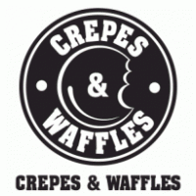

Jose Latorre
Spring 2016

Table of Contents

Executive Summary………………………………………………………. 4

1.Company Analysis……………………………………………………………………. 5
1.1 Background…………………………………………………………………..5
1.1.1 History and Image…………………………………………………..5
1.1.2 Mission, Vision & Values…………………………………………..6
1.1.3 Human Resources…………………………………………………...6
1.1.4 Corporate Social Responsibility (CSR)….………………………….6
1.2 Organization Structure……………………………………………………...7
1.2.1 Internal Analysis…………………………………………………….7
1.2.2 Domestic Business Activity…………………………………………7
1.2.3 Product Categories………………………………………………......8
1.2.4 International Involvement…………………………………………...9
1.3 SWOT Analysis…………………………………………………………......10
1.3.1 Strengths…………………………………………………………...10
1.3.2 Weakness…………………………………………………………..10
1.3.3 Opportunities……………………………………………………....10
1.3.4 Threats …………………………………………………………….10
1.4 Industry Analysis…………………………………………………………...11
1.4.1 Porter’s 5 Forces…………………………………………………...11
1.4.2 Competition………………………………………………………..12
1.4.3 Conclusion & Recommendation…………………………………...13
2.Global Market Research……………………………………………………………..14
2.1 Country Selection…………………………………………………………...14
2.1.1 Country Pre Selection……………………………………………...14
2.1.2 Criteria Selection…………………………………………………..14
2.1.3 Country Comparison……………………………………………….16
2.1.4 Recommendations………………………………………………….18
3.Market Analysis………………………………………………………………………19
3.1 PEST Analysis………………………………………………………………19
3.1.1 United Kingdom…………………………………………………...19
3.1.2 United States…………………………………………………….....20
3.1.3 France ……………………………………………………………..21
3.2 Competition Analysis………………………………………………………23
3.2.1 Main Competitors………………………………………………….23
3.2.2 Globalization………………………………………………………23
3.3 Country Selection…………………………………………………………..23
3.3.1 Criteria Selection…………………………………………………..23
3.3.2 Country Comparison……………………………………………….26
3.3.3 Conclusion & Recommendation…………………………………...27
4.Market Entry………………………………………………………………………….27
4.1 Market Entry Overview……………………………………………………27

4.2 4 P’s …………………………………………………………………………28
4.2.1 Product……………………………………………………………..28
4.2.2 Price………………………………………………………………..28
4.2.3 Promotion………………………………………………………….29
4.2.4 Placement………………………………………………………….30
4.3 Recommendations………………………………………………………….30

Bibliography…………………………………………………………………………….31

Executive Summary

This marketing plan has been developed for Crepes & Waffles, a restaurant chain out of Colombia that is beginning to establish itself throughout Latin America and it’s looking to expand into other prosperous markets. It is a privately owned company without any outside investments or collaborations. Crepes & Waffles is currently in eight countries and I personally believe they should consider expanding into new markets with established growth potential. This marketing plan is an analysis of international markets to find the top countries suitable for the next Crepes & Waffle location. This report is also an overall overview of all business operations. The products and experience that Crepes & Waffles will provide will serve a variety of demands present in current potential markets. The style of Crepes & Waffles will differentiate from the competition and provide a fast yet gourmet dinning experience for all customers. The demand for this type of restaurant is always in high demand and Crepes & Waffles should step right in and fulfill that market share across the globe.

1. Company Analysis

1.1 Background

1.1.1 History and Image
Two university students in Bogotá, Colombia occupying a small local at a local business center founded Crepes & Waffles on April 13, 1980. Located at 85 Street with 11 Av in Bogotá they lunched their dream, a small French crepe place with a rustic style menu and a classic theme to go along with it. Which they founded with the intention to show people a quality product resembling a rustic French style of cooking at affordable prices. While studying at (CESA) University these two students managed to build up this company from the bottom up opening up another restaurant location within two years, and expanding their business model by adding additional ice cream shops.
The restaurant was so simple that even the menu was made of a piece of wood that contained the different product choices that at that time included crepes, waffles and ice cream exclusively. Since then Crepes & Waffles has become an extraordinary restaurant present in 9 countries worldwide focusing mainly in Latin America so far. The Image of Crepes & Waffles is extremely positive associating its brand with European persuasion, quality ingredients. Standing out with a solid reputation in human resources and a well- balanced internal operation. Currently Crepes & Waffles employs 4,000 people in 90 restaurant locations worldwide. The company’s headquarters are now based in Bogotá, Colombia. Crepes & Waffles recorded more than 95 million USD in sales for 2014.While still managing to be a privately owned company.

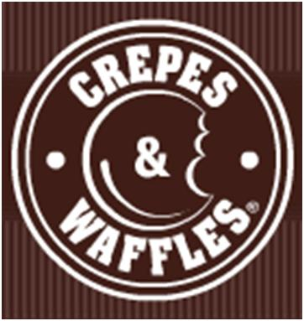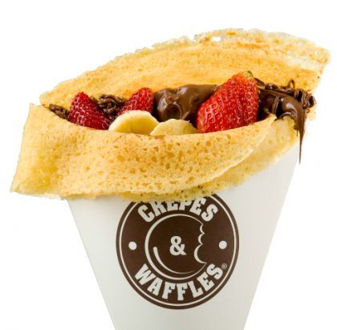

Figure 1 – Crepes & Waffles Logo Figure 2 – Crepes & Waffle’s Sample Crepe

1.1.2 Mission, Visions, and Values
Crepes & Waffles summarize their Mission as “An art that transforms food into love and happiness, nourishes the soul and body, captivates appetites and captures consumers’ hearts”. Using the slogan “Keep it simple”. Since the beginning the mission statement and the vision of this company has been clear to make the customer fall in love with their food and the experience of attending a Crepes & Waffles restaurant. While setting the standard values of a fantastic business model. The company strives to gather feedback from customers and improve their overall service. Therefore, making customer service and customer loyalty a priority in their mission. Even though they are a company that is looking to expand worldwide, their vision has remained the same, and it will continue to remain the same as Crepes & Waffles goes to the next level.

1.1.3 Human Resources
Since the beginning Crepes & Waffles has maintained a great position when it comes to Human Resources, Ethics and Corporate Social Responsibility. In most cases setting the example for other companies to follow. In Bogotá and Quito they hire “women in need” or single women providing them with the opportunity to work and provide for their families. They are also trying to expand this philosophy into their remaining locations of business. Crepes & Waffles is famous for their operations guidelines and their quality standards of both products and overall experience & service. Therefore, the company has always developed employee incentives and privileges for their work force. They also base their position on human resources of including vulnerable groups of workers that other companies won’t usually hire.

1.1.4 Corporate Social Responsibility (CSR)
The values of Crepes & Waffles as a company has been well known throughout their place of business. Always standing out among its competitors for all the right reasons. Crepes & Waffles started one of the most successful social campaigns in Latin America. As described by the company their most valuable asset are their workers, in most cases a team made up of independent women who are head of a household, victims of violence, etc. Crepes & Waffles provides them with decent jobs, under a policy of welfare programs including health, housing, education, recreation and spirituality. Corporate Social Responsibility has been implemented into the Crepes & Waffles business model since the beginning. While also making the case of being environmentally friendly and expecting that from all of their suppliers and business partners. Leading the way for Colombia’s restaurants, and spreading their philosophy throughout the rest of Latin America.

Figure 3 - Word Cloud (CSR)

1.2 Organization Structure

1.2.1 Internal Analysis
Crepes & Waffles has always been a privately own company managed by the two original founders Beatriz Fernandez and Eduardo Macia.With no business experience what so ever they started the first couple of restaurants on their own in the capital city of Colombia. The initial investment was of 1,500 USD. There was no business plan in place when the project started in 1980. In addition limited market research was in place as well. Company investment and company expansion has been the recent growth plan by the company’s top executives. Expanding its market across Colombia, South America and recently opening up two locations in Spain. Crepes & Waffles as a company has been extremely conservative when it comes to their growth strategies. Based on the fact that all expansion is financed by Crepes & Waffles without any outside investments. Based on on the conducted research Crepes & Waffles should take a more aggressive approach and explore other markets with great success. However, the company’s leadership has always been the same, resulting in strategies and ideals that are not going to change anytime soon.

1.2.2 Domestic Business Activity
The majority of business of Crepes & Waffles is conducted in Colombia. There are 66 restaurants in Colombia alone, to go along with 64 Ice Cream Shops. Spreading across 9 cities throughout the country. 24 additional Restaurants are in place in most of Latin America and as far away as Spain.As a company overall Crepes & Waffles is becoming an industry leader and one of the most prosperous brands Colombia has to offer. Crepes & Waffles focuses their resources and investments towards acquiring the best locals in the best locations. That is why they are dominating the restaurant business within Colombia. Brand exposure and brand recognition within Colombia is extremely high. Therefore, Crepes & Waffles competes directly with the biggest restaurant chains in the country.

1.2.3 Product Categories
Crepes & Waffles is a specialized restaurant offering Crepes, Waffles, Salads and Ice Cream. It can be described as an old school Parisian Crêperie providing their customer with a different flavor of rustic simplicity and sweet deliciousness. The full service restaurants offer all of the menu choices, whereas the Ice Cream Shops only offer Ice Cream and Deserts. Crepes & Waffles describe their menu options in 3 major categories quality, taste and nutrition.

QUALITY | TASTE | NUTRITION
Choose the best quality ingredients to provide the best product possible. | Crepes & Waffles is trying to take their food to another level, “if you feel the food, you will enjoy the real taste” | Well balanced menu choices, improve technology and provide healthy and fresh food for consumers.

Figure 4 - Crepes & Waffles Menu Categories

Figure 5 - Salt Crepe Sample Figure 6 - Ice Cream Sample

Figure 7 - Desert Sample

1.2.4 International Involvement
The main portion of Crepes & Waffles operations takes place in Colombia. However, in recent years’ expansion abroad has been growing at an incredible rate. Currently Crepes & Waffles operates stores in Colombia, Venezuela, Panama, Peru, México, Ecuador, Chile, Brazil and Spain. The expansion process to enter other countries is under consideration right now with no clear favorite. However, Crepes & Waffles has been expanding all over Latin America and it should find its way into the remaining countries as well. They should also now consider possible options within the Caribbean, North America and the European Union. A project is currently on hold that would take Crepes & Waffles into Portugal, France and Italy.

Figure 8 - Map of the World with Crepes & Waffles Locations

1.3 SWOT Analysis

1.3.1 Strengths
The restaurant business is always looking for new exciting new comers. As Crepes & Waffles is concerned they are an established brand within their countries of business looking for new business markets. The have shown to have a commitment regarding customer service and providing fantastic products in a revolutionary way. Their brand image is extraordinary and they should continue to use that strength in order to maintain their customer loyalty and increase their market share. Their Corporate Social Responsibility showed also be made a priority when analyzing the strength of potential growth of Crepes & Waffles. They provide great products to go along an unforgettable experience at affordable prices. They will have no problem taking this company to the next level.

1.3.2 Weaknesses
Competition is a major factor in the restaurant business. Crepes & Waffles must be prepared to invest major assets in marketing and brand exposure for future expansion. Going abroad to potential new markets could be challenging based on high degrees of barriers of entry and competition from established restaurants. The culture difference varies from country to country and they must analyze consumer trends of international food consumption. Brand recognition is also a concerning weakness when Crepes & Waffles expands even further.

1.3.3 Opportunities
The possibilities are endless for this company. Throughout its short history already you can clearly see all of the success it’s had. The major strategy of expansion should be to enter new markets by evaluating suiting countries and analyzing the best business decisions for Crepes & Waffles. Through PEST analysis of potential new markets, the company can accurately find a reliable new market and develop a strategy to succeed within that new market by adapting to the requirements as needed. The restaurant industry among developed and developing countries has been on a steady growth rate as of the last couple of years. Making the restaurant industry a prosperous yet competitive one.

1.3.4 Threats
The threats present at the current markets include a wide variety of restaurant options that directly compete with Crepes & Waffles. Barriers of entry and culture adaptation is yet another threat that the company’s management must evaluate when analyzing potential markets. The way people view a Colombian Company is a great threat even though Crepes & Waffles as a brand does not show its Country of Origin from just the brand name. The threat of international cuisine going into a different culture and different food customs is always a challenge. The high degree of competition will also provide a challenge everywhere the company goes to next. The evolution the restaurant business goes through every once in a while provide a challenge for Crepes & Waffles to acquire and sustain their customers and differentiate from innovative competitors.

Strengths | Weaknesses
Brand Image  International Appeal  Human Resources Management  Quality of Products  Quality of Management  Potential | Unknown  Low Market Share  Low International Involvement  Low Brand Recognition
Opportunities | Threats
Developing Markets  Food Industry  New Markets  Bright Horizon | High Degree Competitors  High Degree of Substitution  Unknown in Certain Markets  Established Restaurant Chains

Figure 9 – SWOT Analysis Table

1.4 Industry Analysis

1.4.1 Porter’s 5 Forces
The five forces model of analysis was developed by Michael Porter to analyze the competitive environment in which a product or company works.

Figure 10 - Porter’s 5 Forces

Threat of New Entrants: The market is pretty much set already within Colombia. It is a matter of maintaining and growing market share. The other threat will be being able to adapt to the changing environment around their business, while being able to innovate accordingly. The Treat of new entrants would not be a domestic problem; it would be a problem for their international operations. In their international operations they don’t have as much control as they do in Colombia. To create a chain brand in international environments requires large amounts of capital and investments, to go along with a complex distribution and managerial channels. However, it may be a challenge to expand Crepes & Waffles operations to additional countries were the population have customer loyalty in different brands and restaurants. The positive thing going for Crepes & Waffles is the uniqueness of their brand, products and experience.

Threat of Substitutes: Crepes & Waffles has already established a small market share in their recent new locations to go along with a great brand image. However, there are still major threats of substitution and competition within those markets. Crepes & Waffles targets prime locations and prime locals for their restaurants. Those amenities could be difficult to find in countries with dominating restaurant chains using the same positioning strategy. Crepes & Waffles should develop effective promotion and positioning strategies in order to decrease this potential threat.

Power of Buyers: The power of the buyers in the restaurant industry is extremely high. Do to the fact that there are many options to choose from with totally different products, prices and experiences. Therefore, buyers have a wide field of options and it’s up to Crepes & Waffles to differentiate themselves.

Power of Suppliers: One of Crepes & Waffles requirements is to use their approved ingredients in order to guarantee Crepes & Waffles taste and standards. They do outsource production and use local products to guarantee great quality and freshness. Therefore, bargaining power among suppliers is low because Crepes & Waffles controls their supplier network with a variety of options and possibilities.

1.4.2 Competition
Crepes & Waffles remains the market leader in chained full-service restaurants in Colombia. With a market share of 47% in 2014. It is down slightly from years past due to new arrival of competition, rather than Crepes & Waffles suffering from lower performance. During the last couple of years Crepes & Waffles have expanded its menu of crepes in order to compete with some of the new comers revolutionizing its tastes and dishes. Therefore, they adjusted their diversification strategy by including new flavors and dishes inspired by Spanish Crepes and Peruvian cuisine as well. The company also launched a new breakfast line of dishes in order to join the breakfast and brunch segments of full-service restaurants. Based on these executive actions sales improved by 5% for 2015. Overall Crepes & Waffles popularity remains based on its affordable prices, which makes the outlets accessible to a wide consumer base including mainly of middle and middle-high income consumers. Some of the primary competition of Crepes & Waffles throughout Colombia would be El Corral Hamburgers and Kokoriko, to go along with the American companies already established in the country. Salata, Panera, Crepe Shops and Waffle House are their main international competition. As Ice Cream shops such as Baskin Robbins, Ben & Jerry’s and Häagen-Dazs provide competition for their Ice Cream shops.
COMPANY NAME | ESTABLISHED DATE | SALES ESTIMATED | NUMBER OF STORES
WAFFLE HOUSE | 1955 | 1.1 Billion USD | 2100
PANERA | 1981 | 4.3 Billion USD | 2000
BEN & JERRY’S | 1978 | 350 Million USD | 5812
BASKIN ROBBINS | 1948 | 544 Million USD | 7300
HÄAGEN-DAZS | 1960 | 750 Million USD | 900

Figure 11 – Crepes & Waffles Competitors Table of American Companies

Figure 12 – Restaurant Industry Market Share of Colombia

1.4.3 Conclusion & Recommendation
After conducting the following research, we can conclude that Crepes & Waffles has come a long way. Yet it is that fact alone that predicts the future for the company. They
must take a more aggressive approach and expand their market by expanding among suitable countries, even think about franchising their brand as well. Their business model will carry them to a variety of new markets with no problems. The only factors needed for adaptation would be promotion and placement by adapting to different cultures and different languages.

2. Global Market Search

2.1 Country Selection

2.1.1 Country Pre-Selection
Crepes & Waffles is relatively small compared to some of today’s global brands that have business worldwide. Therefore, Crepes & Waffles has some wonderful opportunities to expand to other international markets. During most of Crepes & Waffles expansion projects the company have followed a consistent pattern of growth. Mostly expanding to neighboring countries next to Colombia in a strategy of regional selection and expansion. Nearby expansion makes the most sense because it would be easier to operate to manage and to develop. Based upon those facts I will only consider potential new countries of business in the Americas. North America, Central America, the Caribbean and the remaining options in South America would be analyzed.

2.1.2 Criteria Selection
Based on four primary factors the countries will be narrowed down from all possible business options.

Population: It will be the most important statistic of this research based on the ability for Crepes & Waffles to enter a market with sufficient potential customers. Due to this factor any country with less than 10 million people would be excluded from potential markets.

GDP Per Capita: Provides a great insight look into a Country’s economy and their current situation. The people of the country needs to be able to have disposable income for eating out expenses.

Consumer Expenditure on Food Per Person: Being in the Restaurant Industry Crepes & Waffles should be able to analyze the consumption of food per capita of each country. This data should provide a good benchmark to judge the demand of food consumption.

Ease of Doing Business: Crepes & Waffles needs to find the perfect country to expand its business even further. Therefore, they must enter a stable country without corporate corruption or questionable business models and systems.

A Likert Scale is used to separate each of the variables analyzed into a scale of 1 to 5 to be able to compare each potential country with fairness and on an equivalent scale.

FACTORS | 1 | 2 | 3 | 4 | 5 | WEIGHT
POPULATION (IN MILLION) | < 25 | 25-40 | 40-55 | 55-70 | 70+ | 30%
GDP PER CAPITA (IN USD) | <12,000 | 12,000-22,000 | 22,000-32,000 | 32,000-42,000 | 42,000+ | 25%
CONSUMER EXPENDITURE ON FOOD PER CAPITA | <950 | 950-1,400 | 1,400-1,850 | 1,850-2,300 | 2,300+ | 25%
EASE OF DOING BUSINESS (INDEX) | <56 | 56-63 | 63-70 | 70-77 | 77+ | 20%

Figure 13 – Likert Scale Table

FACTORS | POPULATION (IN MILLION) | GDP PER CAPITA (IN USD) | CONSUMER EXPENDITURE ON FOOD PER CAPITA | EASE OF DOING BUSINESS (INDEX)
CANADA | 32.16 | $51,958.38 | $2,506.40 | 79.09
UNITED STATES | 318.9 | $53,041.98 | $2,389.50 | 81.98
GUATEMALA | 15.47 | $3,477.89 | $1,296.00 | 64.88
ARGENTINA | 41.45 | $14,715.18 | $1,700.70 | 57.48
BOLIVIA | 10.67 | $2,867.64 | $553.40 | 49.95
DOMINICAN REPUBLIC | 10.4 | $5,879.00 | $1,173.90 | 63.43
PORTUGAL | 10.46 | $21,733.07 | $2,773.30 | 76.03
FRANCE | 66.03 | $42,503.30 | $3,240.50 | 73.88
ITALY | 59.83 | $35,925.88 | $3,080.50 | 68.48
UNITED KINGDOM | 64.1 | $41,787.47 | $2,434.60 | 80.96
Figure 14 – Real Values Tables

FACTORS | POPULATION (IN MILLION) | GDP PER CAPITA (IN USD) | CONSUMER EXPENDITURE ON FOOD PER CAPITA | EASE OF DOING BUSINESS (INDEX) | WEIGHTED SCORE | BASE SCORE
WEIGHT | 30% | 25% | 25% | 20%
CANADA | 2 | 5 | 5 | 5 | 4.1 | 4.25
UNITED STATES | 5 | 5 | 5 | 5 | 5 | 5
GUATEMALA | 1 | 1 | 2 | 3 | 1.65 | 1.75
ARGENTINA | 3 | 2 | 3 | 2 | 2.55 | 2.5
BOLIVIA | 1 | 1 | 1 | 1 | 1 | 1
DOMINICAN REPUBLIC | 1 | 1 | 2 | 3 | 1.65 | 1.75
PORTUGAL | 1 | 2 | 5 | 4 | 2.85 | 3
FRANCE | 4 | 5 | 5 | 4 | 4.5 | 4.5
ITALY | 4 | 4 | 5 | 3 | 4.05 | 4
UNITED KINGDOM | 4 | 4 | 5 | 5 | 4.45 | 4.5

Figure 15 – Likert Scale, Weighted and Base

Each of the factors chosen are key statistics in order to learn from foreign markets. The weight of each category was determined based on importance. There are other factors that will also play a part in this analysis of foreign markets. However, those factors will be considered of secondary importance and have a lower weight in terms of essential characteristics. Based on this information however we can clearly discard some countries from our list of potential destinations. Concluding with a couple of countries that stand out among the rest possessing all the right attributes we are looking for.

2.1.3 Country Comparison
After conducting the first preliminary stages of research the top three countries with the best potential for expansion include the United States, the United Kingdom and France.
The tables below show the results based on our selection criteria.
FACTORS | WEIGHT | UNITED STATES | FRANCE | UNITED KINGDOM
POPULATION (IN MILLION) | 30% | 5 | 4 | 4
GDP PER CAPITA (IN USD) | 25% | 5 | 5 | 4
CONSUMER EXPENDITURE ON FOOD PER CAPITA | 25% | 5 | 5 | 5
EASE OF DOING BUSINESS (INDEX) | 20% | 5 | 4 | 5
WEIGHTED SCORE |  | 5 | 4.5 | 4.45
BASE SCORE |  | 5 | 4.5 | 4.5

Figure 16 – Final Three Countries with Ratings & Values

Figure 17 – Map of Top 3 Country Possibilities

Figure 18 – Final Three Countries Perceptual Map

The Following Perceptual Map give a clear position where the top three countries stand when compared to each other by the three most important characteristics analyzed in our
research. The x and y axis are as labeled were the size of the circle represents the population of each country.

2.1.4 Recommendations
As shown throughout the previous data all of these countries are strong suiters for the next Crepes & Waffles restaurant. All of them have all the characteristics this company needs in order to succeed. Yet the overall favorite so far is the potential the United States market has on up and coming restaurant chains.

3. Market Analysis

3.1 PEST Analysis

3.1.1 United Kingdom
Political Factors: The United Kingdom is a constitutional monarchy with Queen Elizabeth II as the head of state to go along with an elected Parliament which regulates power and pass legislation as well. The prime minister of Great Britain is David Cameron. As of now the Conservative Party leads the government of the United Kingdom. The United Kingdom is a part of the European Union, yet they use different currency. They use the English pound instead of the currency used by the rest of the European Union the Euro. As of late some people are questioning the United Kingdom involvement in the European Union, that manner however will resolve itself promptly. The UK has an extremely stable governmental structure. With a corruption level low if not up solute. The United Kingdom lastly consist of the territories of England, Scotland and Northern Ireland. With its capital being the city of London.
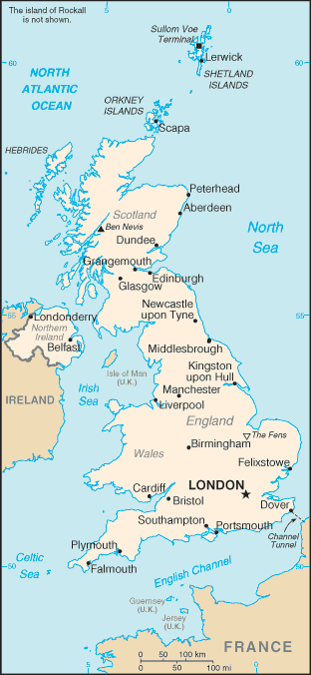
Economic Factors: The economic outlook of the United Kingdom is very good and stable. Consists of a leading economic power and the third largest economy in Europe after Germany and France. Agriculture is intensive, highly mechanized and extremely efficient when compared to other European standards. Producing about 60% of food needs with less than 2% labor force. Therefore, as expected the United Kingdom is also very stable economically. With large production of resources and high growth rates across the board. The GDP is of $2.66 trillion as of 2015. The GDP growth rate of 2.5%. GDP Per Capita of $41,200. A labor force of 32.94 million people. Unemployment rate of 5.4%. All figures are 2015 estimates.

Social Factors: The social factors of the United Kingdom include a population size of 64.5 million people. With the majority of its citizens living in the capital city of London. Other important cities include Manchester, Liverpool and Birmingham. To go along with Belfast in Northern Ireland and Edinburgh in Scotland. The population growth rate is of .6% and the population has a 82.6% urban concentration. Figure 19 – Map of the UK 15% of people are living below the poverty line. The main language of the United Kingdom is English. With the Ethnic groups demographic as follows. 87.2% white, 3% black/African/black English, 2.3% Asian and Indian. With the main religions being Christianity, Roman Catholic, Muslim and Hindu.

Technologic Factors: The United Kingdom is a developed country with the infrastructure and technology of a major economic power. It has 460 airports as of 2013. 30,858.5 KM of Railways, 394,428 KM of Roadways, the United Kingdom also features ports, terminals, oil refineries etc. It has 3,200 KM of waterways with a large percentage of those being used for commerce. Lastly the United Kingdom also features an international telephone system with 33.24 million total subscriptions. About 90% of the population are users of the Internet.

3.1.2 United States
Political Factors: The United States of America has a strong democratic government to go along with an effective rule of law. With the presidential system elections are considered fair and transparent. The United States enjoys a massive political and economic influence over both national and global policymaking, and is recognized as the leading superpower in the world. However, the U.S. is facing international criticism for its interventionist policies regarding the “War on Terror” which is souring foreign relations, and at the same time fueling terrorist groups and increasing the threat of terrorism. The United States has also been labeled the “world’s policeman” because of its influence in other nations affairs. Yet overall the political outlook of the United States would be perfectly suited for receiving international brands and foreign investments.

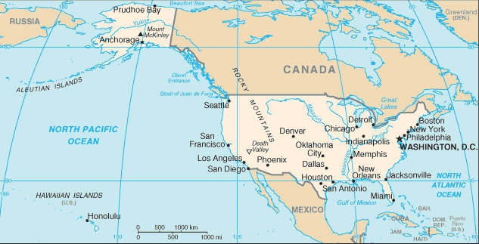

Figure 20 – Map of the United States

Economic Factors: The United States has a GDP per capita of $53,041.48 USD as of 2013. To go along with a GDP (Gross Domestic Product) of $16.77 trillion USD. The United States is the largest economy in the world, and goes along with an economic system that is well developed and well balanced throughout a variety of industry sectors. The unemployment rate is of 5.5% as of 2015. The minimum wage is $7.25 USD per hour and the GDP growth rate is of 2.2%. The recession of 2008 is beginning to stay on the rearview mirror and is quickly bouncing back. The increasing budget deficit puts the economic prosperity of the United States in question. This goes along with an incredible amount of debt. All figures are 2013 estimates.

Social Factors: The United States social factors include a variety of key statistics. The US is currently facing an aging population which can lead to labor shortage and rising tax rates in the future. The United States however has one of the best education systems in the world and a variety of healthcare advancements. As a society the United States is mainly white with a 79.96%, black 12.85%, 4.43% Asian among others. The Hispanic community is also registered but within the parameters of their race not ethnicity. The main language is English although 12.9% of the population speaks Spanish. The main religions are Protestant 51.3%, Roman Catholic 23.9%, with Mormon, Christian, Jewish and other religious presence as well.

Technologic Factors: Innovation and technology advancement are major cornerstones of the United States Economy. The United States has always been the country that is leading the way in adaptation and developing and applying technology. Although some other world powers are advancing as well the United States is expected to maintain the advantage it has had in the technological sector for the years to come. The United States counts with 13,513 airports as of 2013. It has 293,564.2 KM of Railways to go along with 6,586,610 KM Roadways. 41,009 KM of waterways with 19,312 KM being used for commerce. The U.S. also counts with the world best resources and the must technological advance business environment anywhere in the world.

3.1.3 France
Political Factors: France throughout history has had an established and stable political system in place. France has a semi-executive presidency. The current president is Francois Hollande and the Head of Government is Manuel Valls. As we are all aware France and other parts of the European Union have been victims of acts of terrorism in their own soil. Since that time France has also joined forces with various world powers in conducting military operations against the terrorist organization of ISIS. The country of France is involved right in the middle with the European Union and being regarded as one of the engines of the European Region. Unlike the United Kingdom France does use the Euro as its form of Currency. Overall France is considered to be one of the worlds powers.

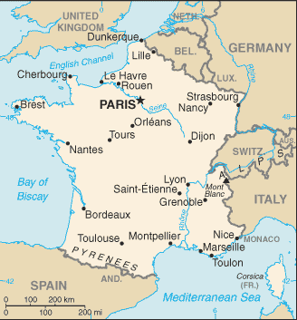
Economic Factors: France is still one of the world economic engines, yet it seems they have not been as effective lately. France is still very diverse in a variety of sectors across the board. The GDP is of $2.647 trillion as of 2015. GDP growth rate is of 1.2%. GDP Per Capita of $41,400. The agriculture sector is one of the biggest in the world and the largest in Europe. The unemployment rate is of 9.9%. All figures are estimates as of 2015.

Social Factors: The social factors within France are as follows. The main language is French with 100% official. The main religion is Christianity, overwhelmingly Roman Catholic with 63-66% accordingly. Muslims consist of 1-9% with others religious presences as well. France has been experiencing a growth in population increasing potential consumer expenditure, yet as stated above the high unemployment rate may contribute to a decrease in expenditure.
Figure 21 – Map of France

Technologic Factors: France has been among the world’s best in technological advancements even though of their rich heritage and sense of their history. France has a total of 464 airports as of 2013. It has 29,640 KM of railways to go along with 1,028,446 KM of roadways. Waterways include metropolitan France with 8,501 KM. The telephone system is highly developed as well as the internet availability and usage. Overall France has all of the qualities one is looking for in order to adapt ones business into an international environment.

3.2 Competition Analysis

3.2.1 Main Competitors
In the United States, United Kingdom and France the Main Competition would be all affordable full-service restaurant with a specialization in French cuisine and Sweet deserts. All though the prices may compare to some fast food restaurants present in all of the countries analyzed the experience and the cuisine is far different. Yet overall there are no clear companies with the same criteria as Crepes & Waffles, therefore one would have to position their company with a certain goal in mind.

3.2.2 Globalization
Globalization shows how a country receives international involvement, international business and foreign investment. The KOF Globalization Index measures three important dimensions. Economics, Social and Political. The index is described as the higher the index value assigned to that country the more globalized the country is. The Globalization Table will show the top three countries so far into the analysis.

Country Name | KOF Globalization Index | KOF Social Globalization | KOF Economic Globalization | KOF Political Globalization
United States | 76.91 | 79.15 | 59.4 | 92.19
United Kingdom | 82.88 | 86.08 | 67.62 | 94.95
France | 83.65 | 87.14 | 66.53 | 97.29

Figure 22 – Globalization Table

As shown by the the table, France is the most globalized between the three countries. However, they are all fairly close when it comes to their KOF Globalization Index.

3.3 Country Selection

3.3.1 Criteria Selection
In order to further analyze our three potential countries, the implementation of a new Likert Scale will be added. The original four categories will be used with the addition of four more characteristics to further dissect these potential markets.

Population: It will be the most important statistic of this research based on the ability for Crepes & Waffles to enter a market with sufficient potential customers. Due to this factor any country with less than 10 million people would be excluded from potential markets.

GDP Per Capita: Provides a great insight look into a Country’s economy and their current situation. The people of the country needs to be able to have disposable income for eating out expenses.

Consumer Expenditure on Food Per Person: Being in the Restaurant Industry Crepes & Waffles should be able to analyze the consumption of food per capita of each country. This data should provide a good benchmark to judge the demand of food consumption.

Ease of Doing Business: Crepes & Waffles needs to find the perfect country to expand its business even further. Therefore, they must enter a stable country without corporate corruption or questionable business models and systems.

The new additional criteria’s will include Culture Distance, KOF Globalization Index and Disposable Income Per Capita.

Culture Distance: The model based on national culture consists of six dimensions. The cultural dimensions represent independent preferences for one state of affairs over another that differentiates countries from each other.

KOF Globalization Index: The index will identify the globalization of each individual country and will stand out those with global exposure and global influence.

Disposable Income Per Capita: Will highlight the disposable income people have to do as they please including eating out and entertainment. We will therefore know what country out of the United States, United Kingdom and France has the most money to spend on leisure per capita.

Unemployment Rate: Will show the percentage of the amount of people that have no job, no income and no disposable income, therefore they cannot go out to one of our restaurants.

FACTORS | 1 | 2 | 3 | 4 | 5 | WEIGHT
POPULATION (IN MILLION) | < 25 | 25-40 | 40-55 | 55-70 | 70+ | 25%
GDP PER CAPITA (IN USD) | <12,000 | 12,000-22,000 | 22,000-32,000 | 32,000-42,000 | 42,000+ | 20%
CONSUMER EXPENDITURE ON FOOD PER CAPITA (USD) | <950 | 950-1,400 | 1,400-1,850 | 1,850-2,300 | 2,300+ | 20%
EASE OF DOING BUSINESS (INDEX) | <56 | 56-63 | 63-70 | 70-77 | 77+ | 15%
KOF GLOBALIZATION (INDEX) | <76 | 76-78 | 78-80 | 80-82 | 82+ | 5%
CULTURE DISTANCE (TOTALS) | <320 | 320-340 | 340-360 | 360-380 | 380+ | 5%
DISPOSABLE INCOME PER CAPITA (USD) | <2,500 | 2,500-2,800 | 2,800-3,100 | 3,100-3,400 | 3,400+ | 5%
UNEMPLOYMENT RATE (%) | >8 | 7-8 | 7-6 | 6-5 | <5 | 5%

Figure 23 – Likert Scale, Weighted

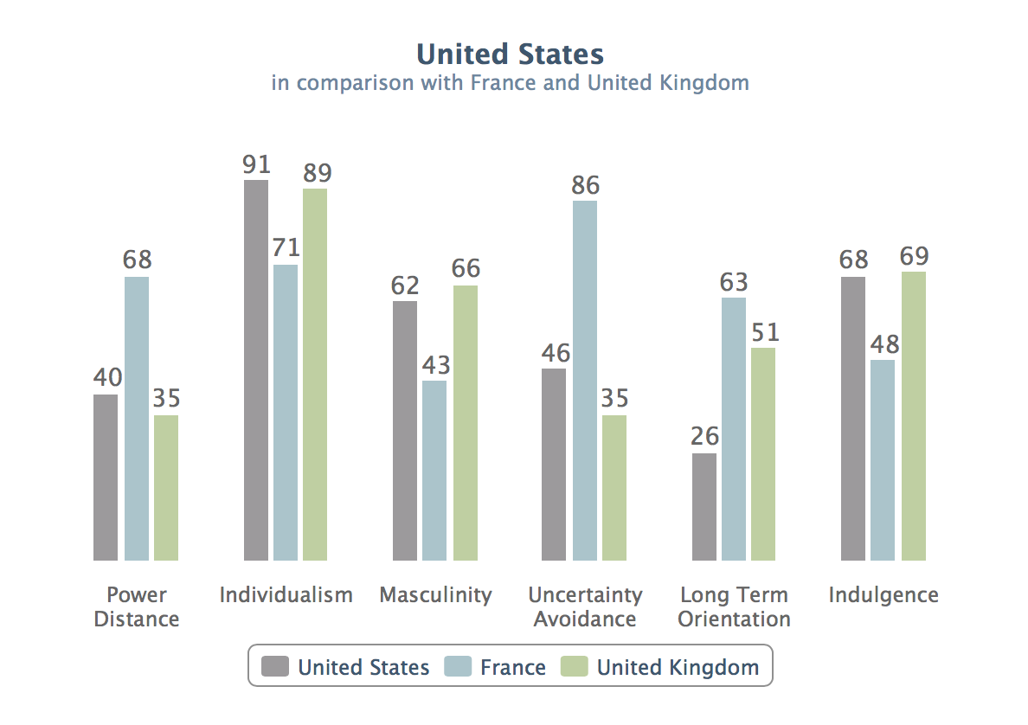
Figure 24 - Hofstede Model Cultural Dimensions Comparison

3.3.2 Country Comparison
By analyzing the remaining countries through all of the statistics required and expanding upon those already research. The following table compared the three countries through all the important characteristics required when entering an international market. After this phase the Country Crepes & Waffles should enter next should be the United States.

FACTORS | WEIGHT | UNITED STATES | UNITED KINGDOM | FRANCE
POPULATION (IN MILLIONS) | 25% | 5 | 4 | 4
GDP PER CAPITA (USD) | 20% | 5 | 4 | 5
CONSUMER EXPENDITURE ON FOOD PER CAPITA(USD) | 20% | 5 | 5 | 5
EASE OF DOING BUSINESS (INDEX) | 15% | 5 | 5 | 4
KOF GLOBALIZATION (INDEX) | 5% | 2 | 4 | 5
CULTURE DISTANCE (TOTALS) | 5% | 2 | 3 | 4
DISPOSABLE INCOME PER CAPITA (USD) | 5% | 4 | 3 | 2
UNEMPLOYMENT RATE (%) | 5% | 4 | 4 | 1
WEIGHTED SCORE |  | 4.6 | 4.25 | 4.2

Figure 25 – Country Comparison Table

3.3.3 Conclusion & Recommendation
Based upon the market research conducted throughout this report the next market Crepes & Waffles should enter into should be the United States. However, all of the final options make a strong case in their favor and they could be a liable option for the future.

4. Market Entry

4.1 Market Entry Overview
The restaurant Industry in the United States is a huge market, yet extremely competitive. Crepes & Waffles would need a well-organized market of entry strategy in order to succeed. Talking a business international is extremely risky, yet it is nothing new to Crepes & Waffles due to its standard business model that does not need too much adaptation when going to different cultures. The entry strategy should be acquisition of everything while outsourcing production of ingredients to local suppliers. Another option of entry would be to franchise the company; however, the top executives have refused this option as of late. Overall the the business model is in place is just a matter of adjusting accordingly and managing the risk of globalization.

RESTAURANT INDUSTRY MARKET OVERVIEW | VALUES
Total U.S. Restaurant Industry (Food & Drink) | $709.24bn
Number of Employees in the U.S. Restaurant Industry | 14.01m
Number of Meals Purchased at a Restaurant in the U.S. | 194 Per Capita
Food & Drink sales of U.S. Full-Service Restaurants | $219.69bn

Figure 26 – Industry Analysis Table United States Restaurant Business

4.2 4 P’s

4.2.1 Product
The products of Crepes & Waffles should remain exactly the same. It will not only be to stay true to the product and brand, but because the United States food market would love what Crepes & Waffles has to offer. The food of Crepes & Waffles is described as international cuisine as well. The concepts and ideas travel well with this company. The consumer will not be able to identify the origin of this company due to the fact that is a Colombian Restaurant selling French style cuisine options. The United States culture fits perfectly with the menu options because of the popularity of the sweet options and the food diversity within the own restaurant of selling house salads as well.

4.2.2 Price
Some adaptation is required to adjust to the United States currency and usual price for this type of product. A currency exchange must be made between the Colombian Peso and the United States Dollar. With the exchange rate present above as of April 2016. The average price per meal in Colombia is extremely cheaper than that of the United States. However, we cannot compare Crepes & Waffles to a regular fast food place in the U.S. in either price and quality. Yet I believe based on the price willing to play for a meal like one would get at a Crepes & Waffles restaurant the company should raise their prices above that of the regular exchange rate. The average visit at Crepes & Waffles is about $30,000 Colombian Pesos per person. Making it around $10 USD on average. At those prices you are competing with fast food restaurants. Therefore, my recommendation on pricing should be to increase prices and compete with full-service restaurants while staying competitive. The menu should show detail of dollar symbols and rational prices.

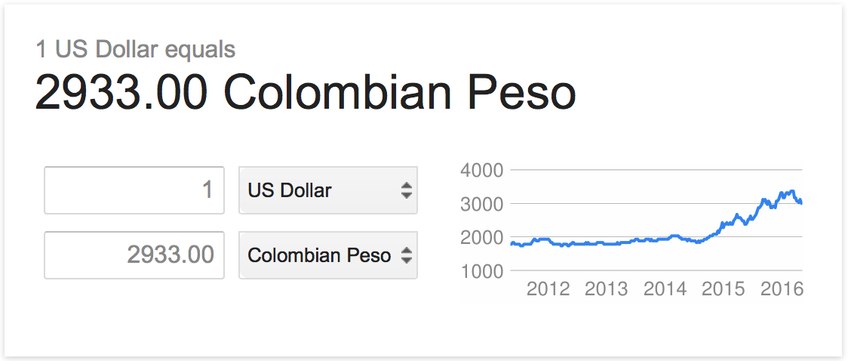

Figure 27 – Colombian Peso to United States Dollar Exchange Rate

4.2.3 Promotion
The biggest adjustment that Crepes & Waffles needs to make is in their promotion strategy, marketing and brand strategy. The United States has millions of brands and companies; therefore, brand recognition should be one of the first priorities. Advertising should be a priority and adapt to successful advertising strategies for full-service restaurants in the United States. The company logo seems to be a bit calm compared to other companies’ logos. They may want to redesign certain things in order to be remembered and build customer loyalty. Sponsoring events, giving away samples, giving promotions and getting involved in the community around them.

STANDARIZE ADAPT

PRODUCT

PRICE

PROMOTION

PLACEMENT

Figure 28 – Adaptation vs. Standardization

4.2.4 Placement
Crepes & Waffles business model on placement would be suitable for this new market. They will not have to adapt too much to the market conditions because the industry requires it to be in the best local and location possible. Human traffic would be ideal in order for customers to pass the restaurant and get familiar with its style, atmosphere and spirit. The goal should be to provide affordable prices, innovating the food culture around them and promote themselves with all of their positive attributes.

Figure 29 – Potential Locations Map

This map shows some potential destinations for Crepes & Waffles as the populations are diverse and the demand for food consumption is high. Eating out statistics also favor these prime locations.

Entry Mode-Franchise? Crepes & Waffles, outsource ingredient production, acquisition of resources.

Product-Crepes & Waffles should remain standardized. No adaptation is required. May be needed in the future by analyzing consumer trends.

Pricing-Crepes & Waffles should adjust their menu prices based on the willingness of customers to pay more. Adjust to different currency, taxes, while maintaining competitive prices.

Promotion-Crepes & Waffles should target high quality low prices market share. Sponsor Events, Advertisement. Location with Traffic.

Placement-Location is key. Right City. Right Local. High exposure. Aim for Brand Recognition.

4.3 Recommendations & Conclusion
Crepes and Waffles should expand their business to the United States as shown throughout this Marketing Plan the possibilities are endless for this company. This Marketing Plan analyzes all characteristics Crepes & Waffles needs in order to be successful in the future and going global. Based on this Research there is a lot of demand out there in the Restaurant business and Crepes & Waffles should take advantage of that opportunity. They should have no problems if this plan is executed.
References

http://crepesywaffles.com.co/
http://crepesywaffles.com.co/quienes-somos/historia-y-filosofia
http://www.eltiempo.com/economia/empresas/crepes-waffles-destrono-a-el-corral-en-ventas/14089358
http://parque93.com/directorio/restaurantes/crepes-waffles/
http://crepesywaffles.com.co/ultimos-placeres/creaciones
http://crepesywaffles.com.co/quienes-somos/cultura
http://crepesywaffles.com.co/quienes-somos/calidad-sabor-y-nutricion
http://crepesywaffles.com.co/quienes-somos/historia-y-filosofia
https://culturaglobalrse.wordpress.com/crepes-waffles/
http://crepesywaffles.com.co/ultimos-placeres/ultimas-noticias
http://www.dreamstime.com/stock-illustration-csr-corporate-social-responsibility-word-cloud-illustration-image53067543
https://culturaglobalrse.wordpress.com/crepes-waffles/
http://www.marketingyfinanzas.net/2014/09/una-receta-para-emprender-de-los-fundadores-crepes-waffles-2/
http://news.trust.org//item/20140513102727-it76s/
http://crepesywaffles.com.co/blog-entry/el-alimento
http://crepesywaffles.com
http://crepesywaffles.com.co/menu
http://crepesywaffles.com.co/sites/default/files/product/almuerzo_cena/800x_16.jpg
http://crepesywaffles.com.mx/sites/crepesywaffles.com.mx/files/styles/top_ten_inner/public/slide/Base-Payaso.jpg
http://crepesywaffles.com.co/sites/default/files/product/almuerzo_cena/big_1_nataly.png
http://crepesywafflesartesano.com/
http://mapchart.net/world.html
http://crepesywaffles.com.co/hablemos/preguntas-frecuentes
http://crepesywaffles.com.co/hablemos/preguntas-frecuentes
http://www.statista.com/statistics/190426/top-ice-cream-brands-in-the-united-states/
http://www.wafflehouse.com/
http://nrn.com/top-100/waffle-house
http://www.huffingtonpost.com/nik-freeman/waffle-house-locations_b_5332044.html
https://www.panerabread.com/en-us/company/about-panera.html
https://www.panerabread.com/en-us/company/financial-reports.html
https://www.panerabread.com/en-us/company/about-panera/our-history.html
http://www.benjerry.com/?keyword=%2Bben%20%2Band%20%2Bjerrys&gclid=CJCKh5rArMwCFUFehgodd7cPSA
http://nrn.com/top-100/baskin-robbins
https://www.baskinrobbins.com/content/baskinrobbins/en/aboutus/international.html
https://www.haagendazs.us/about/
http://fortune.com/2011/05/16/general-mills-global-sweet-spot/
https://www.entrepreneur.com/franchises/haagendazsshoppecoincthe/282406
http://data.worldbank.org/indicator/SP.POP.TOTL
http://data.worldbank.org/indicator/NY.GDP.PCAP.CD
http://www.euromonitor.com/countries
http://www.doingbusiness.org/~/media/GIAWB/Doing%20Business/Documents/Annual-Reports/English/DB15-Chapters/DB15-Report-Overview.pdf
https://www.cia.gov/library/publications/resources/the-world-factbook/geos/uk.html
https://www.cia.gov/library/publications/resources/the-world-factbook/geos/uk.html
https://www.cia.gov/library/publications/resources/the-world-factbook/geos/uk.html
https://www.cia.gov/library/publications/resources/the-world-factbook/geos/uk.html
https://www.cia.gov/library/publications/resources/the-world-factbook/geos/uk.html
http://americanhistory.about.com/od/governmentandpolitics/fl/All-About-the-Electoral-College.htm
https://www.cia.gov/library/publications/resources/the-world-factbook/geos/us.html
http://data.worldbank.org/country/united-states
https://www.cia.gov/library/publications/resources/the-world-factbook/geos/us.html
https://www.cia.gov/library/publications/resources/the-world-factbook/geos/us.html
https://www.cia.gov/library/publications/resources/the-world-factbook/geos/fr.html
https://www.cia.gov/library/publications/resources/the-world-factbook/geos/fr.html
https://www.cia.gov/library/publications/resources/the-world-factbook/geos/fr.html
https://www.cia.gov/library/publications/resources/the-world-factbook/geos/fr.html
http://globalization.kof.ethz.ch/query/
https://geert-hofstede.com/national-culture.html
http://globalization.kof.ethz.ch/query/
http://www.businessinsider.com/disposable-income-infographic-2015-3
https://geert-hofstede.com/united-states.html

http://crepesywaffles.com.co/
http://crepesywaffles.com.co/quienes-somos/historia-y-filosofia
http://www.eltiempo.com/economia/empresas/crepes-waffles-destrono-a-el-corral-en-ventas/14089358
http://crepesywaffles.com.co/hablemos/preguntas-frecuentes
http://parque93.com/directorio/restaurantes/crepes-waffles/
http://crepesywaffles.com.co/ultimos-placeres/creaciones
http://crepesywaffles.com.co/quienes-somos/cultura
http://crepesywaffles.com.co/quienes-somos/calidad-sabor-y-nutricion
http://crepesywaffles.com.co/quienes-somos/historia-y-filosofia
https://culturaglobalrse.wordpress.com/crepes-waffles/
http://crepesywaffles.com.co/ultimos-placeres/ultimas-noticias
http://www.dreamstime.com/stock-illustration-csr-corporate-social-responsibility-word-cloud-illustration-image53067543
https://culturaglobalrse.wordpress.com/crepes-waffles/
http://www.marketingyfinanzas.net/2014/09/una-receta-para-emprender-de-los-fundadores-crepes-waffles-2/
http://news.trust.org//item/20140513102727-it76s/
http://crepesywaffles.com.co/blog-entry/el-alimento
http://crepesywaffles.com.co/hablemos/preguntas-frecuentes
http://crepesywaffles.com
http://crepesywaffles.com.co/menu
http://crepesywaffles.com.co/sites/default/files/product/almuerzo_cena/800x_16.jpg
http://crepesywaffles.com.mx/sites/crepesywaffles.com.mx/files/styles/top_ten_inner/public/slide/Base-Payaso.jpg
http://crepesywaffles.com.co/sites/default/files/product/almuerzo_cena/big_1_nataly.png
http://crepesywafflesartesano.com/
http://mapchart.net/world.html
http://www.euromonitor.com/full-service-restaurants-in-colombia/report
http://revistalabarra.com/ediciones/ediciones-2011/edicion-46/restaurantes-destacados/el-secreto-de-crepes-waffles-su-gente.htm
http://www.statista.com/statistics/190426/top-ice-cream-brands-in-the-united-states/
http://www.wafflehouse.com/
http://nrn.com/top-100/waffle-house
http://www.huffingtonpost.com/nik-freeman/waffle-house-locations_b_5332044.html
https://www.panerabread.com/en-us/company/about-panera.html
https://www.panerabread.com/en-us/company/financial-reports.html
https://www.panerabread.com/en-us/company/about-panera/our-history.html
http://www.benjerry.com/?keyword=%2Bben%20%2Band%20%2Bjerrys&gclid=CJCKh5rArMwCFUFehgodd7cPSA
http://nrn.com/top-100/baskin-robbins
https://www.baskinrobbins.com/content/baskinrobbins/en/aboutus/international.html
https://www.haagendazs.us/about/
http://fortune.com/2011/05/16/general-mills-global-sweet-spot/
https://www.entrepreneur.com/franchises/haagendazsshoppecoincthe/282406
http://www.eltiempo.com/economia/empresas/crepes-waffles-destrono-a-el-corral-en-ventas/14089358
http://data.worldbank.org/indicator/SP.POP.TOTL
http://data.worldbank.org/indicator/NY.GDP.PCAP.CD
http://www.euromonitor.com/countries
http://www.doingbusiness.org/~/media/GIAWB/Doing%20Business/Documents/Annual-Reports/English/DB15-Chapters/DB15-Report-Overview.pdf
https://www.cia.gov/library/publications/resources/the-world-factbook/geos/uk.html
https://www.cia.gov/library/publications/resources/the-world-factbook/geos/uk.html
https://www.cia.gov/library/publications/resources/the-world-factbook/geos/uk.html
https://www.cia.gov/library/publications/resources/the-world-factbook/geos/uk.html
https://www.cia.gov/library/publications/resources/the-world-factbook/geos/uk.html
http://americanhistory.about.com/od/governmentandpolitics/fl/All-About-the-Electoral-College.htm
https://www.cia.gov/library/publications/resources/the-world-factbook/geos/us.html
http://data.worldbank.org/country/united-states
https://www.cia.gov/library/publications/resources/the-world-factbook/geos/us.html
https://www.cia.gov/library/publications/resources/the-world-factbook/geos/us.html
https://www.cia.gov/library/publications/resources/the-world-factbook/geos/fr.html
https://www.cia.gov/library/publications/resources/the-world-factbook/geos/fr.html
https://www.cia.gov/library/publications/resources/the-world-factbook/geos/fr.html
https://www.cia.gov/library/publications/resources/the-world-factbook/geos/fr.html
https://www.cia.gov/library/publications/resources/the-world-factbook/geos/fr.html
http://globalization.kof.ethz.ch/query/
https://geert-hofstede.com/national-culture.html
http://globalization.kof.ethz.ch/query/
http://www.businessinsider.com/disposable-income-infographic-2015-3
https://geert-hofstede.com/united-states.html
http://www.statista.com/topics/1135/us-restaurants/
http://crepesywaffles.com.co/menu

