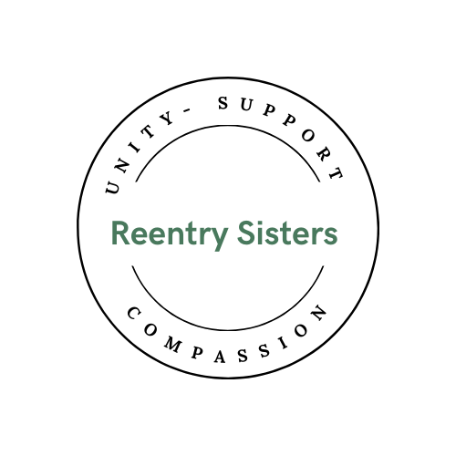

Reentry Sisters Education Initiative
Cohort 2 Application September 2026 to May 2027
Complete by April 30, 2026 and return to:
reentrysistersmaine@gmail.com

Name:

Contact Information - Facility and Caseworker or Address and Phone Number:

Date of Birth: ______________________________________

Please share your personal pronouns if you wish. ____________________________________

How did you hear about the Reentry Sisters Education Initiative program?

____________________________________________________________________________

Release information

SCCP
Are you eligible and applying for SCCP?
- Yes
Approximate release date on SCCP ________________________
Do you have probation after SCCP?
- Yes
- No
If yes, how long are you on probation? ______________________

Who is your probation officer? ____________________

Release with Probation
Release date: __________________

How long are you on probation? __________________

Who is your probation officer? ____________________

Straight Release
- I am not on SCCP and do not have probation.

Already in the community
What was the date of your release from prison? ___________________
Are you on probation?
- Yes
- No
If yes, how long are you on probation? ______________________

Who is your probation officer? _____________________________

Education

List all your current educational programs that you participate in.
(Higher education, certifications, vocational training). If you are in more than one program, please use the back or bottom of this form for additional information.

Name of the school ______________________________________________

Name of program ________________________________________________

Anticipated date of completion ______________________________________

How do you pay for your education __________________________________
(Pell grant, out of pocket, scholarships, internship)

Do you have any education debt?
- Yes
- No
If yes, please tell us about how it impacts your current situation and if you have a payment plan.

_______________________________________________________________________

_______________________________________________________________________

_______________________________________________________________________

________________________________________________________________________

________________________________________________________________________

Can you commit to one year (September 1, 2026 to May 31, 2027) and attend all Reentry Sisters programming, including college courses, financial literacy, empowerment classes, and other wellness programming?
NOTE: This program will take approximately 6 hours per week
- Yes
- No

What are your concerns about keeping your commitment to the program for one year? What time constraints do you have?

___________________________________________________________________________

___________________________________________________________________________

___________________________________________________________________________

___________________________________________________________________________

Well Being

Are you in recovery from drugs or alcohol use?
- Yes
- No
If yes, please tell us about that and any meetings/sponsor you have for support.
.
_______________________________________________________________________

_______________________________________________________________________

_______________________________________________________________________

________________________________________________________________________

Are you in therapy or is it part of your release conditions?
- Yes
- No
If yes, please tell us about that.

_______________________________________________________________________

_______________________________________________________________________

_______________________________________________________________________

________________________________________________________________________

If not in therapy, would you like to talk with a therapist?

- Yes
- No

Would you participate in a cohort Healing Circle? (Healing circles bring together people who seek meaning and connection and to share our challenging life experiences such as incarceration, loneliness, grief, racism, aging, and illness. Healing circles help us step into a safe and accepting environment in which we can explore our healing. Together, we explore ways of deepening our capacity to heal, alleviating our suffering, and finding meaning in both challenge and joy.)

- Yes
- No

Family and Social Support

Do you have children?
- Yes
- No

If yes, please let us know if you have DHHS or custody issues that need to be resolved.

_______________________________________________________________________

_______________________________________________________________________

_______________________________________________________________________

Do you have family support?

- Yes
- No

Please tell us about any friends or community support you have.

_______________________________________________________________________

_______________________________________________________________________

_______________________________________________________________________

________________________________________________________________________

Do you currently have a significant other/partner?
- Yes
- No
If yes, please answer the following.

Where do they live? ___________________________________________

Are they in recovery?
- Yes
- No
If yes, please answer the following.

Are they supportive of your reentry and/or recovery? If so, in what way(s) are they supportive?

_______________________________________________________________________

________________________________________________________________________

_______________________________________________________________________

_______________________________________________________________________

________________________________________________________________________

Are you currently working?
- Yes
- No
If yes, please answer the following.

What is the name of your employer?

__________________________________________________

How many hours per week? ____________________________

Do you plan to keep this job or work during the Reentry Sisters year-long program?
- Yes
- No

If you are in community, do you have the means to pay your rent or mortgage? If yes, how? If you haven't been released yet, do you have a place to live and do you have means to pay for rent?

_______________________________________________________________________

_______________________________________________________________________

_______________________________________________________________________

________________________________________________________________________

Do you have access to transportation?

- Yes
- No
Please explain:

_______________________________________________________________________

_______________________________________________________________________

_______________________________________________________________________

Do you have access to a computer?

- Yes
- No
Do you have reliable internet access?

- Yes
- No

Select the area(s) of essential needs and services that may be challenging or concerning at this time. (Please select all that apply)
- Academic Concerns (tutoring, accommodations, etc.)
- Concern for someone else
- Emotional/Mental Health Concerns
- Thinking about suicide
- Self-Harm
- Childcare Insecurity
- Financial Needs [documentation required]
- Food Insecurity
- Housing Insecurity
- Physical Health
- Social/Relationships Support
- Transportation Insecurity
- Other (please specify in the description box below)
Please share specific concerns and challenges related to the area(s) selected above. The more details you can provide the better. Include specifics about the situation, duration of the challenge(s), barriers you have encountered, other assistance sought and any details related to the situation that may be helpful for us to know.
_______________________________________________________________________

________________________________________________________________________

_______________________________________________________________________

_______________________________________________________________________

________________________________________________________________________

Your Why
Please share why you want to be part of the Reentry Sisters Education Cohort. (Please use as much space as you need at the end of this form or attach a word document when you send your application.)

Please add any additional information you want us to know.

Thank you for filling out the Reentry Sisters initial application for our Education Cohort Program. A Reentry Sisters employee will be in touch with you with potential next steps.

