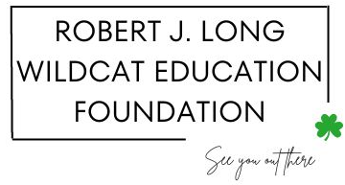

*12th GRADE SCHOLARSHIP APPLICATION*

To recognize the hard work, talent and community dedication of high school seniors who have graduated from East Quogue Elementary School, we are awarding a $10,000 scholarship in memory of Mr. Robert Long, longtime Principal and Superintendent of East Quogue Elementary School. Please complete the following questions as thoroughly as possible. Questions should be typed and double spaced on 8 ½ x 11 white paper. Mail or drop off the completed application to:

Dawn Long

5 Debbie Trail

Hampton Bays, NY 11946

**\*THE DEADLINE IS March 31, 2025\***

**YOUR APPLICATION MUST BE RECEIVED BY THIS DATE**

Name:________________________________________________________________________

Address:_______________________________________________________________________

Email Address:__________________________________________________________________

Phone Number:_________________________________________________________________

Years attended East Quogue School:________________________________________________

Name of High School that you are currently attending:__________________________________

1. Provide the name and address of the institution you will be attending in the Fall of 2025 and describe your career goal(s). Enclose a copy of your acceptance letter, if you have received it, to the institution you will be attending.
2. Provide academic transcripts for your Junior and Senior years of high school.
3. Provide a list of your community service accomplishments and indicate which ones were most beneficial to you personally.
4. Provide a letter of recommendation from a non-relative who is familiar with your academic and/or community service efforts.
5. Provide an affidavit (a written statement signed by you) attesting that the recipient will use the amount of the award ***solely*** for educational purposes.