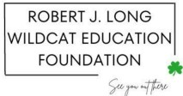
www.rjlscholarship.com
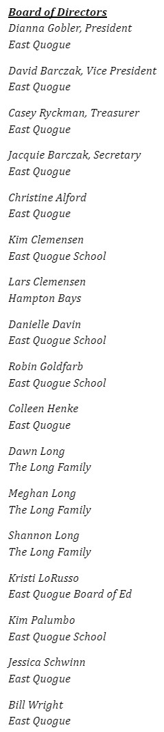
February 2026
Dear Friend,
On behalf of the Robert J. Long Wildcat Education Foundation, thank you for your support in preserving Mr. Long’s legacy. We are grateful for your support, energy and gift of resources that have supported the Foundation in fulfilling Rob’s vision.
The Foundation exists in memory of Rob Long, the long-time principal and superintendent of the East Quogue School District, and provides scholarships to graduating sixth graders and seniors who attended East Quogue, as well as supports important East Quogue School initiatives.

Events That Bring Us Together
Mr. Long See You Out There 5k Saturday, May 16, 2026
Rob’s favorite fitness pastime was running. Promote your fitness and awareness of early cancer screening on the East Quogue streets that Mr. Long knew so well!

Raise a Glass to Rob Fall 2026
The event includes appetizers, auction and raffles. Thanks to Buckley’s Inn Between for sponsoring this event and providing the food and beverages.

Impact That We Make Together
High School Scholarship Recipients:
Miller Brennan, Westhampton Beach Class of 2023, San Diego State University
Will Jankowski, Westhampton Beach Class of 2024, University of Georgia
Reese King, Westhampton Beach Class of 2025, University of North Carolina
Sixth Grade Scholarship Recipients:
Ava Willmott, East Quogue Class of 2023
Mia Rybak, East Quogue Class of 2024
Bailey Hudson, East Quogue Class of 2025

The Foundation was founded by committed community members and school staff. Through the years, the Foundation supported tangible improvements to the East Quogue School, including the donation of indoor and outdoor water stations and funds for a scoreboard for the new baseball fields. The Robert Long Wildcat Education Foundation will host the events mentioned above, and more. Annually, the Board of Directors will manage the scholarship program and work with East Quogue school staff and administration on how best to support the school.
There are easy ways to commit your support. The Foundation is a 501(c)3 and may be able to participate in your corporate matching gift program, as well.
- Venmo or Paypal - @WildcatEdFoundation
- Check payable to the RJL Wildcat Education Fdn., mailed to East Quogue School, c/o Education Foundation, 6 Central Avenue, East Quogue, NY 11942
For 2026, please consider renewing your support or adding your name to our community of supporters. Our sponsorship program allows our supporters to make an annual gift and each level provides opportunities for recognition and benefits.

Annual Sponsorship Program Platinum Gold Silver Bronze Champion
~Admission to all Foundation events x5 x2 x1
~See You Out There 5k Starting Line Sponsor x
~Name on a See You Out There 5k mile marker x x
~Name on the See You Out There 5k runner bib x x
~Name on the 5k Finish Line Poster x x x
~Name recognition at all Foundation events x x x x
~Name on the 5k T-shirt x x x x
~Name on our website x x x x x
Platinum Sponsor $2500 or more
Gold Sponsor $1000 - $2499 Silver Sponsor $500 - $999
Bronze Sponsor $250 - $499
Champion up to $250 and In-Kind Donations
Thank you for your support of the East Quogue School and preserving Rob’s legacy for generations to come. As an educator, there was no more special place to Rob, and our family, than East Quogue.
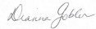
Respectfully,
Dianna Gobler
President

—-----------------------------------------------------------------------------------------------------------------------------
Thank you for your support of the Robert J. Long Wildcat Education Foundation
Please return to RJL Wildcat Education Fdn.
c/o East Quogue School, 6 Central Avenue, East Quogue, NY 11942

NAME: _________________________________________________________________________________________________

ADDRESS: _________________________________________________________________________________________________

PHONE: _________________________________________________________________________________________________

EMAIL: _________________________________________________________________________________________________

(____) Platinum (____) Gold (____) Silver (____) Bronze (____) Champion

The Robert J. Long Wildcat Education Foundation is a qualified 501(c)3 tax-exempt organization and donations are tax-deductible to the full extent of the law. No goods or services were provided for this gift.

