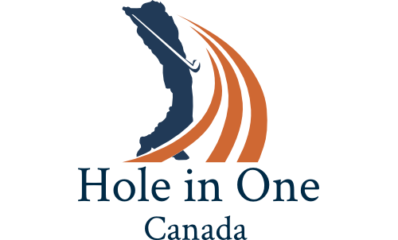

“…your turnkey to tournament success”

2019

Bronze Program Starting $750

Hole #1 Sample (155 yards Men; 145 yards Women)

- Hole In One Canada host / greeter
- Hole-in-one prize, WestJet roundtrip flight for 2 persons anywhere they fly
- Landing on the green wins … Choice of Prizes including One sleeve of Golf Balls,
- Everyone Receives Canada Wonderland $18 discount coupon
- Closest-to-the-pin wins... Bolle Sport Sunglasses
- 1 Drop Sheet... Bushnell GPS

