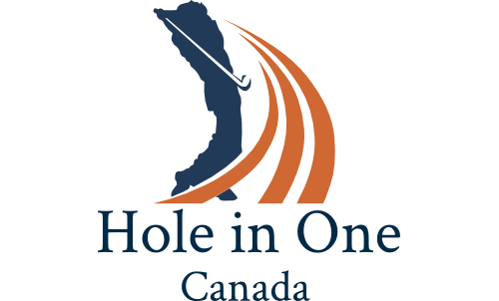

***“…your turnkey to tournament success”***

*2019*

**Platinum Program Starting $2000**

# Hole #1 Sample (170 yards Men; 145 yards Women)

# Hole In One Canada host / greeter

# $20,000.00 hole-in-one prize (option Car on site)

# Landing on the green wins … One sleeve of Golf Balls

# Everyone receives Canada Wonderland $18 coupon

# Land on Dropsheet on green win ... Bushnell Neo X GPS

# Hole #2 Sample (165 yards Men; 140 yards Women)

* **Hole In One Canada host / greeter**
* **$10,000.00 Hole in One Cash Prize or ATV**

# Everyone receives travel discount coupons $100

* **Closest-to-the-pin wins... Bolle Sunglasses (Mens and Ladies)**
* **Land on Dropsheet on green win.. Bushnell neo ion golf watch**

# 

# Hole #3 Sample (158 yards Men; 140 yards Women)

* **Hole In One Canada host / greeter**
* **Hole-in-one prize, WestJet round-trip Flight for 2 persons anywhere they fly**
* **Land on Dropsheet on green win.. Bushnell neo ion golf watch**

# Hole #4 Sample (153 yards Men; 140 yards Women)

* **Hole In One Canada host / greeter**
* **Hole in One Prize…Gold Trip for 2 to Ireland**
* **Land on Dropsheet on Green win…Putter**