**Anna Riedl – AWS Demand Generation Sales Internship Narrative – 8/10/2021**

**Business Summary:**

Anna Riedl was an AWS Sales Intern in the Demand Generation (DG) department from June 14th, 2021 to August 18th, 2021. She participated in a Value Map creation, ChefRide Presentation, and Greenfield Calling Project. She engaged in networking sessions, professional development bootcamps, passing her Cloud Practitioner Examination (CPE) (Appendix B), and writing a final narrative. For her Value Map, Anna researched how ONE Gas could quantify the business value of moving to the cloud by aligning their business outcomes with AWS cloud solutions. She received a perfect score of 10/10. The ChefRide presentation entailed research, presentation creation, and sales motions for a fictional company. She received an average score of 2.55/3 from her mentor, Heidi Vanderlaan, and her manager, Namrata Padhi. The Calling Project included cold-calling and emailing to encourage re:Invent registrations. She reached 327% metric attainment by making 302 calls (20.8% above goal), sent 216 emails (44% above goal), made 66 connects (1,220% above goal), and 0 registrations. Her connect rate was 21.85%. Anna passed her CPE after 4 weeks of studying, balancing her projects, and networking. The purpose of this document is to display Anna’s sales and research competency as an AWS Demand Generation Sales Intern for the summer of 2021 while establishing fit for a full-time Demand Generation role in the Sales Talent Acceleration Rotational (STAR) program.

***Summer Observations***

***Observation #1: Value Maps***

Anna was tasked with visually communicating a business analysis that aligns with AWS solutions and use cases for ONE Gas, a natural gas distribution service provider (Appendix C). To identify their business strategy, Anna researched the company’s website, news articles, public documents, and press releases. She recognized their goals of increasing revenue through accelerating customer base, commitment to reducing emissions by modernizing technology, improving security, and ensuring resilient delivery. She related their initiatives to AWS success stories and use cases such as how to limit cyber attacks through Virtual Private Network and remote collaboration systems (VPC). Anna was able to get feedback form her mentor and manager 2+ times during the research phase and networked with 4 peers when the cohort was split into groups to conduct research simultaneously. By applying these perspectives, this allowed Anna to demonstrate thinking big. She presented her Value Map for 30 minutes in a role-play scenario to her manager, who acted as the CTO, and her mentor, who acted as the CFO. She received a perfect score of 10/10 by acing every topic such as business outcome selection (5/5), customer initiatives (5/5), use case relevance (5/5), and visualizing, template, and readability (5/5) (Appendix D). She demonstrated insisting on the highest standards according to her manager who stated, “The business outcomes, key initiatives, and use cases were very relevant and clearly stated. Anna did a great job in asking and answering the right questions.” Anna struggled to find clear insight in a timely fashion because she could not meet with the account manager without Salesforce access. She could have been more efficient if she read through customer success stories within the industry prior to researching to understand recurring needs of similar partners.

***Observation #2: ChefRide Observation***

Anna was tasked with creating and presenting a slide deck that consisted of AWS components to a fictional company called ChefRide (Appendix E). The purpose of this project was to test Anna’s AWS technical proficiency, her understanding of high-level information on pricing and infrastructure, and ability to create trust with her customer. Her slides included benefits of cloud computing, global infrastructure, innovation as a market leader, security, partner ecosystem, use cases, and migration structure in alignment with ChefRide’s needs as a networking application platform. She was given 50 minutes to bridge the gap between her knowledge of AWS and ChefRide’s needs as a company. Anna prepared for this project by partnering with a fellow intern in her cohort and participating in a mock-presentation for a fictious company called Wicked Rugby. She studied the “gold standard” presentation, attended office hours, and met with her mentor to discuss formatting and organization. In her dry-run with her mentor, she was told to display customer obsession by making them feel like a partner instead of a customer and exemplifying her AWS knowledge. She prepared a FAQ document to understand the type of information a customer could request. Anna received positive feedback on maintaining a customer-centric environment and showcasing her sales acumen. After completion, her manager stated, “Anna raised the bar in establishing a connection during her presentation. She was poised, thorough, and handled questions for which she did not have answers really well. She earned trust by focusing on customer’s needs, and her level of depth in understanding the AWS technical services was just right. She achieved the objective of the meeting and kept the customer on track.” Her mentor stated, “Anna raised the bar in several areas. She maintained the trust of the audience by admitting what she didn’t know, used case studies that aligned with the customer’s challenges/outcomes, and defined clear next steps utilizing the resources available. Anna managed the meeting according to the customer’s goal and outcomes, though could have demonstrated her understanding of the customer in more depth (Appendix F).” Anna learned that she could have demonstrated customer obsession by diving deeper into follow up questions and keeping the meeting more interactive. Her strongest areas of performance were maintaining customer trust and referencing additional resources. Areas where the L4 bar was reached but not raised included meeting delivery and management and understanding of the customer.

***Observation #3: Calling Project Observation***

Anna was tasked with 536 prospects to familiarize herself with and contact to promote 2021 re:Invent registrations (Appendix G). The project manager’s goal for Anna was to reach 250 calls, 150 emails, 5 connects, and 3 registrations. Her personal goal was to make an average of 30 calls and send 16 emails a day. She exceeded this by making an average of 33 calls and sending 24 emails a day while balancing networking and professional development sessions. She was tasked with verifying and familiarizing herself with the contacts, executing strategic prospecting and outreach, and promoting registrations. To prepare, she did mock-calls with a fellow intern in her cohort, met with a DGR to discuss conversational strategies, and attended office hours. To stay organized she researched and filtered her accounts to prioritize her contacts for the day such as targeting the East Coast customers first to accommodate for the time difference. In the second half of the project, she circled back to leads who wanted more information to assist and answer questions. She reached 327% metric attainment by making 302 calls, sending 216 emails, getting 66 connects, and 0 registrations. Anna was one of the top 5 interns within her cohort for most calls and connections because she demonstrated frugality and bias for action. Anna could have reached her registration goal if she focused more on quality customer connects and reaching 6 or more touches per prospect. By researching the company and identifying if AWS has worked with them in the past, she was able to open up a conversation based on their needs, which allowed for customer trust and longer connections. Using a color-coding metric, Anna tracked that 24 of the 66 connects stated that they will sign up in the future. Mr. Vandersommen at Iron Eagle X requested that Anna send him information to forward on to his colleagues as he plans on multiple employees attending. The rest were not interested or requested more information via email. She learned that if she demonstrates earning trust by treating prospects with respect and understanding, she is likely to build a stronger relationship with others.

***Conclusion/Key Learnings:***

By exemplifying the principle learn and be curious, Anna fine-tuned her sales acumen through each project and developed technical skills by passing her CPE with a 74.8%. She experienced the selfless culture of being an Amazonian through her multitude of networking sessions. She attended 7 social events to meet her intern cohort and full-time Demand Generation Representatives (DGR) and 17 professional development events to fine-tune her professional persona in the sales industry. She attended 2 of her mentor’s team meetings to witness interactions between Inside Account Representatives and Inside Sales Representatives. To experience different roles throughout AWS and gain different industry perspectives, Anna organized 1:1 meetings with Morrie Low (DGR), Jackson Kinley (DGR), Sam Singer (DGR), Peter Whitney (Sales Manager), and Katie Martell (DG Program Manager). For the last week of the internship she will continue 1:1 meetings, attending intern social hours, and studying for the Associate Solutions Architecture (ASA) certification in attempt to continue raising the bar. Anna discovered her passion for AWS sales this summer due to her ability to form and maintain personal connections. There are areas where she could have utilized her time and resources more efficiently to double her project goals. Her biggest takeaway is the confidence she has gained when interacting with leadership and peers, working directly with customers through sales, and building her technical proficiency. Anna would be honored to represent AWS as a full-time Amazonian by displaying Day One mentality, which was represented in her work as an intern.

# Appendix

Appendix 3

Appendix A: FAQ 3

Appendix B: AWS Cloud Practitioner Certificate 4

Appendix C: ONE Gas Value Map 4

Appendix D: ONE Gas Value Map Feedback 5

Appendix E: Sample ChefRide Slides 5

Appendix F: ChefRide Scoring 6

Appendix G: Calling Project Final Results 7

# Appendix A: FAQ

1. What is a Value Map?
2. A mapping technique used to communicate a customer’s long-term goals
3. Data is organized into the top 3 business outcomes and corresponding initiatives and use cases
4. Used to familiarize interns with research sales motion experience
5. What is ONE Gas?
6. Natural gas utility distributor
7. Company highlighted in the Value Map
8. What is ChefRide?
9. Mock sales presentation and case study that is used to gauge sales and technical acumen
10. Fictional company that needs to migrate to the cloud
11. What is Greenfield Calling Project?
12. Interns call Greenfield accounts to invite prospects to a webinar called re:Invent
13. Inform prospects about the events, topics covered, and benefits of attending
14. What is Salesforce?
15. What is the STAR Program?
16. Sales Talent Acceleration Rotation is a 24-month sales rotation program designed to accelerate skill and progression into seller roles

# Appendix B: AWS Cloud Practitioner Certificate

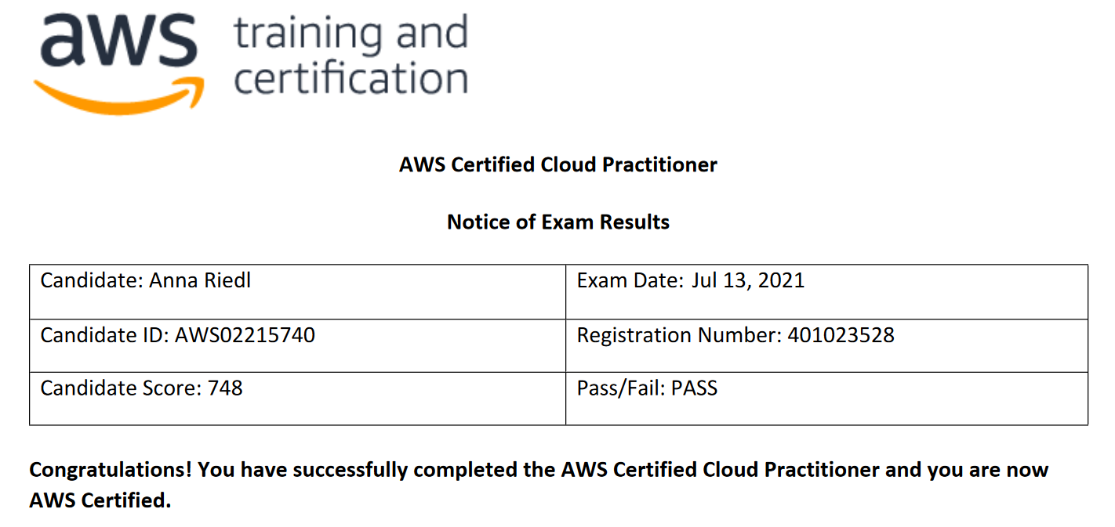

# Appendix C: ONE Gas Value Map

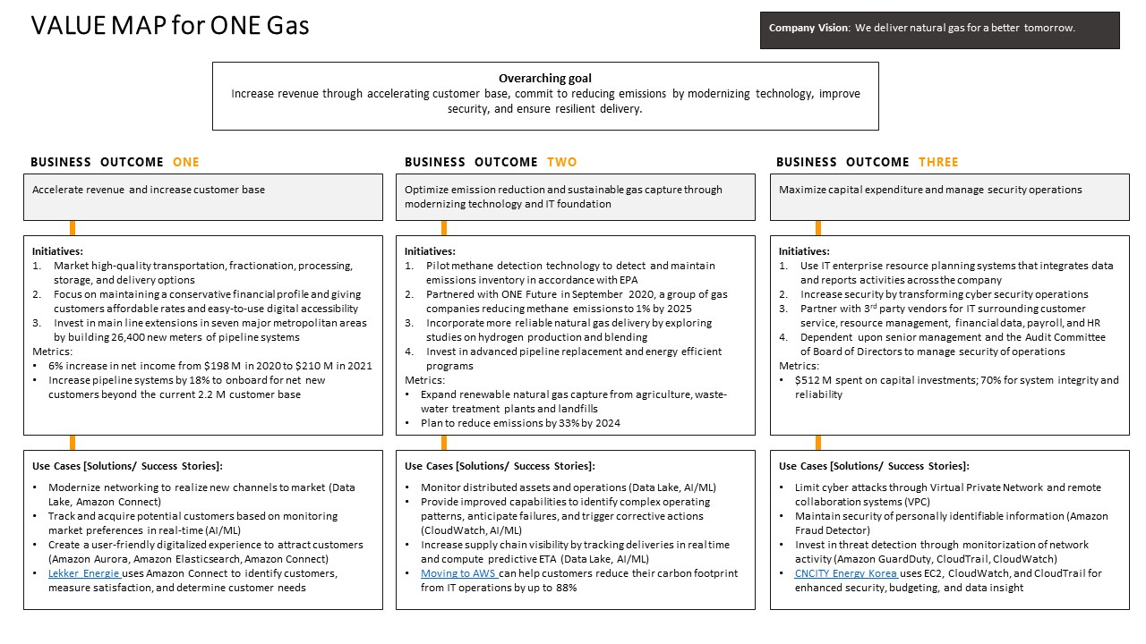

# Appendix D: ONE Gas Value Map Feedback

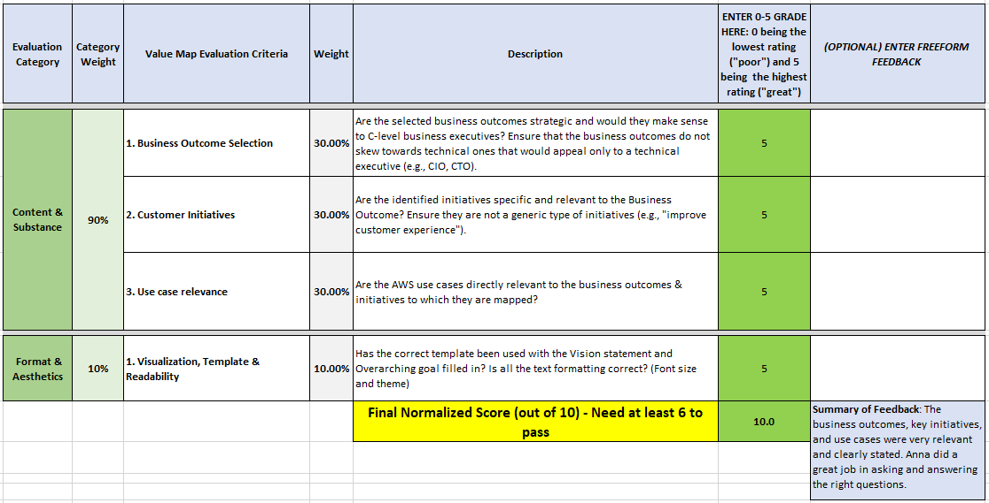

# Appendix E: Sample ChefRide Slides

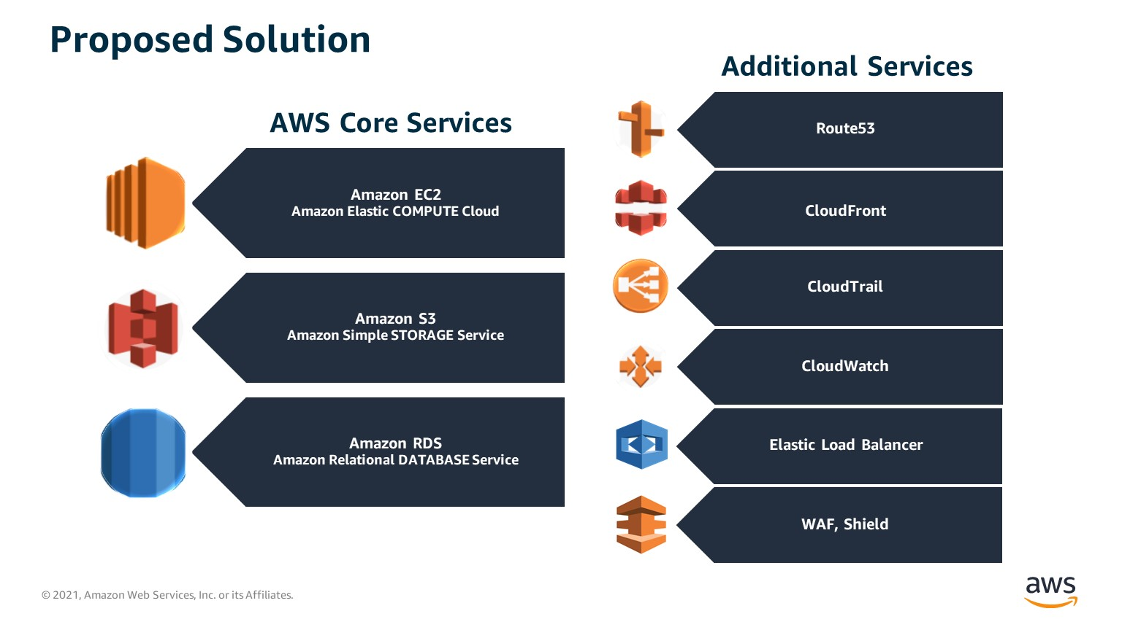

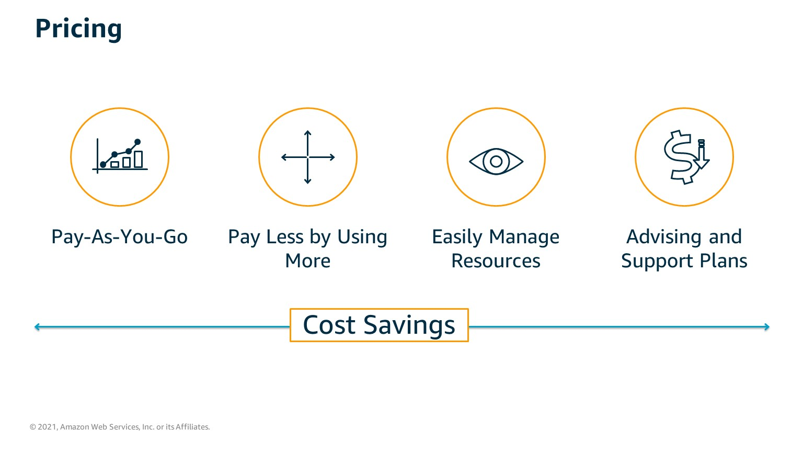

# Appendix F: ChefRide Scoring

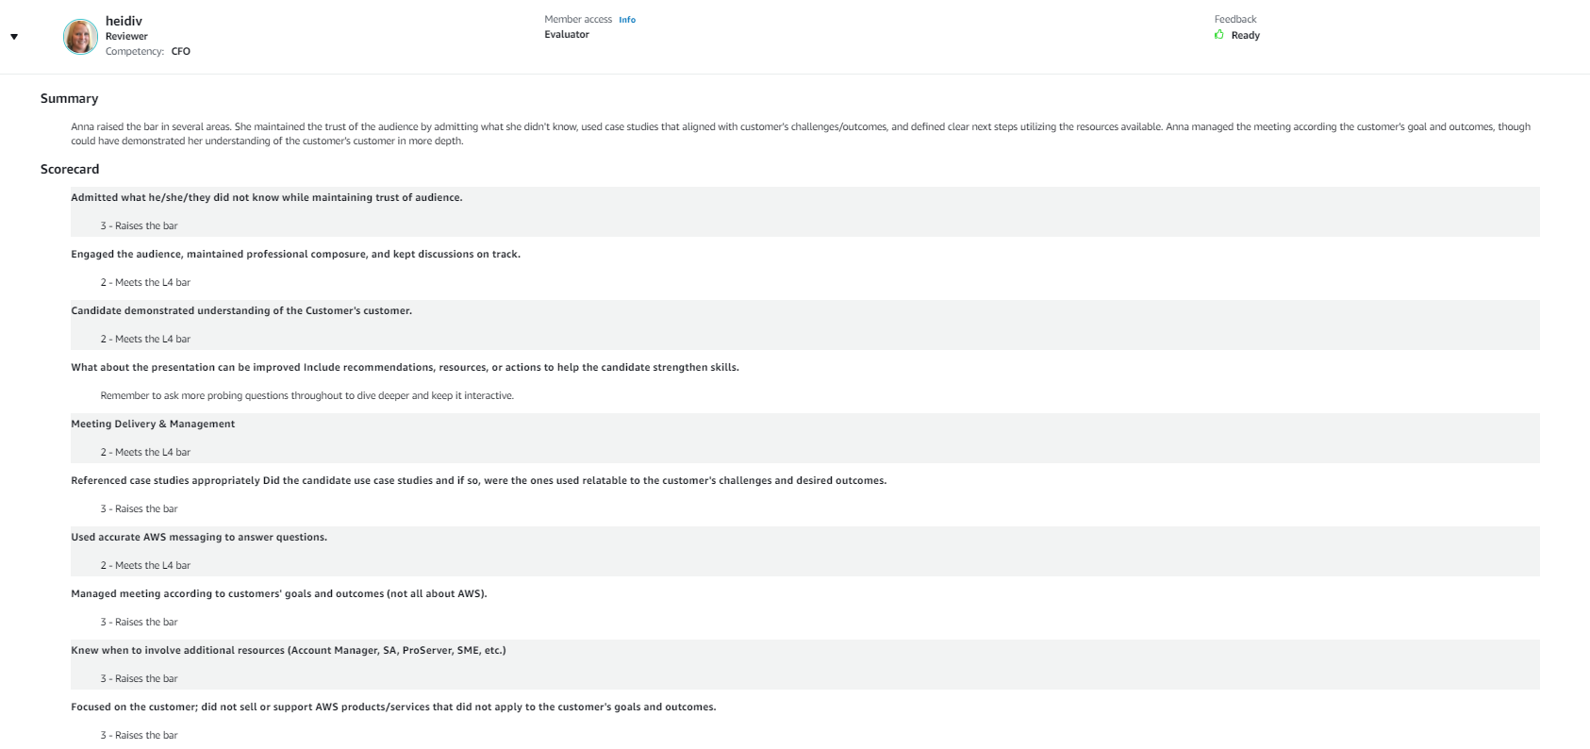

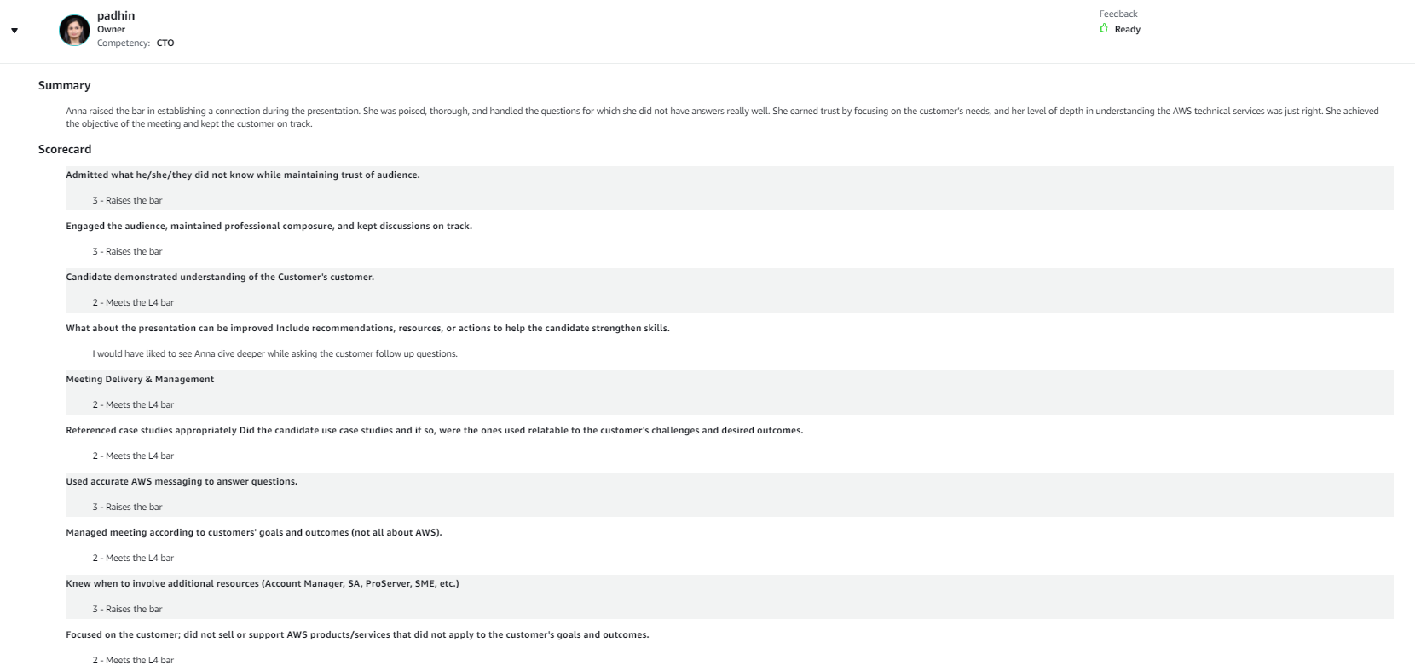

# Appendix G: Calling Project Final Results

