How to Register with the Medical Use of Marijuana Program: Instructions for Patients

Registering online with the Medical Use of Marijuana Program (“Program”) is the fastest and most convenient way to register to possess marijuana for medical purposes.
Please note that in order to register as a patient in the Medical Use of Marijuana Online System (MMJ Online System) you must first be certified by a qualified health care provider.
If you are unable to register online, a more lengthy paper registration process is available. Please call 617-660-5370 to request a paper registration form.
As a patient, you can gain access to your online account at any time by self-registering with the Program’s Virtual Gateway portal at https://sso.hhs.state.ma.us/VGPortal/faces/SelfReg.jspx
Once your registration application is reviewed by the Program, you will be notified by email regarding the status of your registration. Registration applications are reviewed in the order they are received.
If approved for registration, you will be able to print a temporary paper Program ID Card and will receive your plastic Program ID Card in the mail in 1 – 2 weeks. The temporary paper Program ID Cards expire four weeks from the date that your registration is approved by the Program, at which time you should have received a plastic Program ID Card. If you do not receive your plastic Program ID Card within three weeks, call the Program at 617-660-5370.

PREPARING FOR REGISTRATION
Before registering in the MMJ Online System, you will need to gather the following:
- Access to a scanner or a mobile phone or other device capable of uploading documents;
- Your PIN, as provided to you by your health care provider, and emailed to you by the Program, after you are certified;
- valid form of identification (as explained below);
- A photograph of yourself (as explained below); and
- A form of payment, or proof of verified financial hardship (as explained below).

VALID FORM OF IDENTIFICATION
Valid forms of identification include one of the following:
- Massachusetts driver's license;
- Massachusetts ID card (with a photograph of yourself);
- U.S. passport and another document that proves your Massachusetts residency; or
- U.S. military ID and another document that proves your Massachusetts residency.
If submitting a driver’s license or ID card issued by your state’s Department of Motor Vehicles:
If you submit a driver’s license or Massachusetts ID card as your valid form of identification, the name and address you submit on your application must match the name and address on your driver’s license or Massachusetts ID card. If it does not match, your application will be returned to you for further clarification.
For more information on how to update the name and address on your ID, contact the RMV, or visit their website at www.massrmv.com .
If submitting a passport or US military ID:
If you submit a passport or US military ID as your valid form of identification, you must also submit a document that proves your primary residence (as outlined below). The name and address on your application must match the name and address on the document that you submit to prove your primary residence.
Submit one of the following to prove your primary residence:
- Utility bill (gas, electric, telephone, cable, or heating oil), that is less than 60 days old and contains your name and address;
- Current Massachusetts motor vehicle registration card with your current address;
- Tuition bill with a due date of less than 6 months ago and addressed to your current address;
- Car insurance policy or bill that is dated less than 60 days old;
- Home mortgage, lease or loan contracts dated within 6 months of today with your name, address and signature;
- Certified U.S. Marriage Certificate dated within the past 6 months;
- Property tax or excise tax bill for the current year with your name and address;
- First-class mail dated less than 60 days old from any federal or state agency that displays your name and address; or
- Current Massachusetts-issued Professional License with your address.

PHOTOGRAPH OF YOURSELF
This photo will be placed on your Program ID Card. If you are using a Massachusetts driver’s license or a Massachusetts photo ID card, you may be able to use your RMV photo during the online registration process.
If the MMJ Online System is able to retrieve your RMV photo, you do not have to upload a separate photo of yourself.
If you are not submitting a Massachusetts-issued driver’s license or ID as your valid form of ID or the MMJ Online System is unable to retrieve your RMV photo, then you must upload a photo of yourself. Your photo must be:
- In color;
- A square photo in portrait/upright format;
- Taken in front of a plain white or off-white background;
- Taken within the last 6 months to reflect what you look like now;
- Showing only your head and the top of your shoulders (see example below);
- Taken looking directly at the camera held at eye level;
- Taken with both eyes open, and without eyewear; and
- Taken without any item that covers your face or head, except for religious purposes.
A passport photo meets these requirements and can be obtained at any location that issues passport photos, such as a pharmacy, the post office, or a camera store. Alternatively, you may upload a photo from a cell phone camera if the photo meets the requirements outlined above.

FORM OF PAYMENT
There is a $50 fee to complete a patient registration.
Acceptable forms of payment include:
- Credit card;
- Debit card; or
- Electronic Funds Transfer (by providing a bank account number and bank routing number).
Prepaid cards (e.g. Visa gift cards) are not an acceptable form of payment.

PROOF OF VERIFIED FINANCIAL HARDSHIP
If you have a verified financial hardship, you may be qualified for a waiver of the $50 registration fee. You are considered to have a verified financial hardship if you are a recipient of MassHealth or Supplemental Security Income, or your household income does not exceed 300% of the federal poverty level for your family size (see table below).
300% of Federal Poverty Level
Family Size | Annual Income
1 | $36,180
2 | $48,720
3 | $61,260
4 | $73,800
5 | $86,340
6 | $98,880
7 | $111,420
8 | $123,960
Each Additional | $12,540
From the U.S. Department of Health & Human Services2017Poverty Guidelines

To apply for a waiver of the registration fee, you must submit proof of verified financial hardship.
Proof of verified financial hardship includes a copy of one of the following:
- Official MassHealth acceptance letter for the current year, OR official MassHealth redetermination letter for the current year, OR official MassHealth card;
- Supplemental Security Income (SSI) benefit verification letter for the current year;
  - SSI is not the same program as Social Security
  - SSI is not the same as SSDI (Social Security Disability Insurance)
- Supplemental Nutrition Assistance Program (“SNAP”) statement from the current year; or
- Complete State or Federal tax return from this year or last year, including all attachments (all schedules and forms such as Form W-2, Form 1099, etc.).

REGISTRATION PROCESS
The MMJ Online System is housed within the Executive Office of Health and Human Services Virtual Gateway (“VG”). You will first need to register with the VG and then with the MMJ Online System.
You will be sent an email from VG during the registration process. We recommend keeping your email account open during the registration process so you can easily access this email. This email will contain a link that you will click on in order to finish the VG registration process. The link may expire as soon as seven (7) days after being emailed to you and is only valid the first time that you click on it.
Be sure to keep your VG username and password. You will need your original username when you renew your registration.

REGISTRATION RENEWALS
Registrations expire annually. You may re-apply for registration, on an annual basis, up to 60 days before the date that your registration expires by following the instructions outlined above.
It is highly recommended that applicants apply for a registration renewal at least 60 days prior to the expiration of their current Program ID card. This will ensure that there is no gap in the applicant’s active status.

SELECTING A PERSONAL CAREGIVER
You have the option of designating a personal caregiver to assist you with your medical use of marijuana. After your registration has been approved by the Program, you may log back in to the MMJ Online System and designate up to two personal caregivers who are not currently designated by another patient, unless that personal caregiver is your immediate family member.
To select a personal caregiver, please follow these steps:
- Step 1: Log in to VG at https://sso.hhs.state.ma.us and select “Medical Use of Marijuana System.”
- Step 2: Click on “My Caregivers” at the top of the screen.
- Step 3: On the next screen click on the "Generate PIN" button to generate a PIN for your personal caregiver. On that screen you will be given the option to print the PIN or enter your personal caregiver’s email address where you would like the PIN emailed.
- Step 4: Provide the PIN to your personal caregiver and direct them to register with the Medical Use of Marijuana Program at https://sso.hhs.state.ma.us/VGPortal/faces/SelfReg.jspx.
- Step 5: After your personal caregiver has registered with the Program, you will be sent an email notice confirming their registration. Log back in to the MMJ Online System, click on “My Caregivers” at the top of the screen, and verify that the individual displayed is your personal caregiver. If yes, select “Yes, I validate that this is my Personal Caregiver,” and indicate whether your personal caregiver is an immediate family member, or not. Then click on “Approve.”
You will then be taken to a screen that indicates that your personal caregiver’s registration is pending approval by the Program. After their registration is processed, an email will be sent to your personal caregiver regarding the status of their registration.

OTHER IMPORTANT INFORMATION ABOUT REGISTRATION

IMPORTANT
Patients must maintain an active certification from their health care provider and an active registration with the Program in order to be protected for medical use of marijuana under Massachusetts Law.

PROGRAM ID CARD
You must carry your Program ID Card at all times while you are in possession of marijuana for medical use.
Program ID Cards are issued every three (3) years. However, you are required to renew your registration with the program every year in order to remain active.
Notify the Program within five business days after discovering that your Program ID Card is lost, stolen, or destroyed by calling 617-660-5370.
There is a $10 fee to replace a Program ID Card.

VALID FORM OF IDENTIFICATION
After registering with the Program, your valid form of identification on file with the Program must remain active and not expired in order to access a Registered Marijuana Dispensary (RMD) or obtain marijuana for medical use from an RMD.

CHANGE OF REGISTRATION INFORMATION
If, at any time, there is any change to the information you submitted for registration (such as a change in your name, address, email, or phone number), you must update this information in the MMJ Online System within five business days of the change.
To update your registration information, please follow these steps:
- Step 1: Log in to the VG at https://sso.hhs.state.ma.us and select “Medical Use of Marijuana System.”
- Step 2: Click on the “My Registration” link at the top of the screen.
- Step 3: To update your information, click “Edit” at the left side of the screen. Edit the necessary information and click the “Update” button.

ACCESSING A REGISTERED MARIJUANA DISPENSARY
In order to access a Registered Marijuana Dispensary (RMD) to obtain marijuana for medical use, an adult patient must:
- Present their Program ID Card and their valid form of identification;
- Have an active certification from their health care provider;
- Have an active registration with the Program; and
- Maintain on file with the Program a valid form of identification that is not expired.

QUESTIONS
Should you have questions regarding the registration process, please contact the Medical Use of Marijuana Program at 617-660-5370.

The following pages provide detailed step-by-step instructions on how to register with the Program using the MMJ Online System.

Step-By-Step Registration Instructions

STEP 1: Scan and save on to your computer:
- The valid form of identification (and the document that proves your Massachusetts residency, if applicable); and
- The photograph of yourself (if applicable).

If you are applying for a registration fee waiver, scan and save the proof of verified financial hardship onto your computer.
These documents will be uploaded to the MMJ Online System during the registration process.
If uploading a US military ID, scan and upload the front and the back of the card. Be sure to have the copy of the front and back of the card saved on one file.

STEP 2: Go to the Program’s online system at: https://sso.hhs.state.ma.us/VGPortal/faces/SelfReg.jspx
- Accept the “Terms and Conditions” by clicking “I ACCEPT”
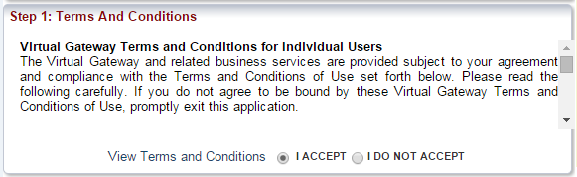
- Enter your information in the “Personal Information” section
  - Under “Service Name” select “Medical Use of Marijuana System;”
  - Type in your personal information for each section;
    - Please note that this is not the same PIN that was provided to you by your health care provider after you were certified (keep this PIN for Step 6). This (4 digit) PIN is any four digit number that you chose.
  - Answer the security question; and
  - Click “Submit.”
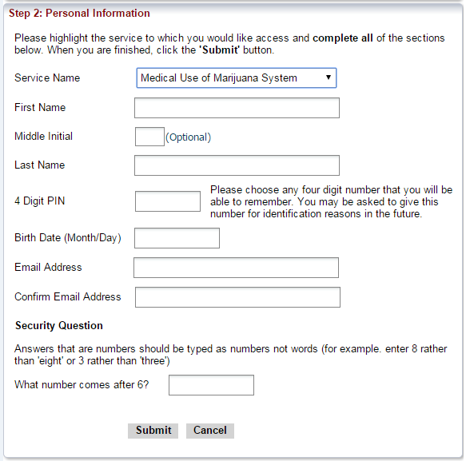
- The next page explains how you will receive an email to the email address you provided from virtualgateway@state.ma.us. This email will contain a link to complete your self-registration.
- After clicking the link in the email, review your information to ensure it is correct. If it is incorrect, you may edit the information by clicking the “Edit” button.
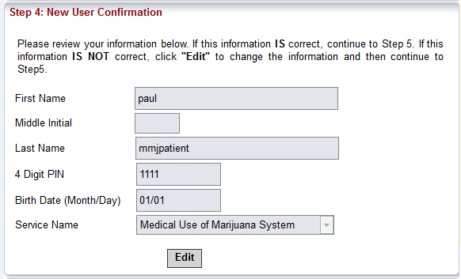
- Create a password by following the instructions on the screen.
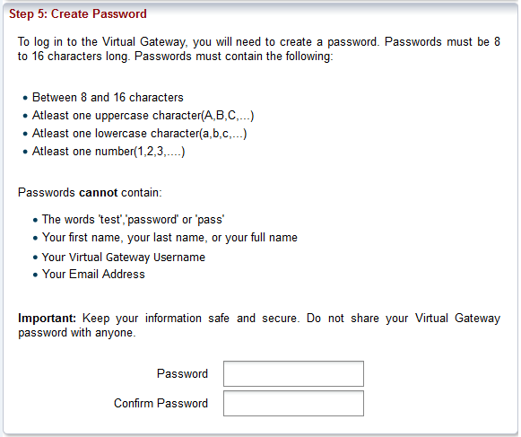
- Next, select two secret questions and provide answers to them. These questions will be used to reset your account if you forget your password. Once complete click “Submit.”
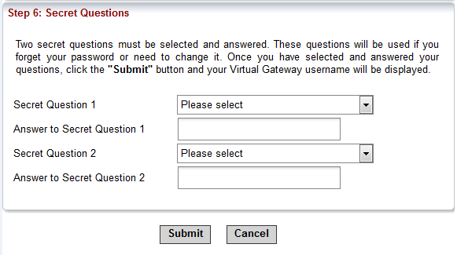

- You will then see a confirmation page with your new user name and a link to log in to the Virtual Gateway.
The Virtual Gateway log in page can also be reached at https://sso.hhs.state.ma.us/.
You will also receive an email from virtualgateway@state.ma.us with your user name and a link to the log in page.
Be sure to keep your Virtual Gateway username and password. You will need your original username when you renew your registration.

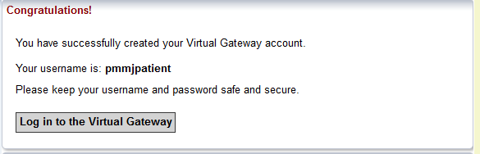

STEP 3: Enter your user name and password, and click “Login” to enter Virtual Gateway.
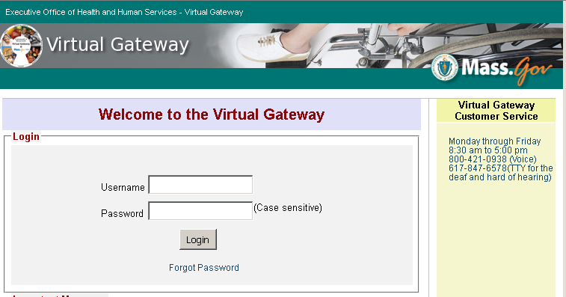

STEP 4: Click on the “Medical Use of Marijuana System” link.
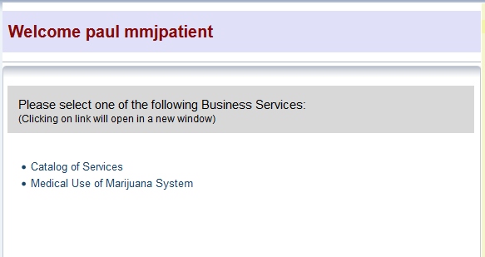
STEP 5: Click the “Register as a Patient” button.
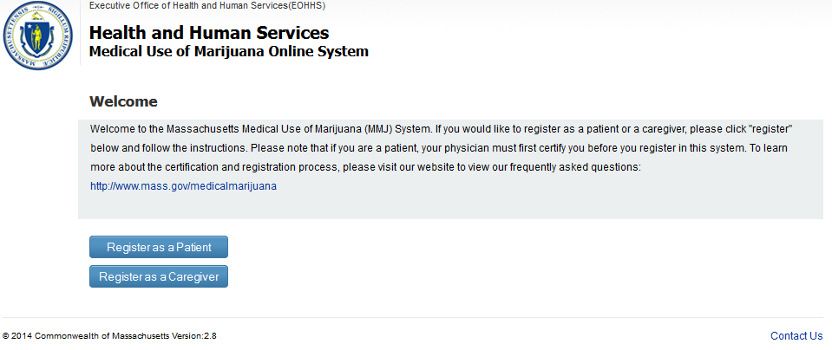

STEP 6: Enter all 4 identification fields and click the “Proceed” button.
- The PIN Number is the 6 digit alpha-numeric number you received from your health care provider, and that was emailed to you by the Program, after you were certified.
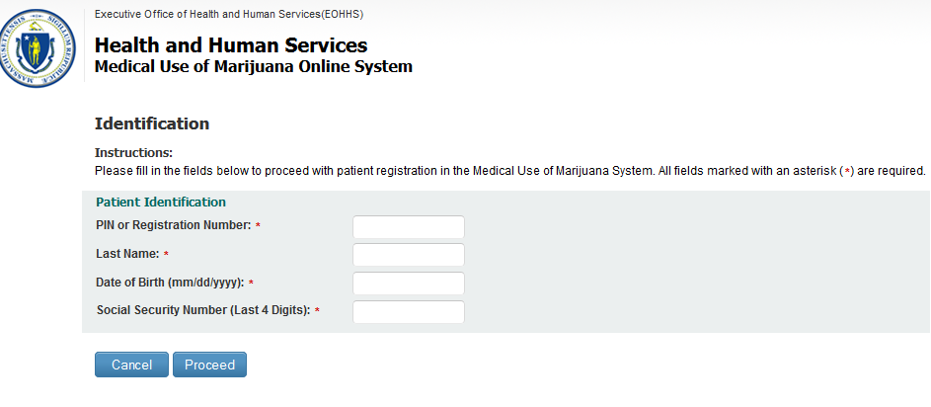
STEP 7 & ONWARD: If you successfully enter all of the identification fields you will be taken to the instructions page. Review these instructions and click “Proceed.”

When you are signed in to the MMJ Online System, you may use the “Help” link in the top right corner for further detailed instructions.

