Arm Rest  - Where: Amazon  - Price: $10.59  - Purpose: Keep forearms parallel with the floor.  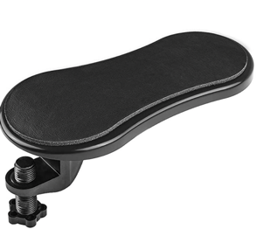 | Back Rest  - Where: Amazon  - Price: $32.95  - Purpose: Keep the spine supported by the back of the chair.  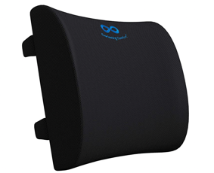
Footrest  - Where: Amazon  - Price: $29.99  - Purpose: Promote lower body alignment  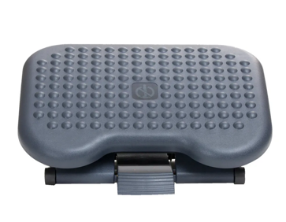 | Lazy Susan  - Where: Amazon  - Price: $19.99  - Purpose: Allow for easy to reach items that can become closer when spun.  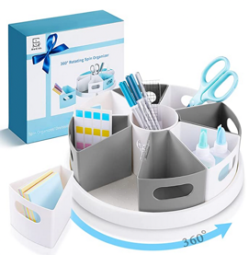
Laptop Stand  - Where: Amazon  - Price: $12.97  - Purpose: Monitor at eye level.  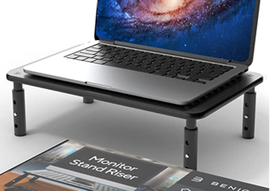 | Headset  - Where: Amazon  - Price: $24.99  - Purpose: Allow for hands-free talk to maintain posture when multi-tasking.  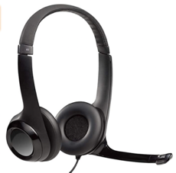
Ergonomic Mouse  - Where: Amazon  - Price: $24.98  - Purpose: Keep the wrist in a neutral position.  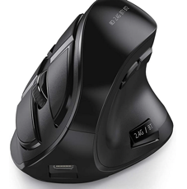 | External Keyboard  - Where: Amazon  - Price: $24.99  - Purpose: Position the keyboard in ergonomic position when using a laptop.  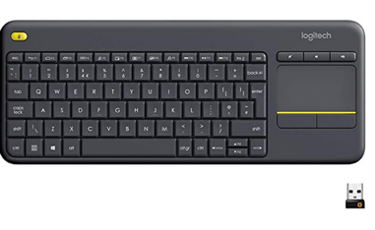
Lighting  - Where: Amazon  - Price: $34.99  - Purpose: Enhance lighting on needed items to prevent eye strain.  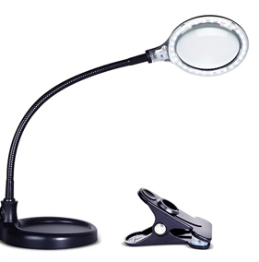 | Curtains:  - Where: Amazon  - Price: $15.94  - Purpose: Adjust the lighting coming from a window, especially in bright winter months.  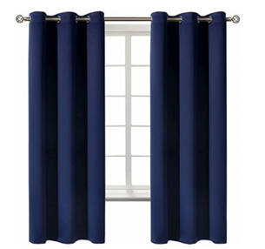
Blue Light Blocking Glasses  - Where: Amazon  - Price: $13.99 (3 pack)  - Purpose: Prevent eyestrain from the blue light on the computer.  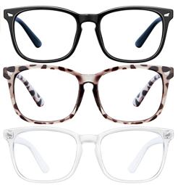 | Blue Light Blocking Application  - Where: f.lux  - Price: Free  - Purpose: Download a blue light blocking screen right on the computer.
Document Holder  - Where: Amazon  - Price: $9.36  - Purpose: Hold paper in an ergonomic prevent to prevent neck strain.  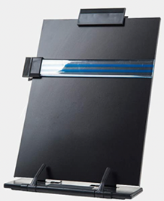 | Ergonomic Mouse Pad  - Where: Amazon  - Price: $16.99  - Purpose: Support wrist when mousing  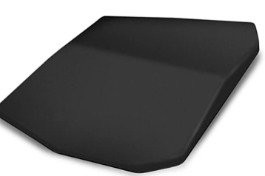
Split Keyboard  - Where: Amazon  - Price: $69.99  - Purpose: Reduces forearm tension and promote natural position  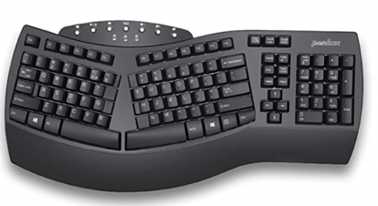 | Flex Clip Copyholder  - Where: Amazon  - Price: $10.29  - Purpose: Allows you to place document at the most comfortable viewing position  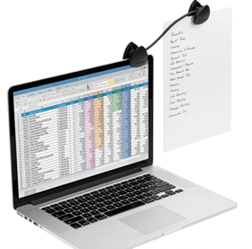
Office Chair Seat Cushion and Lumbar Support  - Where: Amazon  - Price: $49.95  - Purpose: Adapt and customize support  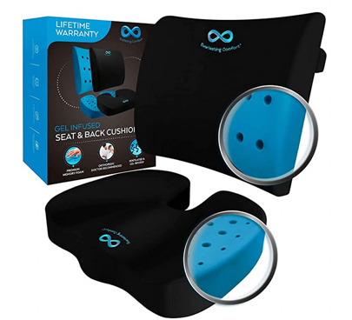 | Note Tower Monitor Document Paper Holder  - Where: Amazon  - Price: $16.99  - Purpose: Reduce eye and neck strain  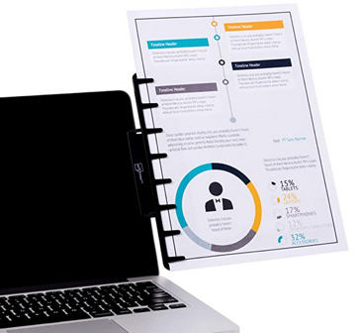
Finger Trackball Mouse  - Where: Amazon  - Price: $50.46  - Purpose: Minimize pain in forearms from twisting  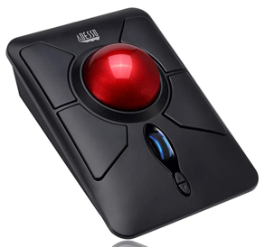 | Large Key Keyboard  - Where: Amazon  - Price: $89.95  - Purpose: Bold print for ease on eyes  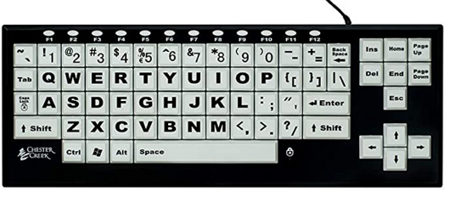
Soft Foam  - Where: Amazon  - Price: $7.99  - Purpose: Multi-function purpose to improve grasp | Adjustable Laptop Stand  - Where: Amazon  - Price: $21.99  - Purpose: Increase the height of screen to eye level  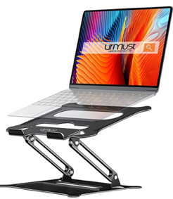
Wide-Grip Stylus  - Where: Amazon  - Price: $8.99  - Purpose: Wider design for easier grip  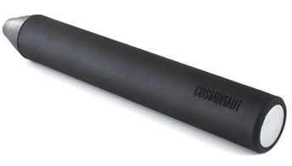 | Regular Stylus Pens  - Where: Amazon  - Price: $6.99  - Purpose: Touch screen stylus  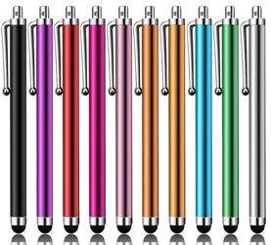
Phone Tripod  - Where: Amazon  - Price: $23.99  - Purpose: Create a low-cost standing desk  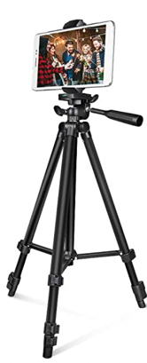 | Flex Stylus  - Where: Etsy  - Price: $49.99  - Purpose: Bend in a way that is customized to your needs  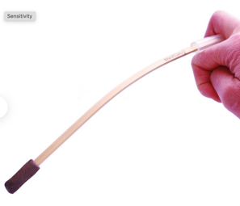
Rolling Laptop Bag  - Where: Amazon  - Price: $68.99  - Purpose: Transfer workload in an ergonomic manner  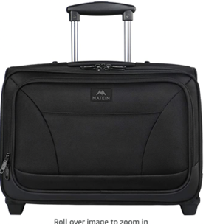 | Hands Free Bag Holder  - Where: MedicalMega  - Price: N/A  - Purpose: Distribute the weight of heavy bags across back and shoulders
Velcro  - Where: Amazon  - Price: $13.99  - Purpose: Multi-function  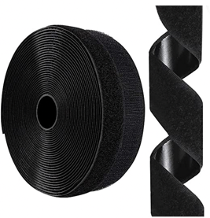 | Dycem  - Where: Amazon  - Price: $36.77  - Purpose: Enhance grip  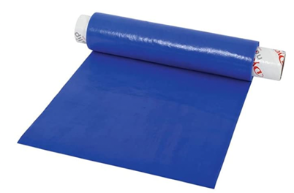
Zip Ties  - Where: Amazon  - Price: $13.98  - Purpose: Multi-use  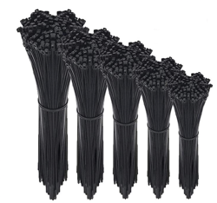 | Pencil Grip  - Where: Amazon  - Price: $9.99  - Purpose: Easy and comfortable addition to pencils or pens  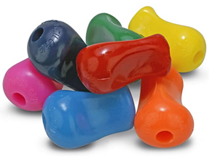
Power Strip Tower
- Where: Amazon
- Price: $39.99
- Purpose: Meet charging needs in your office
