Places for ergonomics MA services
- https://mn.gov/admin/government/risk/safety-loss-control/ergonomics/

Fundamentals of Body Positioning During Work Tasks
Neutral Sitting
- Head and neck should sit directly above the torso
- Elbows should be aligned with shoulders and close to the body
- Forearms should be parallel with the floor when bent
  - INSERT ARM RESTS
- Spine should be completely supported by the back of the chair
  - INSERT BACK REST
- Hips should be aligned with the shoulders.
- Thighs should be parallel to the floor.
- Knees should be aligned with the hips; bent at a 90-degree angle
- Ankles should be directly underneath the knees – not out-stretch/tucked towards hips
- Feet flat on the floor
  - Footrests can be used if needed to promote proper lower body alignment

Office Tool Positioning
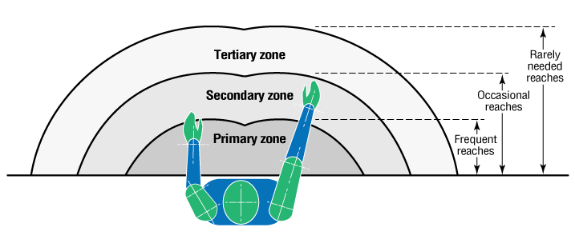
Place frequently used tools and/or material closest to the work or in the primary zone. Place least used items farthest away from the work in the tertiary zone to reduce excessive reaching.

Head and Monitor Positioning
Eye Distance to Monitor
- Eyes should be at least 18 inches and no more than 38 inches from monitor.
- Font size and screen brightness can be adjusted on the device for optimal comfort.

Height and Tilt of Monitor
- The monitor and eyes should be level for optimal performance.
  - Books can be used to stack underneath the monitor to adjust the screen to the proper height.
- The screen should be tilted upwards 15-220 degrees perpendicular to the gaze.

Making Phone Calls
- Headsets with a microphone to allow hands-free talk to maintain a proper posture while working.

Dual Monitor Use
- If one monitor is used more often – Position primary monitor directly in front of the worker and place the secondary monitor directly in line with the primary and angled inward at a slight angle of about 30 degrees.
- If both monitors are used equally – Position monitors at equal viewing distances and both at a slight inward angle, with the interior edges of the monitors meeting directly in front of the worker.
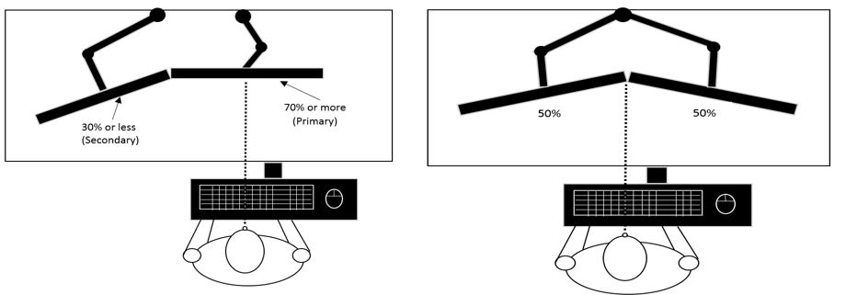
Mouse Options
- Trackballs
- Joysticks
- Vertical Mouse

Keyboard Options
- Modified Standard Keyboard
- Left Hand Keyboard
- Split Keyboard

Eye Strain
Office Lighting
- Position adjustable lighting to the side of the non-dominant hand to prevent shadow.

Glare Prevention
- Reduce on the computer monitor, phone, and tablet screen to prevent eye strain. Position the work desk parallel to the window to eliminate glare.
- Window blinds and light covers may be used to reduce the glare from light sources.
- Anti-glare screen protectors are another option to reduce glare.

Blue Light Blocking
- Download f.lux
- Blue light blocking glasses
- Blue light screen protectors for phones, tablets, & computers

Movement
Break Reminders
- Use tools such as alarms and phone applications to schedule breaks throughout the workday.

Task Breaks
- Stagger tasks to incorporate movement breaks into the day. For example, get up to use the bathroom, get a drink of water, fold laundry, retrieve items from the printer, etc.

Stretch Breaks

