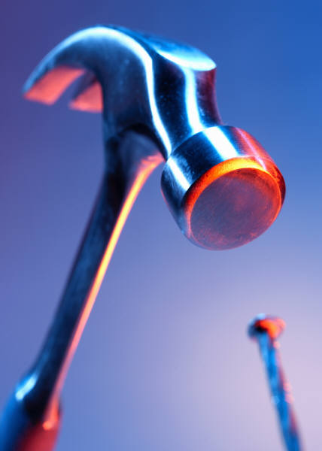 M.L DAVIS CONSTRUCTION, INC

Dear Irene,

Although we have only been a client for 2 years, your tax knowledge and

bookkeeping expertise is phenomenal.

You have saved us money on correcting tax errors from the past and set up our

bookkeeping accounts so we can move forward correctly.

Thank you for keeping your sense of humor with our mishaps and always meeting

us when and where it was convenient for our schedule.

We would recommend your services to anyone who breaths!

Thank you
Michael and Michelle Davis
Davis Construction.

2732 LEOLETA WAY  CARMICHAEL, CA 95608-4102

