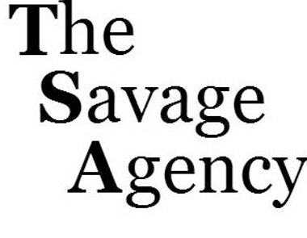
LILY MAE SILVERSTEIN
SAG-AFTRA
Stella Alex, Mark Smith
(323) 461-7615

FILM
ALEX AND ME Supporting Nick/Warner Bros.
A Happening of Monumental Proportions Supporting Dir. Judy Greer
OowieWanna Lead Dir. Bridget Palardy
Gabe the Cupid Dog Supporting Dir. Michael Feifer
BTK Supporting Dir. Michael Feifer

TELEVISION
Henry Danger Co-star Nickelodeon
Teachers Co-star TV Land
Bunk’D Recurring Disney
Walk the Prank Recurring Disney XD
Fresh Off the Boat Co-star ABC
Chevy – Pilot Co-star ABC
DeadTime Stories Guest Star Nickelodeon
Modern Family Co-star ABC
Parenthood Co-star ABC
Outnumbered – Pilot Co-star FOX
Men of a Certain Age Co-star TNT

VOICE OVER
Loud House Co-star Nickelodeon

DIGITAL
Kohl’s Back-to-School DIY Host DreamWorksTV
Spirit Promo (Netflix) Host DreamWorksTV
Mary Poppins w/Kristen Bell Jane Banks FunnyOrDie.com

TRAINING
Workshop Intensive (Talent House): Ty Harman, Krisha Bullock, Jaime Snow,
Harriet Greenspan, Julie Gale
Private Coaches: Helen Gordon, David Kaufman, Vicki Bauman
David Gray, Loren E. Chadima, Lisa Picotte

Scene Study: Gray Studios, Intentional Acting, Simply Acting

Voice/Guitar: Jennie Kwan, Barbara Greenspan, Kelly Wakelin
Dance (Broadway/Jazz): Melanie Wildman, Rage Entertainment, Eshe
Leon Henderson, Debbie Allen Dance Academy
Gymnastics: Brad Meynhert, Leon Henderson
SKILLS
Competitive Dance, Gymnastics, Soccer, Guitar, Skateboard, Improv, Beginning French

