Cheeky Monkeys Day Nursery


Prospectus

Thank you for your interest in our Nursery. We have provided this prospectus for your information. Please don’t hesitate to contact us should you require any further information or have any questions.

Opening hours
Monday to Friday 07.30 – 18:00
We close for all Bank Holidays and for one week over Christmas.

Long Lane, Chapel-en-le-Frith, High Peak, Derbyshire, SK23 0TQ
(01298) 811731
Email address: cheekymonkeys@mail.com

Website: https://cheekymonkeysonline.com/

About us
Cheeky Monkeys was established in April 2003 and is owned By Claire and Garry Millner. We provide care for children between the ages of 3 months to 5 years. We are registered with OFSTED and at our last inspection were graded as Good.
We are blessed to have lots of indoor and outdoor space for all of our children to access and explore.
Cheeky Monkeys offer a loving nurturing environment where children are always a priority.
Staff
At Cheeky Monkeys we have fantastic, caring, and dedicated staff with relevant childcare qualifications and experience. Staff are paediatric first aid trained and update their qualifications every three years as required. As part of our continued development, we undertake relevant training to ensure we are up to date with current legislation and all good practise requirements. As part of safer recruitment procedures all staff are DBS checked and we seek a minimum of two references for any staff joining our team. Qualified staff members are allocated Keyworkers for the children who attend nursery and are responsible in monitoring and supporting their overall development. We have systems in place which ensure all staff know all of the children who attend as well as their own key children.
Our Team
Sara – Manager | Heather – L3 Nursery Practitioner
Abby H – Deputy Manager | Charlotte – L3 Practitioner
Caz – Duty Manager | Abby N – L3 Practitioner
Niki – Baby Room Leader | Gemma – Nursery assistant
Sally – L3 Nursery Practitioner | Emma – L3 Nursery Practitioner
Chloe – L3 Nursery Practitioner | Amy – L2 Practitioner
Natalie – L3 Practitioner | Eibhlin – L3 practitioner
Hannah – L2 Practitioner | Jane– Nursery Cook
Justine – L3 Practitioner

Curriculum and Intent
Here at Cheeky Monkeys Day Nursery, we have an holistic approach to learning in which we aim to make children feel inspired and motivated to learn within a caring, nurturing and stimulating environment. The children are at the centre of what we do and are the absolute focus of our curriculum. We strive to help all children to reach their full potential.
There are seven areas of learning within the Early Years Foundation Stage Curriculum which we follow.
Prime areas of learning (main focus of what we do)
- Communication and Language.
- Personal, Social and Emotional Development.
- Physical development.
Specific areas of learning (an extension of the prime areas for further learning and development)
- Literacy.
- Mathematics.
- Understanding the world
- Expressive Arts and Design.
In planning for children, we also consider the different ways in which they learn. We refer to the three characteristics of effective learning. These support effective teaching and underpin how children learn and how adult interactions work alongside these.
- Playing and Exploring
- Active Learning
- Creating and thinking critically.
Children enjoy singing, dancing, stories, art and craft, construction, imaginative play, exploring malleable materials, role play, nature walks, experiments, festivals and celebrations, baking, sports, technology, small world play and opportunities to experience activities we may not have access to at home.
We are an inclusive setting where diversity is of a high priority. The children learn about different cultures, religions, family structures, celebrations, and people with additional support needs. We promote that no matter what our differences/challenges are in society we do need to live respectfully and peacefully together. Children learn about kindness, friendships, turn taking and making positive choices. We celebrate achievements no matter how big or small and value all children and each other.

Nursery Rooms
Baby areas – 3 months to 2 years
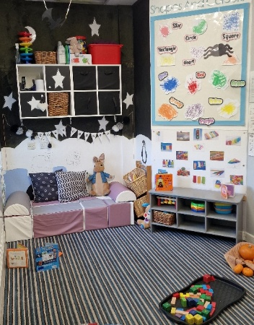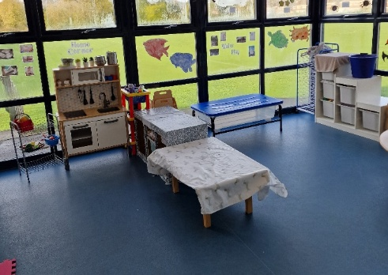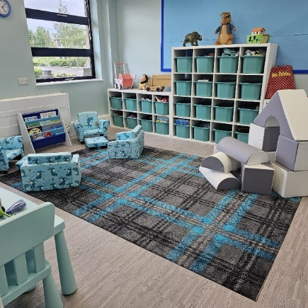
Our Baby provision caters for children from aged 3 months to appx 2 years. We provide a safe, nurturing and stimulating environment where children can explore freely and safely to develop vital skills and some independence at the earliest point of their nursery journey with us. The resources in this designated area are age appropriate and support all areas of their development and interests in a safe, separate environment to the older children. When the children reach 2 years old we support them with a smooth transition into our Pre – School room.
Pre School rooms – 2 – 5 years
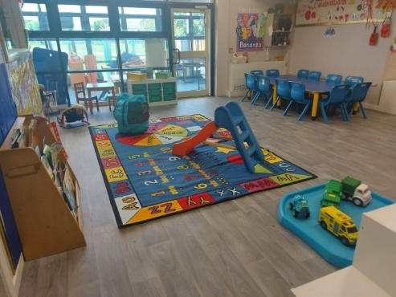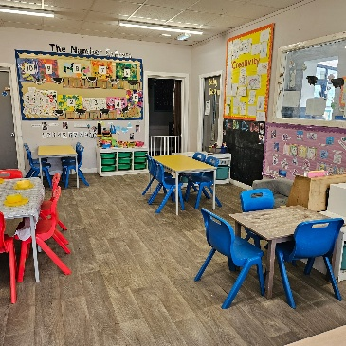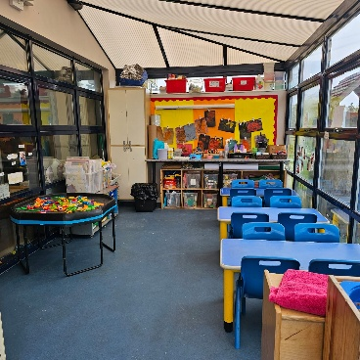
Our Pre School-Rooms cater for children aged appx 2 – 5 years. They consist of a large classroom, quiet room, and multi-purpose playroom. Within our preschool rooms we can find older children acting as positive role models for our younger children and here is where we begin to have some focus on school readiness. Along with free play and an array of age-appropriate resources children can also access smaller, adult led, group sessions (pre school time) where we can promote, language, mathematical awareness, social skills and self-care etc. at a more targeted level. Once children are at the age where they are leaving us for school we support transitions and work with children to help them feel confident and ready for the next chapter in their education.

Typical Nursery Day
We support children to make independent choices whilst accessing our extensive core provision. We use supportive adult interactions to extend on learning opportunities and provide appropriate challenge. We feel that children make the most progress when we follow their interests and understand their individual needs and learning styles. We introduce some more formal/routine daily activities such as registration time, pre-school time and some more focused/targeted adult led and external agency activities to ensure children are accessing all areas of the EYFS curriculum and so that they can access new opportunities and have their needs and developmental milestones met. All transitions are carefully planned and supported so that children can feel confident, safe and ready to take their next steps in life. We have a variety of learning spaces available within our setting for all of our children to access and staff deploy themselves accordingly. We have various session times available to suit the needs of all children and their families.
Meal times:
- 07:30 – 08:30 Breakfast is served.
- 09:30 – Snack time
- 12:00 – Lunch time
- 14:30 Snack time
- 16:10 Tea time

Outdoors
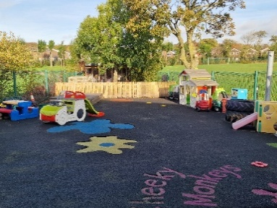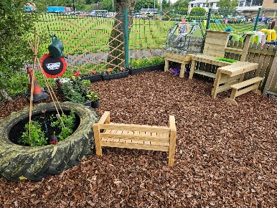

We are lucky to have lots of outdoor space for the children to explore. We have a large, safe and enclosed playground where children can climb, build, use ride on vehicles and experience activities to improve gross motor skills and improve physical development. The children love the mud kitchen and can often be found making mud pies, digging and using construction vehicles (very messy so wellies and waterproofs are essential!) Children can go on nature walks and trips out into the wider community to further support their learning and understanding of the environment and world around them. During high school holidays we often make use of the space that the extensive playing fields have to offer for running races, various sports/activities and sometimes mini picnics.

Staff to child ratios
To keep children safe and appropriately supported we adhere to the following ratios of adults to children.
0 – 2 years – 1:3
2- 3 years – 1:5
3 – 5 years – 1:8

Keyworker system
Children are allocated a key worker during their time in nursery. Key workers spend quality time with their allocated children to develop a further understanding of their interests, needs and stages of development. Staff create personal observations and provide activities/interactions which support children to make progress in all areas of their development.

Parents/carers as partners
Parent/carer partnerships are very important to us here at Cheeky Monkeys Day Nursery and we really value your input and cooperation. When children first join us we use information provided by parents/carers as our starting point and to begin to get to know the children in our care at the earliest opportunity. We share nursery life via an online learning journal called Tapestry and this allows us to share photos, videos and observations of the children and the activities we do in nursery. Parents/carers can also share lovely memories and achievements from home. We have an open-door policy so at any given time parents/carers can approach staff for advice or to discuss any aspects of their children with us. Parents/carers are the most important people in a child’s life and we aim to work together in order to promote the best outcomes.

Settling new children
Making children feel safe and comfortable when they join us for the first time is of huge importance to us. We use settling in sessions so that children can become familiar with a new environment and new people. For the first session we ask parents/carers to stay and here we can gather lots of information about the children, their routines, likes and dislikes, dietary needs, health needs and all aspects of their development which will help us to learn as much as we can from the people who know them best. At the second session we recommend the parent stays for the first part then leaves for the second part of the session. This is a short burst of time and helps us to see how well children can settle away from their main carer. For the third settling session we recommend that children are dropped off and left with staff. At this session we also try to include a different part of the day within this session e.g a mealtime. Once we have completed the settling in sessions we can usually determine if a child may need more settling in sessions or if they feel confident enough to start their booked session pattern.

Funded children
We are able to offer sessions to children who are eligible for 15 or 30-hours government funding. The funded sessions can be taken as term time only or we can stretch the funding to cover 51 weeks of the year. Funding allocation covers teaching hours only so there may be additional charges for extra hours, meals, and other supplements if these form part of the requested session. (Terms and conditions apply, please speak to a member of staff for further information)

Fees
Fees are dependent on the sessions children attend and are invoiced at the beginning of each month to be paid by 15th of the month. Any late payments incur a charge of 15%. Fees are payable all year round and any absences, sickness days and holidays will be charged at the usual daily rate. We have various sessions available within nursery to offer flexibility where possible and to suit individual needs.

Meals and snacks
We employ a Nursery Cook to provide freshly prepared meals and snacks in nursery every day. It is our aim to provide a balanced and nutritious diet for all children in our care. All dietary needs and allergies are catered for. Our menus include a good variation of foods so that children can experience things that they like and try new textures and tastes. Meal times are a sociable time where children learn about being healthy and the importance of a balanced diet. Sweet treats are in moderation. Fresh drinking water is available throughout the day.

Sickness and Illness
We follow guidelines as set out in public health England regarding symptoms and incubation periods. We aim to minimise the risk of staff and children being poorly and to prevent the spread of infection. If children are unwell and require medication to control a high fever or if they have an illness which could be passed on to others, we ask that they stay at home until they are well enough to attend. If children need any medication as part of their personal care plan, then medical forms can be completed. We can only provide medication if they are prescribed by a medical practitioner are in date and are clearly labelled with the child’s name and dosage instructions. We can only give antibiotics/penicillin if children have had them previously or after 48 hours of taking them. Children who have been given paracetamol or ibuprofen before a nursery session should not attend as this can mask symptoms of illness and cause a delay in interventions.

What do children need to bring to nursery?
Children need to dress appropriately for the season and wear clothing you are happy for them to soil as we spend lots of time exploring the outdoors and engage in messy play activities. All children should bring a named bag containing spare clothing and any comforters. We provide all nappies, creams and wipes as part of our all-inclusive package. For children who require any medication linked to their personal care plan e.g inhalers these should be handed to a member of staff and a medical form should be completed.

Session Bookings
Should you wish to book a place we ask that this is requested in writing. Please provide a name, date of birth, contact information, start date and details of the sessions you require. For any changes to current booked sessions we ask for 1 months notice in writing.

Thankyou for taking the time to read our prospectus.
For Further information please see our website https://cheekymonkeysonline.com/
We look forward to welcoming you to our Cheeky Monkey’s Family.
Kind Regards
Claire, Garry and the Cheeky Monkeys Team

