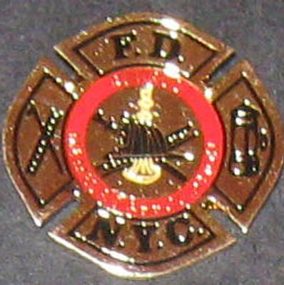
RMA Lapel Pin $6.00 for One, $10.00 for Two*
Retired Member's Association, Inc.
Fire Department, City of New York
PO Box 1332 Baldwin, NY 11510

2022 Official Application

NAME_________________________________________________

HOME ADDRESS______________________CITY_______________

COUNTY______________STATE________ZIP_______________

BEST CONTACT PHONE NUMBER__________________________

DATE RETIRED__________LAST UNIT________LAST RANK______

DATE OF BIRTH___________SPOUSE’S NAME___________________

E-MAIL ADDRESS___________________________________________
Type of Membership (Circle)
ANNUAL MEMBERSHIP: $25.00 LIFETIME MEMBERSHIP: $250.00
Download, Print and Remit this application along with your payment
To: The RMA PO Box 1332
Baldwin, NY 11510 *Add Payment of Lapel Pin(s) to Your Membership Fee* Receive Pin(s) back in the US Mail along with your Membership Card

