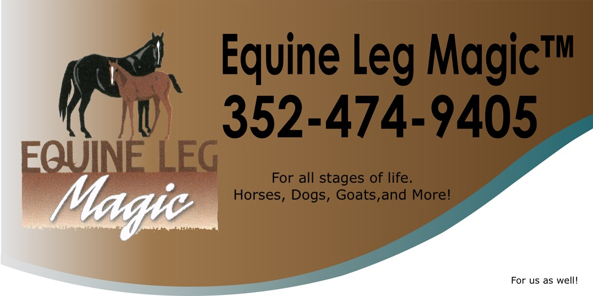
Testimonial
Please tell us your horses’ issue(s) and your experiences/observations while using Equine Leg Magic ®

________________________________________________________________________________________________________________________________________________________________________________________________________________________________________________________________________________________________________________________________________________________________________________________________________________________________________________________________________________________________________________________________________________________________________________________________________________________________________________________________________________________________________________________________________________________________________________________________________________________________________________________________________________________________________________________________________________________________________________________________________________________________________________________________________________________________________________
Thank you Anne & Pam, your ELM support.

