AFTER ACTION REPORT
Calvary Outreach Program
Date of Outreach | Wednesday, April 15, 2026
Location | Calvary Refuge Center, 4265 Thurman Rd. Forest Park, GA 30297
Prepared For | Association of Christian Ministers of Clayton County (ACMCC)
Primary Lead | Pastor James Whitely

The Calvary Outreach Program was conducted on Wednesday, April 15, 2026, as a coordinated act of Christian service and community encouragement. The outreach combined meal preparation, food service, volunteer teamwork, and a brief inspirational message entitled “Keep Hope Alive,” dedicated to the late Rev. Jesse L. Jackson and to the community being served.
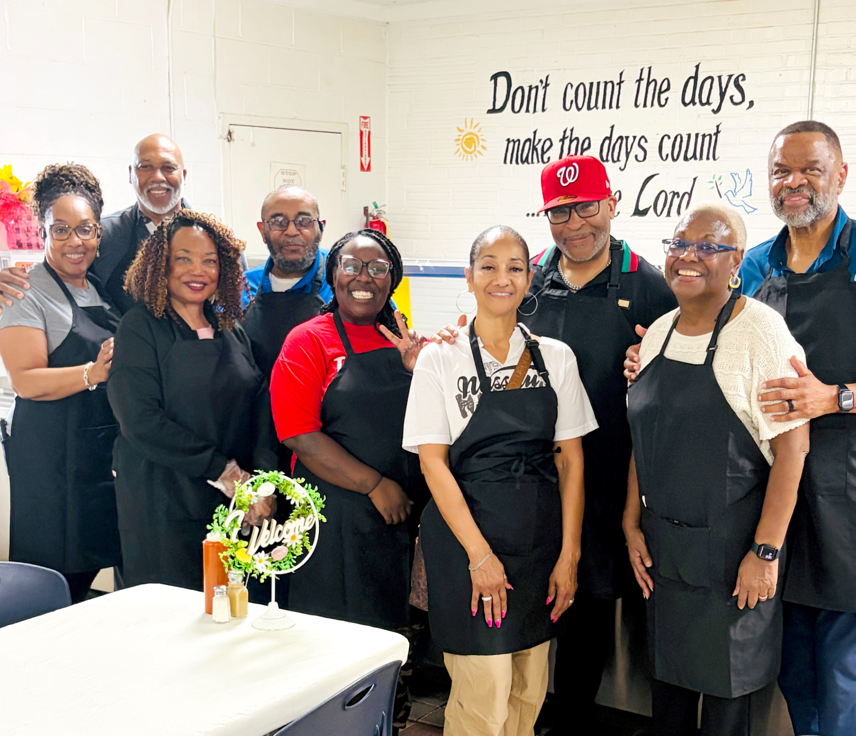
The Calvary Outreach volunteer team assembled for ministry and service.

1. Purpose
The purpose of the outreach was to serve members of the community with compassion, dignity, and hope through a prepared meal, hands-on assistance, and a word of encouragement rooted in faith. The event reflected the ACMCC commitment to practical ministry and visible community engagement.

2. Pre-Event Coordination
Before the event, Pastor James Whitely and Lady Denise Whitely visited Calvary Refuge Center to meet with Keisha Zimmerman and the kitchen staff. During that visit, they reviewed procedures, confirmed the kitchen workflow, and made the necessary connection to help ensure that operations would be smooth and in order on the day of service.

3. Operational Plan
The food was transported to Calvary on Tuesday morning, and the chicken was obtained on Wednesday afternoon. Volunteer responsibilities included cutting up the chicken, warming and seasoning the canned food, combining the chicken with the remaining meal components, assisting with serving, and cleaning the work areas afterward. Denise helped oversee a portion of the meal preparation to support timely readiness.

4. Execution
The outreach team carried out the plan in an organized and cooperative manner. Volunteers worked in the kitchen to prepare the food, assisted in serving, and cleaned up after the meal. The attached photographs reflect both the team’s fellowship and the active food-preparation effort that supported the outreach mission.
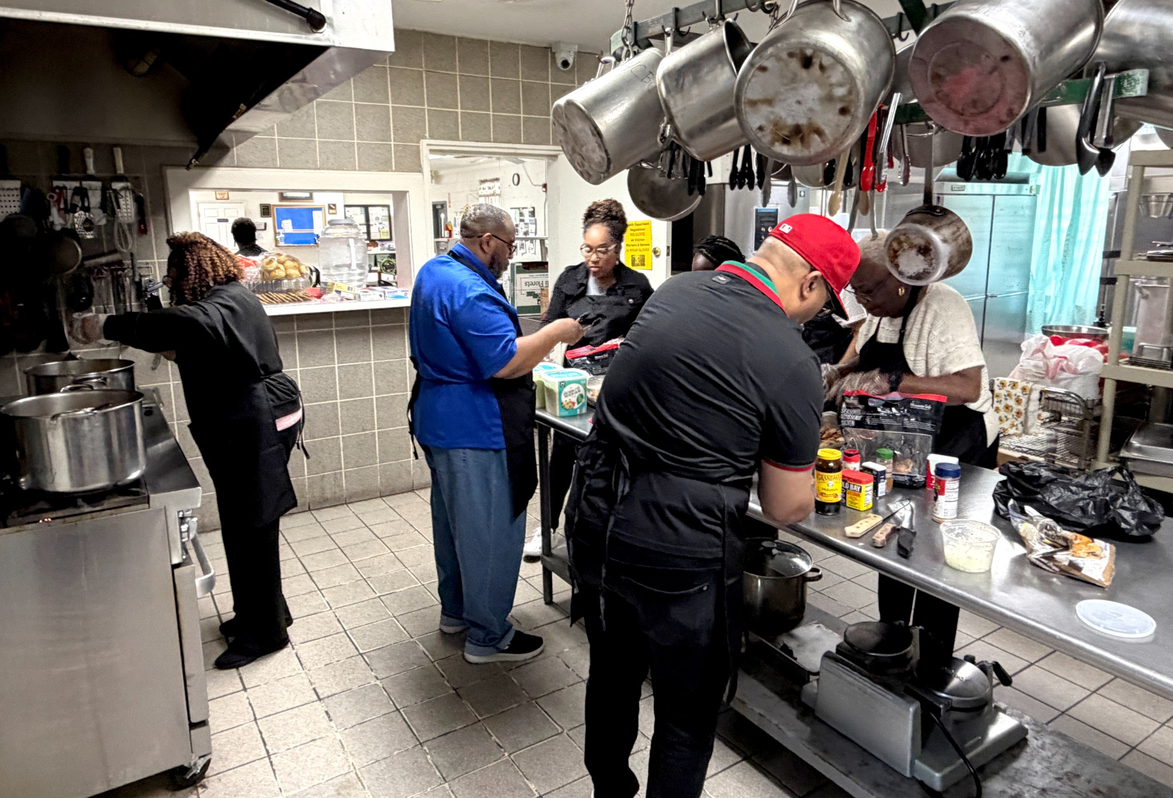
Volunteers actively prepare and organize the meal service in the Calvary kitchen.

5. Inspirational Message
Pastor James Whitely prepared a 10-12 minute Word entitled “Keep Hope Alive.” The message offered spiritual encouragement to those present and honored the legacy of Rev. Jesse L. Jackson while speaking hope to the community being served.

6. Strengths and Successes
Key strengths included strong advance coordination with site staff, a clear division of volunteer duties, cooperative teamwork, respect for the host facility, and the successful blending of practical service with spiritual encouragement.

7. Lessons Learned and Recommendations
This outreach reaffirmed the value of early site visits, clear task assignments, and written timelines for food delivery and preparation. Future outreach events would benefit from maintaining a simple volunteer checklist, confirming supply and pickup times in advance, and continuing to include a brief devotional or message as part of the overall ministry experience.

8. Volunteer Roster
The following volunteers participated in or supported the Calvary Outreach Program and are listed here for coordination and record purposes.
Last Name | First Name | Phone Number | Email
Burton | Robert | 678-923-9633 | RobertBurton_7@hotmail.com
Horton | Keith & Mary | 404-202-8224 | Ascnupe83@aol.com
Moore | Shirley | 404-673-7500 | Shirleyjmoore06@gmail.com
Rodriguez-Burton | Diane | 678-923-9633 | drodriguezburton@yahoo.com
Whitely | James & Denise | 770-842-1063 | covenantcom@mindspring.com
Griffin | Derek & Lisa | 404-324-1362 | derektoddagency@gmail.com

9. Conclusion
The Calvary Outreach Program on April 15, 2026, was a meaningful and well-coordinated expression of service. Through preparation, partnership, and compassionate ministry, the team met practical needs while also strengthening hope in the community. The outreach stands as a positive example of faith in action.
Source Note: This report was prepared from planning information provided by Pastor James Whitely and supplemented with the attached event photographs.

