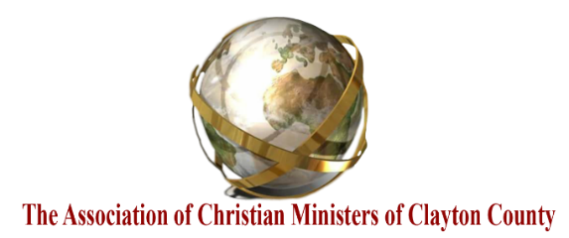
“Let brotherly love continue” (Hebrews 13:1-3)
Agenda
November 17, 2025, at 7:00 p.m.

Meeting Location and Host:
Christian City. Location: 7345 Red Oak Road, Union City, GA 30291
(Directions to 7345 Red Oak Rd, Union City, GA - MapQuest).
Host: Dr. Keith Horton, President, Christian City

- Call to Order, Welcome & Devotional Song (Dr. RL Burton, Dr. K. Horton, and Pastor EJ Childs)
- Opening Scripture, Prayer, and Bless the Food – Serve the Meal (Pastor/Chaplain Thomas Simpson)
- Adoption of the Agenda – (Motion to Approve) (Dr. Robert Burton)
- Inspirational Word: (10 minutes) – Dr. Robert Burton, President, ACMCC
- Presenters:
- 15 Minutes: Update: Pastor Terry Woodard, Sr. (Thanksgiving Giveaway)
- Old Business:
- Appeal for 2025 Dues and Donations (Pastor Derek Griffin)
- Update: 12/5/2024 @ 7:00 p.m.: ACMCC Scholarship/Award Banquet (Dr. Robert Burton/Pastor Derek Griffin)
- Distribute Tickets / Eventbrite Tickets are distributed online!
- New Business:
- Review of Minutes dated 10/20/2025 - (Motion to Approve) (Dr. R. Burton)
- Financial Reporting 11/17/2025 – (Motion to Approve) (Dr. R. Burton)
- Review: 2025 ACMCC Calendar of Events (online)
- ACMCC Chaplain Report (Pastor/Chaplain Thomas Simpson)
- Introduction of New Member: Mr. Sylvester Johnson, WinShape.Org, if available.
- Next Meeting: Friday, 12/5/2025@7:00 p.m. – ACMCC Annual Award Scholarship Banquet – Black-Tie Affair at This Is It! BBQ & Seafood Corporate Headquarters Event Center, 105 McIntosh Crossing, Fayetteville, GA 30214
- Adjournment and Prayer
Handouts w/Agenda (on website):
- ACMCC Monthly Minutes dated 10/20/2025.
- Financial Report (11/17/2025) (online)
- 2025 ACMCC Calendar of Events (online)

