Membership begins May 1, 2024, initial membership dues will not begin till March 1, 2026. Take advantage of this opportunity to be a part of the unique opportunity to support Building in Indian Country! An ICC membership is not a prerequisite for Native Americans to join! One of the main goals of NACO is to create a community of emerging Native American communities and established code professionals!
NAME | Click or tap here to enter text.
EMAIL | Click or tap here to enter text.
CITY | Click or tap here to enter text.
STATE | Click or tap here to enter text.

ARE YOU A MEMBER OF ICC?  YES☐ NO☐ |  |  | NUMBER OF ICC CERTIFICIATIONS  Click or tap here to enter text.
JOB TITLE  Click or tap here to enter text. |  |  | JURISDICTION OR EMPLOYER  Click or tap here to enter text.
ARE YOU AN EMPLOYEE OR OFFICIAL OF A FEDERALLY RECOGNIZED TRIBAL GOVERNEMENT WHOSE PRIMARY DUTIES ARE THE ENFORCEMENT OR DEVELOPMENT OF BUILDING CODES AND RELATED ORDINANCES |  |  |  | YES ☐ NO☐
IF YES WHAT TRIBAL GOVERNMENT? |  |  |  | Click or tap here to enter text.
ARE YOU A MEMBER OF A FEDERALLY RECOGNIZED TRIBE? |  |  |  | YES ☐ NO☐
IF YES WHAT TRIBE | Click or tap here to enter text.
ARE YOU A MEMBER OF A STATE RECOGNIZED OR A TRIBE NOT FEDERALLY RECOGNIZED? |  |  |  |  | YES ☐ NO☐
IF YES WHAT TRIBE |  | Click or tap here to enter text.
ARE YOU A LINEAL DECENDANT OF A MEMBER OF A FEDERALLY RECOGNIZED TRIBE? YES ☐ NO☐
IF YES WHAT TRIBE |  | Click or tap here to enter text.

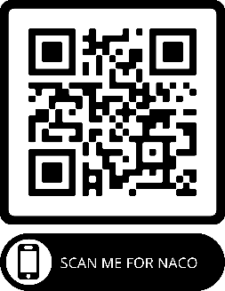
For Further Information or
Any firm, company, or corporation having an
interest in sponsoring the NACO chapter,
please contact info@joinnaco.com OR ewhitethunder@lakotafunds.org

