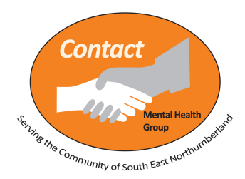
Contact (Morpeth Mental Health Group) Ltd.

Summary of Complaints Policy and Procedure
Contact Morpeth Mental Health Group Complaints Policy outlines how we treat complaints about the service. Your attention will be drawn to this policy when you join a group, receive counselling or become a member.
This information is designed to help you use our complaints policy and covers all the main points.
You have the right to complain:
- If you feel that the service you have received breaches the Membership Agreement and Code of Conduct for Members.
- If you are unhappy with the behaviour of another service user, a member of staff or a volunteer (including that of Trustees).
A two-stage complaints process has been set up for people who feel unhappy about the services we provide or their treatment at Contact.
Stage 1 looks at your original complaint.
Stage 2 is used if you are unhappy with the way we have handled the original complaint and wish to appeal any decisions or outcomes made.
Complaints should be submitted in writing for the attention of the Chair of Trustees and a complaints form is provided at the end of this document.
We will deal promptly with all complaints using this policy and procedure, aiming to learn from any mistakes we make and complaints we receive.

Stage 1 – Receiving Your Complaint:
- We will acknowledge receipt of the complaint asap, either verbally or by email, telephone call or text message.
- We will send out a letter, stating who is investigating the complaint within 3 working days of receiving the complaint.
- We will appoint a member of staff or Trustee / Trustees to investigate the complaint and aim to provide you with the outcome within 7 working days of receiving the complaint.
- The case will be closed within 14 working days of receiving the complaint, unless notice is received that our response is not satisfactory.

Stage 2 - If you tell us that you are not happy with the outcome of a complaint or wish to appeal:
- An alternative member of staff or Trustee / Trustees will be appointed to review the process above and investigate the complaint further, if required.
- We aim to have this followed up and inform you of any outcome within 28 working days of receiving your appeal.

Please complete the form on the next page if you wish to make a formal complaint.
Place it in an envelope marked “Private and Confidential”, addressed to the Chair of Trustees and hand it to a member of staff or Trustee.

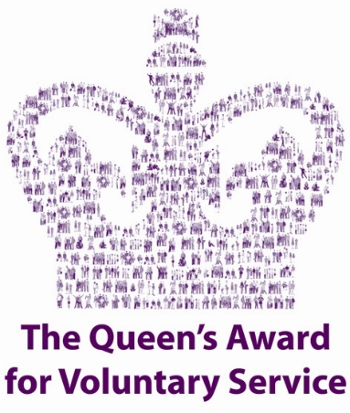

Contact Morpeth Mental Health Group Ltd.
7 Grey’s Yard, Oldgate, Morpeth, Northumberland NE61 1QD
Tel: 01670 510652 E-mail: contact@contactmorpeth.org.uk www.contactmorpeth.org.uk
Registered charity number: 1124547 Company Limited by guarantee: 06182748

Complaint Form
Name (& Organisation, if applicable):

Address (including Postcode):
Contact Number:
Email Address:
Summary of your complaint:

How you would like to see your complaint resolved:

Please attach any supporting statements, documents and list below if applicable:

Signed: Date:

Office Use: | Date Received

