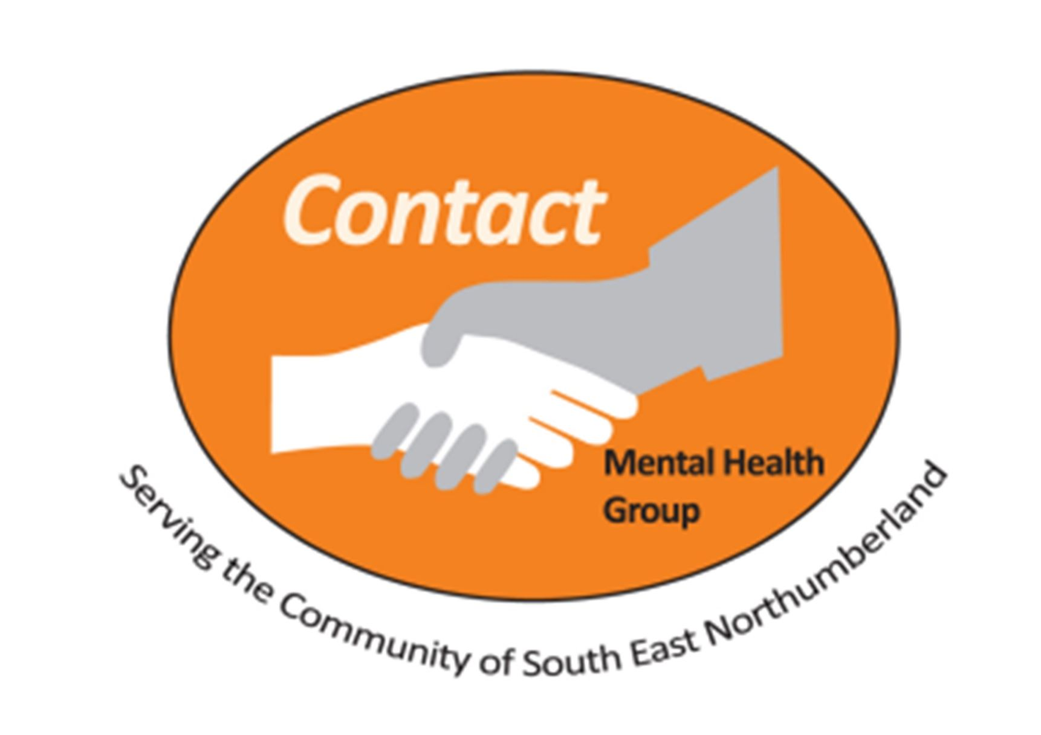
Contact Morpeth Mental Health Group
Self-Referral Form 2024 Counselling Only
Your details
Name: | Address & postcode:
Landline phone number: | Mobile phone number:
Email address: | Date of birth:
Your preferred method of contact and other important information:
Are we able to contact you on your landline / mobile or via email? Please circle at least one choice
Are we able to leave a message for you with another person? |  | Yes / No
Are we able to leave a message on your answer machine, by voicemail or text? |  | Yes / No
Are you receiving any other form of therapy / or seeing any other mental health professional at present?  (If so, please what and who that is with) |  | Yes / No
Please briefly state what you think your current issues are and tick the appropriate boxes:

Depression | Anxiousness | Finding it hard to Cope | Anger
Family Problems | Loneliness | Relationships | Death/Loss
Job/Workplace | Money Problems | Gender/Sex/Identity | Unemployment

Communication & Disability:
Do you have any special communication needs i.e. hard of hearing / need a sign language interpreter? (If so please state) |  | Yes / No
Some activities and the toilets are on the first floor but are accessible via the stairs or a chair lift, is this acceptable? |  | Yes / No
The Counselling Service we offer is on the first floor but is accessible via a chair lift or stairs, is this acceptable? |  | Yes / No
In general, the appointment is for yourself only, is this acceptable? |  | Yes / No
If you know, please tell us what form of transport you intend to use to access Counselling at Contact Morpeth?
First Emergency Contact: (Please let them know you have provided their details)
Name: | Address & postcode:
Relationship (i.e. son, daughter, friend, neighbour etc.)
Landline phone number: | Mobile phone number:
Second Emergency Contact: (Please let them know you have provided their details)
Name: | Address & postcode:
Relationship (i.e. son, daughter, friend, neighbour etc.)
Landline phone number: | Mobile phone number:
Medical Contact Information: (Your G.P. will only be contacted to inform them that counselling has commenced or has ended)
Name of Doctor / G.P. Surgery: | Address / postcode / phone number:
I have voluntarily provided the above contact information and authorise CONTACT MMHG and its representatives to contact any of the above on my behalf in the event of an emergency and / or to inform my GP that counselling has commenced.
I will respond to communications from Contact as soon as I can.
All information provided on this referral form is treated with the utmost confidentiality and will NOT be shared with anyone outside of Contact Morpeth Mental Health Group, in accordance with our Data Protection Policy / GDPR and Privacy Policy.

Signature: Date:

