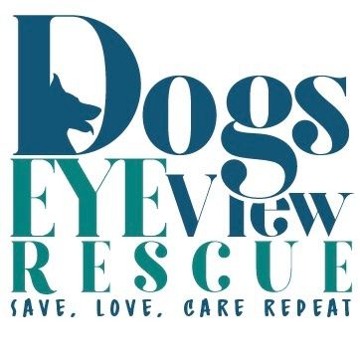
443-523-8817

Adoption Application
Contact Information:
Full Name: __________________________
Full name of spouse/significant other: _______________________
D.O.B.: _______________________________
Mailing Address: ____________________________
Physical Address: ____________________________
Home Phone: ________________________
Cell Phone: __________________________
Work Phone: ________________________
Employer: __________________ Position: ______________________
Email: ______________________________
Best Time to Contact: _____________________
Family and Housing:
Are any family members active-duty military: _________________
Are there any children in the house: __________________________
List ages: _________________________________
Do any family members have pet related allergies: ___________________________
What type of residence: ____________________________________
Rent or Own: __________________________
If renting, may we contact your landlord to verify permission for having a dog? : __________________________
Landlord name and contact number: ___________________
Do you have a fenced yard: ________________
Do your neighbors own dogs: ______________
Do you own a pool: ______________________
If you were to separate who would take the dog: _________________

About You:
Do you currently have a dog (Name/Breed): ______________________________
If so is it spayed/neutered: _____________
Current on vaccines: _______________
Monthly heartworm and flea prevention: ________________
Any other animals in the household (Name/Type): ______________________________
If so is it spayed/neutered: _____________
Current on vaccines: _______________
Monthly flea prevention: ________________

Have you ever surrendered a dog: __________________________
If yes please explain: ___________________
Have you ever been in contact or investigated by your local Animal Control:___________
If yes please explain:_____________
County: ____________________
Hobbies, interests: _____________________________________
How long would the dog be alone during the day: ________________________
References:
Vet Reference: ___________________________
Family Reference: _________________________
Non-Family Reference: _____________________
Potential Dog:
Male or Female: ______________________
Puppy, Young Adult, or Senior: ___________________
What energy level: _____________________________
What size dog: ________________________________
What breed: __________________________________
What would be your ideal dog to adopt: ________________________________

What personality traits are you looking for: ________________________________
Do you have a particular dog in mind: ____________________________________

