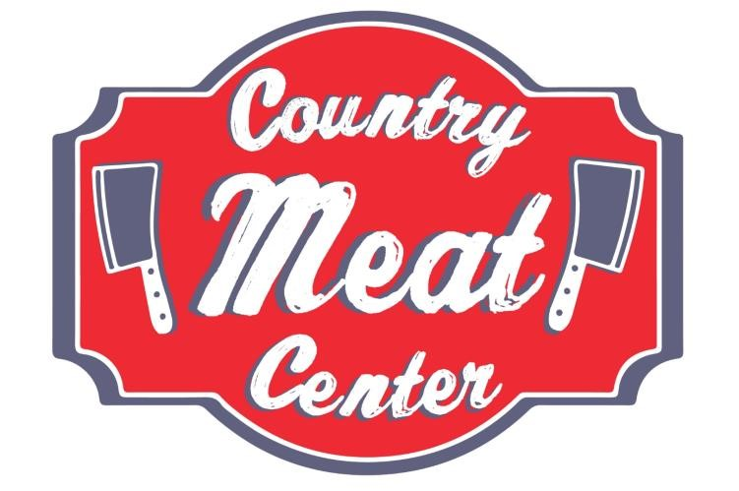

Our Beef is Western, Grain fed and only the best cuts for our customers!

Beef
Eye Round Steak
Beef Stir Fry
Beef Tips
Whole Sirloin Tips
Beef Chuck Eye Steak
Beef Round Breakfast
Beef Short Ribs
Beef Neck Bones
Sliced Beef Liver
Whole Ribeye Loin

Choice T-Bone Steak
Ribeye Steak
Sirloin Steak
Fillet Mignon

80/20 Ground Chuck Beef
73/27 Ground Beef
Hot Dog Weiners
Beef Brisket
Eye Round Roast
Beef Rump Roast
Boneless Chuck Roast
Cube Steak
Beef Stew
Skirt Steak
Flank Steak

Chicken
Chicken Thighs
Chicken Drumsticks
Chicken Wings
Whole Cut Up chicken
Baking Hens
Boneless Breast
Chicken Tenders

Pork
Country Hams
Sugar Cured Ham
Boneless Pork Loin
Cubed Pork
Boneless Ribs
Boneless Pork Chops
Bone-In Pork Cops
Pork Stew
Boston Butt Pork Roast
Pork Liver
Sausage- Hot or Mild
Cured Bacon
Smoked Pork Chops
Smoked Ham Hocks
Center Cut Ham Slices
Smoked Hog Jowl
Smoked Neckbones
Pig Feet
Ears
Tails
Stomachs
Ox Tails Pork Ribs

Turkey
Ground Turkey
Turkey Necks
Wings
Gizzards
Smoked Turkey Necks
Wings
Drumsticks
Frozen Butterball Turkeys

Other Meats
See our Frozen Specialty Cooler for Duck, Alligator, Local Ostrich, Elk, Bison, Boar and so much more!

See our Butchers for your own special cuts and deli meats/ cheeses.

Seafood
Snow Crab Clusters
Oysters
Scallops
Tuna
Shark
Salmon
Grouper Snapper
Catfish
Swai
Trout
Flounder
Perch
Whiting
Tilapia
Croaker
Haddock
Cod
Crab Cakes
Shrimp
Swordfish
Mahi Mahi

Odds and Ends
The Country Meat Center carries fresh produce, dairy products and a great selection of groceries. The dry goods include all your necessities including bread, paper products and charcoal for your grilling needs.

We also carry Maurice’s Bar-b-q sauces, Pirate’s Gold and multiple local products to top off your grilling masterpieces.

