SECAC Statement of Purpose:
The Code of Maryland Regulations (COMAR 13A.05.02.13I) requires the following for a Special Education Citizens Advisory Committee (SECAC):

(1) Each local school system shall establish a special education citizens advisory committee to advise the local school system on the needs of students with disabilities within the jurisdiction.
(2) The Department shall annually allocate federal funds to each local school system to support the activities of the local special education citizen advisory committee.
(3) Each local school system shall submit a budget for the use of federal funds, consistent with §C(1)(a) of this regulation.

Each SECAC is given a grant of $2,500 each year to support such activities. SECAC has used funding this year primarily to support parent advocacy and training, and educational sessions for parents to learn more about the process and laws of Special education, reading interventions, etc.

SECAC Purpose: The Howard County Special Education Citizens Advisory Committee (SECAC) advises the school system on the needs of students with disabilities. We collaborate with other community disability advocacy groups to improve special education and the lives of our students in Howard County, MD.

Background Information: The Individuals with Disabilities Education Act (IDEA) is a federal law that makes available “a free appropriate public education to eligible children with disabilities throughout the nation and ensures special education and related services to those children.”
Under the law, Congress defined disabilities as, “a natural part of the human experience and in no way diminishes the right of individuals to participate in or contribute to society. Improving educational results for children with disabilities is an essential element of our national policy of ensuring equality of opportunity, full participation, independent living, and economic self-sufficiency for individuals with disabilities.” The purpose of IDEA 2004 is “to ensure that all children with disabilities have available to them a free and appropriate public education that emphasizes special education and related services designed to meet their unique needs and prepare them for further education, employment, and independent living.” A Free Appropriate Public Education means special education and related services that are: (a) provided at public expense; (b) meet the standards of the State Education Agency; (c) include an appropriate education; and (d) are provided in conformity with an IEP that meets the student’s needs that result from the disability to enable the student to be involved in and make progress in the general education curriculum. (34 CFR §300.17). An Individualized Education Program, or IEP is created by the IEP team to include strengths, concerns, areas of functional need and academic need, and evaluations. The law also requires parents to be equal participants in the IEP process, citing “almost 30 years of research and experience has demonstrated that the education of children with disabilities can be made more effective by strengthening the role and responsibility of parents and ensuring that families of such children have meaningful opportunities to participate in the education of their children at school and at home.”
Membership: SECAC has taken great care in creating an environment of inclusion while promoting parent involvement in Howard County. At general membership meetings, we have had an overall attendance of 30-68 parents, teachers, and community partners. We have been more intentional about creating relationships with the PTA Council of Howard County by attending their monthly meetings and giving reports to PTA representatives. We are continuing to ask the PTA presidents to create or continue a SECAC representative position on their respective PTAs in order to share our information with their schools. We still maintain community relationships with Howard County Autism Society, The Parents’ Place of Maryland, and have formed a new connection with the NAACP Education Committee. We are sustaining membership through utilization of allocated federal funds to provide scholarships to Howard County parents to participate in training workshops on special education advocacy and for providing materials to educate parents during this time of COVID-19. Due to COVID-19, we have transitioned our general meetings to an online platform beginning in May 2020 which allows for more parents to attend and engage with our Department of Special Education staff. We had over 100 participants in our May general membership meeting which informed us that parents appreciated the online access. We will continue our advocacy through online means for as long as it is needed.

Inclusivity: SECAC has continued to look for ways for families to have access to our general meetings and the resources and information we provide. This year, we have begun to Facebook Live our general meetings in the hopes of reaching more parents who are unable to attend. We have seen an increase in attendance with the social media platform. Since we have heard positive feedback, we will continue to meet our parents needs through the use of Facebook Live and other social media outlets. We also moved our monthly general meetings to Wilde Lake Middle School; a school that is centrally located and has access to public transportation. We are asking membership for ideas on where to host 2020-2021 meetings.

State of Special Education: Howard County Public Schools follows an inclusive model of education where children with disabilities are educated with their non-disabled peers as much as possible. Currently there are 6,148 or (10.4%) students in this district receiving special education services from birth to 21 years of age. This is an increase of 430 students from 2018 and a little over 1600 since 2008.

# SPED students | 2017 | 2018 | Current
PS | 569 | 622 | 682
ES | 2001 | 2292 | 2486
MS | 1160 | 1165 | 1320
HS | 1546 | 1626 | 1670

Howard County’s population has increased from 49,905 in 2008 to 59,099 as of the student membership counted by October 31, 2019. The number of students with disabilities has risen from 4,501 to 6,158. Howard County has maintained a single digit percentage of students identified with disabilities, hovering around 9-9.9% from 2008, 2013, and 2018. The only other districts with single-digit percentages from 2018 are Dorchester County (4,785 students population, 465 special education, 9.8%) and Garrett County (3,842, 370, 9.6%). The state percentage for special education from 2008, 2013, and 2018 are 12.2%, 11.8% and again 12.2%.

From the census data of October 2019, the breakdown of those disabilities in the district are as follows: Specific Learning Disability (SLD) is at 22.15%: Autism is 16.27%, Speech Language Impairment (SLI) is 16.18%, Other Health Impairment (OHI) 14.69%, Developmental Delay is 13.83%, Emotional Disability is 6.25%, Multiple Disabilities at 5.15%; Intellectual Disability at 4.19%, and collectively those identified with Hearing Impairment, Deafness, Visual Impairment, Orthopedic Impairment, Deaf- Blindness, and Traumatic Brain Injury at 1%. Howard County’s numbers coincide within 1-2% of the states except in the areas of SLD (5% below the state), Autism (5.0% above) , and OHI (3.3% below). Of these disabilities, 69.3% are male and 30.7% are female. Of these disability categories, Specific Learning Disability is most prevalent. It corresponds to the high number of concerns parents had contacted SECAC, which will be discussed in our Concerns section.

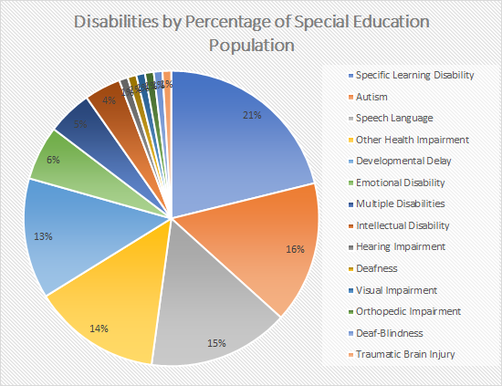

There are two areas to note in the breakdown of students with disabilities in relation to the general education population for non-white students. 22.7% of the general education population are designated Asian but only make up 11.4% of the special education population. African American students make up 21.4% of the general education population, yet are 33.8% of the special education population, which is down 2% from last year. Hispanic students make up 12.0% of the population and 13.8% of the special education population. The higher percentage of African American and Hispanic students reflect disproportionality within the special education program. Efforts to understand this phenomenon will be discussed later in our Concerns.

Inclusive model: Howard County follows an inclusive model where students with disabilities are educated with their nondisabled peers. The issue of ensuring that students with disabilities are in their most appropriate learning environment is one that is still being discussed. These numbers reflect the same data as the last report due to school being closed due to COVID-19. Right now, students are being educated in their homes, which is not their least restrictive environment. Conversations regarding the learning environment will take place once schools open again.

Roughly 76% of students with disabilities are educated in the general education classroom. SWD are educated in their Least Restrictive Environment or LRE which is discussed in regulations §§300.114 through 300.120 of IDEA’s provisions that address “State Eligibility”. In each school, children with disabilities are to be educated with nondisabled children which includes children in public and private institutions or other care facilities.

Not every child with a disability is able to meet success within the general education classroom and therefore the child’s LRE is divided into an A, B, and C classification. A child in LRE A will spend 80% or more in the general education setting; LRE B 40%-79% in general education; LRE C less than 40% in general education. According to IDEA, special classes, separate schooling be it private or non-public, or removal of children with disabilities from the regular educational environment happens “only if the nature and severity of the disability is such that education in regular classes with the use of supplementary aids and services cannot be achieved satisfactorily.”

In 2018, Howard County had 320 students, 6.8% of the special education population, receiving services in separate facilities identified as Home, Hospital, Public Separate Day School, Private Separate Day School, Public Separate Residential, and Private Separate Residential.

#SPED by LRE | 2017 | 2018 | 2019*
LRE A | 3682 | 3694 | 3868
LRE B | 575 | 647 | 761
LRE C | 91 | 123 | 119
* 2019 reflects numbers up until November

Below is a chart describing the LRE for students identified with Other Health Impairment, OHI; Autism Spectrum Disorder, ASD; and Specific Learning Disability which are three of the top four disabilities being serviced in this county. The chart is further delineated according to school level. The highest number of children in each category for school and disability are in LRE A from 2017 to this year. Students diagnosed with SLD makeup the largest number of SWD in LRE A through all 3 school levels. Students diagnosed with ASD are the highest number in LRE B and LRE C at all 3 school levels from 2017-to 2019.

#Students by LRE, Level, & Disability (OHI, SLD, ASD) | ES OHI | ES SLD | ES ASD | MS OHI | MS SLD | MS ASD | HS OHI | HS SLD | HS ASD
LRE A 2017 | 225 | 342 | 182 | 186 | 398 | 114 | 256 | 459 | 140
LRE B 2017 | 18 | 11 | 85 | 7 | 6 | 46 | 10 | 11 | 77
LRE C 2017 | 5 | 0 | 22 | 2 | 0 | 7 | 0 | 0 | 13
LRE A 2018 | 254 | 337 | 176 | 192 | 411 | 111 | 262 | 477 | 150
LRE B 2018 | 31 | 12 | 107 | 7 | 5 | 44 | 12 | 18 | 78
LRE C 2018 | 7 | 1 | 23 | 0 | 0 | 10 | 1 | 0 | 22
LRE A 2019* | 261 | 361 | 181 | 258 | 434 | 101 | 259 | 483 | 146
LRE B 2019* | 43 | 9 | 114 | 10 | 11 | 42 | 14 | 22 | 97
LRE C 2019* | 10 | 4 | 21 | 3 | 0 | 10 | 1 | 1 | 18
*2019 reflects numbers up until the month of November

Budget Concerns

We are always concerned about the budget for special education. We aspire to ensure inclusivity of students with disabilities and that their needs are being met in the school system. We were happy to see the FY 2021 budget fulfilling several of HCPSS’ highest priorities including addressing a critical shortage in special education by adding new positions. With these new positions, we hope that student’s needs can be met within the classroom. “With the adoption of the FY 2021 Budget, HCPSS will have increased the Special Education budget by $23 million since FY 2019, working toward closing a longstanding gap in funding for special education, adding 239.5 new positions to support ages birth through 21.” In order to address that “longstanding gap” in special education funding and where that wording came from, we wanted to bring your attention to the years that special education was not funded, and the consequences of those years.

This graph illustrates the change in the number of students with disabilities by year versus the change in funding in dollars per year. Even though this year's funding reflects a positive growth due to an increase of students, we must look at years 2014-2016 where there was little to no change in funding even though there was growth in the special education numbers. Because of that lack of funding for years of growth, special education could have been negatively impacted by not having enough specially trained teachers, paraprofessionals and other support staff needed to properly and legally implement a student’s IEP.

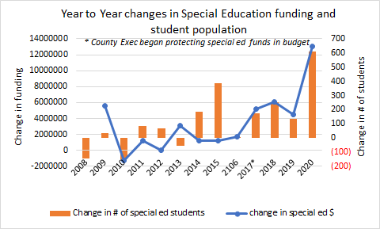

This next graph illustrates the quantitative view of Year to Year changes in Special Education Funding and Student Population.

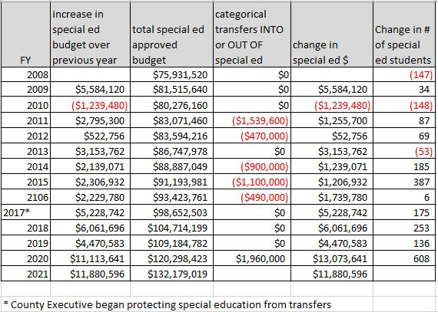

While there was significant growth in the number of students served in special education, there were some years where the budget did not follow the trend. The budget shortfall beginning in 2014 proved difficult for the county to recover from. The Department of Special Education (DSE) has used reliable data to determine the staffing ratio, or the number of teachers, paraeducators, and student assistants that are necessary for FY21. This staffing plan is required by COMAR (Code of Maryland Regulations). This is not an aspiration – this is an obligation that our school system must provide. Because of the lack of funding for those years, the staffing formula did not meet the needs of students. We are still not at a level needed to fully staff special education according to the current staffing formula.

We asked ourselves what it meant to not fund special education for a period of time. There has been no qualitative data collected that demonstrated the negative impacts that no funding had on classrooms and students other than what individual parents report. However, Maryland has safeguards in place to protect the rights of parents and their children. When there are problems with the IEP process and implementation, parents are supported through a hierarchy of resolutions. First, they go through their IEP teams, then school systems, compliance, mediation, state complaints, then several dispute resolution processes. Staff investigate and resolve formal State Complaints that allege a school was in violation of State and Federal IDEA requirements. Parents have up to one calendar year to lodge a State Complaint in their county if they feel their child’s IEP or IFSP has been violated or not followed. The reasons are numerous, but as an example, parents can allege that speech services were taken away due to lack of qualified staff, or access to assistive technology did not take place due to being told the school cannot purchase a device. The State keeps track of every county’s filing of a State Complaint. Below is a graph representing Howard County’s filing of State Complaints from SY 2013-2019.

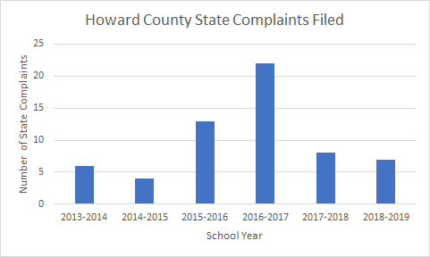

Recall the Year to Year changes in Special Education Funding and Student Population graph. The special education budget was cut in 2014-2016. It can be correlated that the very next school year, parents felt like their child’s IEP was not being implemented. Again, the reasons are numerous, but the coincidence of State Complaints skyrocketing after not receiving financial support is telling. Once funding was restored in 2017 did we see a drop in complaints.

Another concern with the budget lies with an increasing number of students with complex needs. If a student has severe Autism, for example, some supports she might need are a paraprofessional to monitor behavior interventions and elopement, or adult support to help remind her to use her assistive technology device for communication. Those supports are a lot more hands on than an occupational therapy consult done every quarter. With a rising demand in severe, complex student needs, comes the demand for additional support staff. In the graph below, we see an increase in Autism and Specific Learning Disability (SLD). SLD utilizes a variety of supports including different and/or multiple reading interventions, appropriate technology, and trained personnel including reading specialists, special educators and speech-language pathologists.
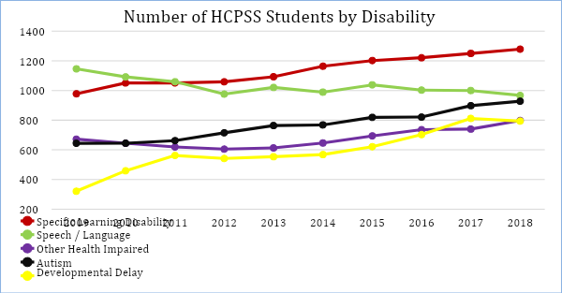

To continue the number of HCPSS students by disability is the following graph which shows a climbing number of emotional disabilities and multiple disabilities. These two categories also require more complex, hands-on adult support to monitor challenging behaviors.
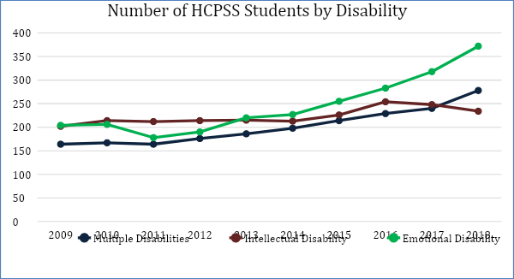

SECAC Priorities and Concerns
- Due to COVID-19, parents have had to become their child’s teacher. Not just any teacher, but a special educator, paraprofessional, speech therapist, occupational therapist, and other support staff. Parents not only feel the strain of this undertaking, but also noted the lack of progress their child has made during the time of school closure. They have seen their child regress. Parents have worked together with their IEP teams to help monitor such regression and loss in skills. However, parents also know that they may ask the school team for compensatory services. Compensatory services can be provided by schools if the IEP team determines there was a negative impact on the student due to the loss of their Free Appropriate Public Education. Under the IDEA, the Local School System “is responsible for providing a student with a Free Appropriate Public Education (FAPE). 1 During this period of extended school closure and re-opening, the FAPE obligation includes: (1) reviewing the appropriateness of the IEP in effect when a change in service delivery model occurs or when student progress monitoring indicates a lack of progress, AND (2) addressing the need for compensatory education/recovery services if there is a loss of FAPE.” School systems, through no fault of their own during school closure, still have an obligation to provide a student with a FAPE and the student may be entitled to remedial services. We anticipate many students will require compensatory services once schools are opened. This may stretch an already tight budget in needing more support staff, teachers, tools and devices, and evaluations.
- SECAC supports the continued professional development of teachers and educational staff working with diverse learners to ensure an equitable education.
a) Howard County began screening kindergarteners this past spring by reading
specialists. Some reading specialists were unable to provide their services during
this time period due to the high number of students. One of the next steps is to
train all elementary general educators, speech language pathologists, and special
educators in the science of reading. A second step is to train secondary general
education teachers in the lingering reading problems children identified with SLD
(Dyslexia, Dysgraphia in particular) have, how Executive Functioning skills
interact with Dyslexia, and the comorbidity between other disabilities such as
ADHD.
b) Appropriate behavior and safety training for all applicable staff particularly a
safety care class completed by those who work in self-contained classes and/or
with our most vulnerable students who display behaviors. Educating staff
members on how to de-escalate a situation and know how to provide proper
restraints are imperative for the safety of our students as well as staff members.
c) Disabilities do not discriminate based on race, religion, socio-economic status,
nor sexual preference or identity. The Diversity, Equity, and Inclusion department
has provided Cultural Proficiency Training to HCPSS staff which is not specific
to any one group but looks at all cultures. The training is provided in three levels;
awareness/implicit bias, action, and facilitation. But the training is not mandatory
and therefore not seen district-wide. Such training might help in understanding effects of disproportionality and attempt to provide resolutions to this problem.
3) Concerns have arisen over lack of substitutes and the need for additional funding in this
area. Teachers and paraeducators miss instruction time due to various reasons, one being
professional development, yet paraeducators are left without designated substitutes which
leaves teachers without support. Long-term substitutes, primarily those in classes with a
high concentration of special education students, are still responsible for specialized
instruction and therefore need to be certified and highly-qualified.
4) SECAC is concerned about schools having the appropriate staffing to support students
with disabilities due to the redistricting process. An open dialogue between incoming
families and the school’s staff and administration ensures the student will be supported.
We look forward to hearing from the BOE and Department of Special Education on how
redistricting has/ will affect students with IEPs.
5) Multiple Intense Needs Classes (MINC) serves toddlers and preschoolers who have
moderate to severe needs in engagement, independence, communication, and social
interaction. These low ratio classes with a high level of adult support are located in
Regional Early Childhood Centers throughout Howard County. Early intervention is the
key to success in special education. It primes young learners for kindergarten readiness.
MINC services our youngest children with severe disabilities through a 4 hour, 4 day a
week program with a ratio of 3:8:8 staff: student with IEPs: student without IEPs. We just
learned less than a week ago that parents received notice that this program would
decrease hours from 4 hours to 2.5 hours. Due to a decrease in this coming budget and
lowering the class size to meet COVID-19 concerns, these hours will take into effect in
the fall. Naturally, parents of this population were extremely disappointed to see hours
decreased in an already fragile population who depend on positive social interactions
with peers and adults. Parents are concerned that their children’s needs will not be met in
a 2.5 hour program and will see a regression of skills. We are concerned for the long
term implications that reduced hours will have on these children (due to the recent
timeliness of the concern, numbers of participants in the program are not known yet, but
can be produced if so interested).
6) One of the responsibilities of SECAC is to advocate for our Howard County families.
Parents have come to us with their educational documents and concerns for their child’s
special education. Our priorities for the coming school year will be around these parental
concerns. The top concerns are (in order of importance): specific learning disabilities (specifically in reading and dyslexia), understanding the IEP process, student’s challenging behaviors, transition over the age of 14, 504 plans, eligibility, home and hospital, transportation, and cooperation within IEP teams. These categories had numbers of parents less than two: ADA discrimination, inclusion, speech services, nonpublic placement, and mental health. Based on this data, we will offer more informational sessions and presentations on those topics and inform the Department of Special Education of these results so we can work together to facilitate these concerns.

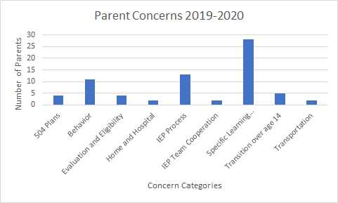

Individuals with Disabilities Education Act. Retrieved from https://sites.ed.gov/idea/about-idea/
Individuals with Disabilities Education Act. Retrieved from https://sites.ed.gov/idea/about-idea/
Table 1. Maryland Early Intervention Special Education Services Census Data and Related Tables. October 1, 2019.
Ibid., Table 1
Ibid., Table 2
Ibid., Table 8
Table 10. Maryland Early Intervention Special Education Services Census Data and Related Tables. October 1, 2019.
Key Definitions of IDEA. Retrieved from https://www.parentcenterhub.org/fapebrief-ref-list-lre/
Ibid.
Board of Education Adopts FY 2021 Operating Budget. 2020. Retrieved from https://news.hcpss.org/news-posts/2020/06/board-of-education-adopts-fy-2021-operating-and-capital-budgets/#:~:text=With%20the%20adoption%20of%20the,support%20ages%20birth%20through%2021.
HCPSS Operating Budget, Multiple Years. Retrieved from https://www.hcpss.org/about-us/budgets/fy20/
Table 1. Maryland Early Intervention Special Education Services Census Data and Related Tables. October 1, 2019. Multiple Years.
State Complaint Letters of Finding. Retrieved from http://marylandpublicschools.org/programs/Pages/Special-Education/FSDR/index.aspx
Table 2. Maryland Early Intervention Special Education Services Census Data and Related Tables. October 1, 2019.
Ibid.
Recovery Efforts: Addressing the Provision of FAPE through Alternative Service Delivery Models for Students with Disabilities during the Re-Opening of Schools. MSDE Technical Assistance Bulletin. 2020.

