Special Education Citizens Advisory Committee

Annual June 2019 Report to the Howard County Board of Education

**SECAC Statement of Purpose:**

The Code of Maryland Regulations (COMAR 13A.05.02.13I) requires the following for a Special Education Citizens Advisory Committee (SECAC):

(1) Each local school system shall establish a special education citizens advisory committee to advise the local school system on the needs of students with disabilities within the jurisdiction.

(2) The Department shall annually allocate federal funds to each local school system to support the activities of the local special education citizen advisory committee.

(3) Each local school system shall submit a budget for the use of federal funds, consistent with §C(1)(a) of this regulation.

Each SECAC is given a grant of $2,500 each year to support such activities. SECAC has used funding this year primarily to support speakers and educational sessions for parents during the SECAC Parent Forum Event to learn more about the process and laws of Special education, guardianship, sibling engagement, reading interventions, etc. SECAC funds were also used towards the printing of SECAC Awards and programs for our events.

**Background Information**

The Individuals with Disabilities Education Act states:

“Almost 30 years of research and experience has demonstrated that the education of children with disabilities can be made more effective by strengthening the role and responsibility of parents and ensuring that families of such children have meaningful opportunities to participate in the education of their children at school and at home.”

The recent Supreme Court case in 2017, Endrew F Vs. Douglas County School District: A Case for Full Inclusion put to test that public schools must provide each student with a disability a free and appropriate public education (FAPE) in the least restrictive environment (LRE) 20 U.S.C.1412 (a)(1)(A) and 1412 (a)(5)(A). This case has changed judges verdicts across the country and students with disabilities to no longer just have an “open door to public education” and “some educational benefit” ( per Rowley case) but instead are entitled to and deserve more than de minimis education. Now, after the unanimous ruling of the Supreme Court in Endrew F, we have a standard that establishes a “markedly more demanding standard for what determines an “appropriate” education, requiring an ambitious educational program that provides challenging objectives and be reasonably calculated to enable the student to make progress appropriate in light of their unique circumstances”.

Furthermore, it is important to note and remember that the Supreme Court’s declaration in Brown Vs. BOE was that educational opportunity “is a right which must be made available to all on equal terms”, the stated purpose of the IDEA is to “ensure equality of {educational} opportunity….for individuals with disabilities” Id. 1401 (c)(1).

**CALL TO ACTION….**

During FY2020 Budget work sessions, Central Office staff justified the large increase in special education teachers and assistants by stating that special education has been “falling further and further behind.” Recognizing the moral obligation to educate students with disabilities, there was a common response that HCPSS was not truly meeting the needs of many students in special education. However, following the Board’s proposed budget, the Superintendent’s budget summary “Call to Action”, special education funding fell to the category of programs that were “beyond our obligations”. And, in the end, the approved budget has very little increases in special education staff.

SECAC is encouraged by the efforts and desire of leadership staff of the Dept of Special Education and Central Office to do the work necessary to close the educational gap for students with disabilities and are working to improve the outcomes for these students albeit with less budget than is needed. We thank the DSE, the Superintendent and his leadership staff as well as many BOE members who are champions of students with disabilities. While there are many students with disabilities thriving in HCPSS, the focus of this report is the list of items where, working together, we can address areas for student improvement and staff success in the classroom.

Since 2017, SECAC has continued to bring forward many needs identified by hundreds of hours of community and HCPSS leadership input into the HCPSS Special Education Strategic Plan. This plan, at the time, captured identified needs and wants of students with disabilities by community members, staff, advocates, parents and students. Many of these “asks” remain un-remediated to date and SECAC has added some additional needs to the list.

**Previously identified needs that remain**:

**#1** **Priority: Budget**

In the March 2020 FY budget request, the Superintendent requested $5.8 million for 144.7 Special Education positions to support student growth and program/placement needs from Birth-age 21, to “begin to raise the level of services provided and ensure equity and consistency throughout the system” ( Mavis Ellis letter in Executive Summary, page 4). Some points to consider as the budget relates to special education:

**Enrollment Data Graphs ( power point)**

The anticipated student growth in FY 2020 for special ed is up to an estimated 20% of the total student growth potential. The 9-10% “usual” growth of students with special needs entering the county public school system has been surpassed in the last few years. Autism rates are also on the rise in MD and across the nation( Data from HCAS Education Committee Chair).

|  |  |  |  |  |
| --- | --- | --- | --- | --- |
| Autism Incidence | 2012 | 2014 | 2016 | 2018 |
| US | 1 in 88 | 1 in 68 | 1 in 68 | 1 in 59 |
| MD | 1 in 80 |  | 1 in 55 | 1 in 50 |

|  |  |  |  |  |  |  |  |  |  |  |
| --- | --- | --- | --- | --- | --- | --- | --- | --- | --- | --- |
| **2018 PARCC Proficient (Level 4 and 5) Results for ELA grade 4** | | | |  |  |  |  |  |  |  |
|  | **SWD** | **SWD-Male** | **SWD-Female** | **FARMS** | **Non-FARMS** | **504** | **EL** |  |  |  |
| All Students | 15.20% | 16% | 13.70% | 29.90% |  | 48.80% | 14.60% |  |  |  |
| African American | 8% | 10.20% | 5% | 27.30% | 39.70% | 25% | 26.10% |  |  |  |
| Asian | 16.70% | 20% | 9.10% | 53.80% | 76.60% | 47.10% | 21% |  |  |  |
| Hispanic | 6.30% | 5% | 10.50% | 23% | 36.50% | 25% | 8.20% |  |  |  |
| White | 22.10% | 21.70% | 22.60% | 31.30% | 70.60% | 60.50% | 16.70% |  |  |  |
| Male |  |  |  | 24.70% |  | 48.30% | 12% |  |  |  |
| Female |  |  |  | 35.50% |  | 50% | 17.50% |  |  |  |

* The achievement gap for students in special education is 19.5% in elementary school, 22.9% in middle school, and 33.5% in high school, higher than many similarly general education achieving districts (source: FY2018 MSDE report card).

Achievement Gap (as defined by MSDE) and Special Education as % of enrollment, per County

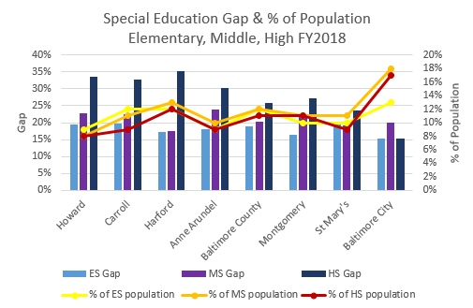

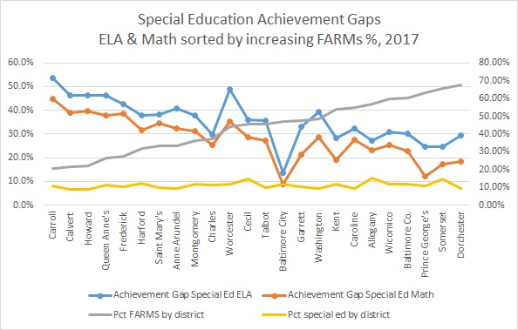

Students with Disabilities vs. All Proficiency in ELA and Math PARCC, Grade 3

Grade 3

Grade 6

High School

Unfortunately, the budget funding shortfalls do not allow for many new teaching positions in Howard County and important and necessary para positions have been cut. By removing desk side supports that help to close achievement gaps for vulnerable students, the risk of more intense educational remediation, discipline, deteriorating behaviors, and regression will occur as adequate supports are no longer readily available. Classroom teachers will work with less resources overall, less supplies, less access to professional development, less technology and equipment causing students to potentially be negatively impacted with their ability to make educational progress and be successful learners and future Howard County citizens.

Overall, due to budget constriction and very little opportunity for new highly qualified staff in our classrooms, SECAC has concerns about the risk to students in increasing the achievement gap, school to prison pipeline, inability to access standard based curriculum and less academic rigor for students with disabilities.

Juvenile Arrest and Collateral Education Damage in the Transition to Adulthood. 86 Sociology of Education 36 (2013) https://www.ncbi.nlm.nih.gov/pubmed/25309003

**#2 Priority: Staffing**

SECAC is concerned about the distribution of staff and the cuts to the paraprofessional workforce in our schools. A look at trends over the last several years shows an increase in the ratio of school-based special ed students to special ed teachers, while the ratio of general ed students to teachers has remained relatively flat. This is true even with the increases in teachers in the last couple of approved operating budgets.

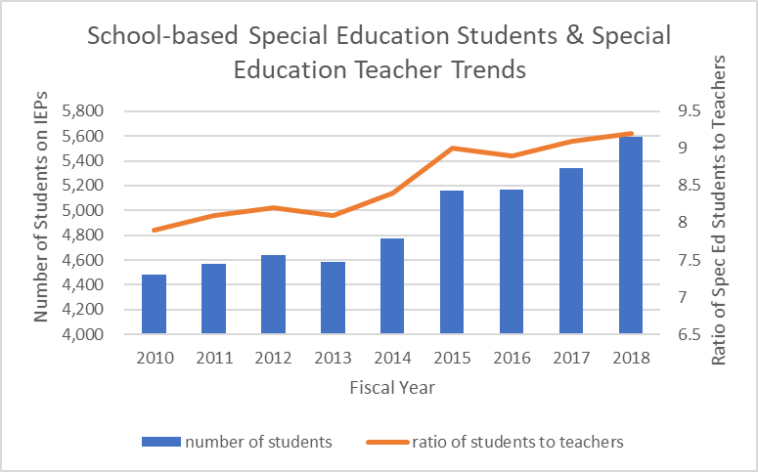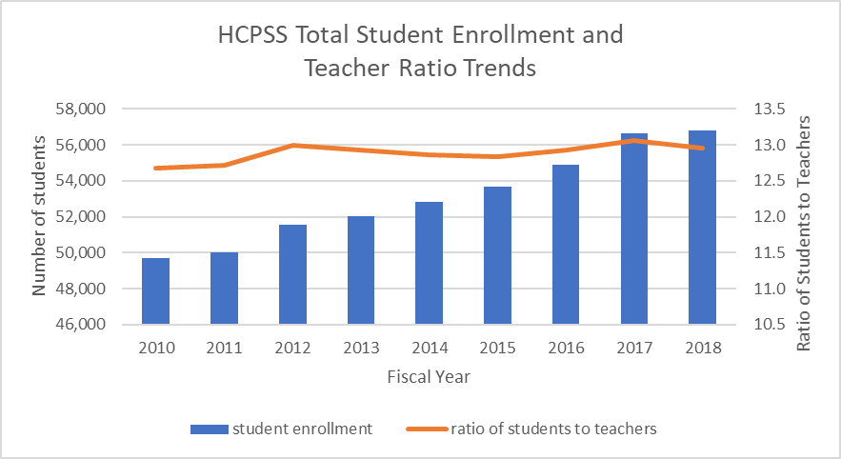

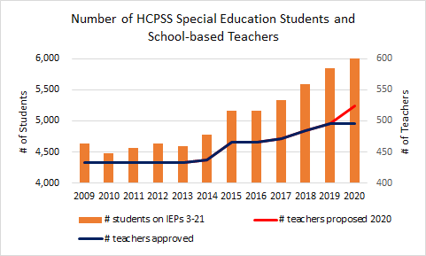

The development of a more effective special education staffing formula should be considered in the future, one that accounts for the severity of students needs by assessing such variables as (1) student minutes per week, (2) instruction minutes per week, and (3) the number of lEPs for which a teacher is responsible to manage or coordinate and (4) behavioral needs in the classroom. There should also be a limit on the number of students on IEPs per class.

**#3 Priority: Behavioral Support/Education for staff**

Behavioral Support: Behavior training and safety care classes should be mandatory for all staff working in segregated classrooms. Atypical behavior is the main reason for the segregation of students with disabilities. An MPIA this year brought to light the lack of staff appropriately trained in safety care putting students and staff at risk for injuries. Staff and student safety must be a priority in our schools. Maladaptive behaviors need to be managed by teachers, SAs, paras and bus drivers successfully to minimize injury. Additionally, HCPSS should consider intense yearly professional development in strategies to deescalate and manage behaviors in the classroom. Coordinated efforts between Behavioral Specialists and BCBAs are necessary to create appropriate Functional Behavioral Assessments (FBAs) and Behavioral Intervention Plans (BIPs). Parents are concerned FBAs/BIPs are done often times by school psychologists who do not have specialized formal training and education on the function of behavior and therefore create BIPs that are inappropriate.

**#4 Priority: Reading Crisis/ Closing the Reading Achievement Gap**

SECAC is aware of educators who have completed Orton Gillingham and Wilson. Teachers with these skills should be able to use these techniques to teach our students how to read. Best practices in reading and math need highly trained staff who understand individual student needs and can differentiate instruction styles to meet the needs of all students in their classrooms. SECAC requests that the “fierce urgency of now” be followed in this area as well as all the recommendations in the new law HB690/SB734 Ready to Read Act in MD. This bill also includes the need to create and utilize an evidenced based universal screener to be completed by teachers for students Pre-k to first grade to identify reading difficulties in pre and early literacy skills. By using evidenced based instruction that is explicit, systematic, and intentional in phonological awareness, phonics decoding, vocabulary, language structure, reading fluency and reading comprehension as laid out by ESSA, Literacy for All (section 2221), can truly be literacy for all!

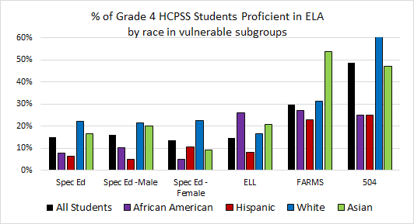

**Additional Priorities/Needs:**

**Social-Emotional Learning:** We are recommending an increase in focus on social/emotional learning for special education students using an evidenced based curriculum. We are grateful for the implementation of content around this issue in some of our elementary schools but believe all students system wide would benefit from the understanding and ability to practice self awareness, self regulation, manage emotions and body movements in time of stress, understanding social cues, identify strengths and skills in oneself and peers, etc.

**Disability awareness embedded in K-12 curriculum:** While we applaud HCPSS’ efforts to comply with the law surround Least Restrictive Environment, there continues to be a lack of empathy, from student to student (sometimes rising to the level of harassment and bullying) and teacher to student. Injuries and incidents related to a lack of understanding of disability leave HCPSS exposed to liability. A fully vetted disability awareness curriculum should be the gold-standard on how to educate all students, and is critical as more and more children with disabilities are rightfully taking part in all aspects of the school day. Restorative circles and practice models do not solely meet the needs of disability awareness and sensitivity training for students and staff.

**Transition Planning**: Transition coordinators and Central Office staff need to improve advocacy and the use of evidenced based Transition tools to identify individual strengths and desires of students in special education. Enclave options are limited and not an appropriate placement for all students. Transition planning and preference checks should start at age 14 to identify student desires for future education, work/volunteer in the community, work likes and dislikes, physical access needs in a workplace and living in the community. Linking students with disabilities to community based internships/ volunteer opportunities through our business partners committee may be one option to consider. Additional on the job training considerations should be sought out by HCPSS Transition team. Historically, people with disabilities who work in our communities make sub-minimum wage and HCPSS should look to help our transitioning youth reduce barriers to employment and help students in the advancement of equal employment opportunities.

**Assistive Technology**: There continues to be a perception among parents that the use of devices as educational tools for students with disabilities is being minimized. We are asking for the DSE to create opportunities to use educational apps while in the classroom, provide instruction and suggestions for use of apps at home and over the summer to engage student learning and proficiency on these tools/devices. Parents have also noted that devices that house speech and language software like Touchchat are not being updated routinely and teacher and para training is not occurring routinely to support student need and work efforts in the classroom. Please assess device training needs for all staff as soon as possible.

**IEP Compliance:** One of the significant recommendations out of the IEP compliance workgroup under the Special Education Strategic Plan was to split the duties for IEP Compliance and Nonpublic Placement. Each of these two functions require a full-time staff member to adequately manage the processes. Very little compliance data currently exists and is not being tracked. The data presented to the state each year has little value to determine true compliance as it relates to student outcomes. SECAC believes that increased data monitoring will assist in better service delivery and potentially decrease costly nonpublic placements.

HCPSS should designate a staff member dedicated to IEP compliance – someone who knows the law and can perform spot audits – not simply for the items that must be reported to MSDE, but true compliance with individual IEP goals and data collection, supplementary aids and services, etc.

**Continuum of Services:** The overwhelming perception of our members is that there is a general lack of services and/or programs for students with disabilities in HCPSS. While there are preschool and early elementary autism programs, there is a significant gap for later elementary and middle school students. Not every student with a disability who needs additional supports fits within the Emotional Disability or Academic Life Skills regional programs. SECAC is aware of new pilot programs in MS for students with Autism and looks forward to the sharing of data with the community about the student outcomes and evaluation of this program.

SECAC has recommended in the past and still requests further consideration of courses that are taught at a slower pace, as well as reading and math interventions, all of which are essential for students with disabilities. SECAC members have expressed concern over the push for more GT, AP, and other advanced courses and the removal of on-grade level, below grade-level, and review courses designed to meet the needs of certain students who need more time on task. Additionally, twice gifted students and students with IEPs who are enrolled in GT/AP courses may need additional classroom supports and this should be provided to ensure FAPE for these students. HCPSS should immediately stop the practice of allowing a school to elect to not providing any supports to students with disabilities enrolled in GT, AP, or Honors classes.

**Best Practices:** Some of our members speak very highly of programs, services, and expertise at their children’s schools. Some schools have developed their own “grass roots” programs that can and should be shared with the entire district. Educators who have developed expertise in certain areas should share their training, programs, and/or ideas with the DSE to be provided to all schools. The Superintendent shared that certain staff have expertise in scheduling students to limit the maximum number of students on IEPs in a single class. This expertise should be shared prior to next school year across all schools to increase the possibility of meeting the needs of all students. HCPSS has staff with untapped “goodness” and ideas being utilized in certain schools and not offered in others. We believe that Community Superintendents and Performance Directors are aware of much of this and can help in creating best practice models across all schools.

**Better Communication of student needs/ Progress in the Classroom:**This year, SECAC has spent the majority of our meeting time and events to help parents/guardians understand the IEP process and assist parents in advocating for their needs with school teams and staff. It was brought to our attention that informal consults are being done by Autism specialists, behavioral specialists and other related services without the knowledge of parents. When school staff ask for assistance to help manage a student’s educational need in the classroom, especially if this service/discipline continues to see the student routinely throughout the year, parents are requesting information about how this provider is assisting the student in the classroom.

Class work and other progress monitoring efforts should be done with parent knowledge. This includes logs of service hours and related service providers documentation with students as per the IEP. Parents are not kept abreast on an ongoing basis about what the service providers are doing and whether or not certain interventions are working prior to the quarterly progress report. Parents want and need to hear more from providers and teachers about what is working and what is not working in the classroom in order to have meaningful participation in a student’s educational process.

**Data Collection/Report Card Info:** The SECAC community is requesting transparent information on ongoing identification of students with disabilities who are minorities, disability category, school, FARM status, gender, age. A transparent review of students being placed in nonpublic schools to include disability, age, race, gender, sending school is also of interest to SECAC.

Data is an essential part of providing services to students with special needs in a manner that allows them to make educational progress. It is used by the IEP team to determine if the student is making progress towards his/her goals. IEP goals need to be measurable and data should be monitored often and transparently so parents understand progress in strategies/modalities used. Data sharing is extremely important so parents can understand what is happening with their student’s learning trajectory. SECAC continues to hear there is a lack of willingness to share data in a timely transparent manner.

**Disproportionality/Discipline**: People with special needs have been discriminated against for decades and continue to be today. Students with special needs cross all races, gender, disability status, age and other characteristics. The disproportionate representation, discipline, and eligibility identification of students of color is an urgent problem in special education across our nation. Implicit bias is one reason contributing to disproportionality and over representation in special education. This subject matter is a concern of SECAC. Research shows that signs and symptoms of disabilities predispose individuals to negative implicit biases and negative stereotypes. We appreciate the recent transparency over the last two school years on data and the engaging discussions on this important topic. SECAC appreciates the work of the leadership team within HCPSS and through the Office of Diversity, Equity and Inclusion to help staff and community members identify and work through biases that impact all students of color in our district. SECAC will continue to engage in conversation and hopes to continue to be included in committees and work groups around equity, biases and potential over representation of students of color in special education.

**Continued ongoing needs for Students with Disabilities and Recommendations from SECAC**

**ESY:** Enhance ESY programs with more Behavioral Specialists and qualified staff and consider extending the program for 6 weeks so “students will not suffer a regression of critical life skills caused by the normal break or fail to recover skills in a reasonable time”. Provide a budget that supports the individualized needs for these students in ESY as needs continue to rise and budget supports continue to fall. Parents expect services in ESY that mimic the school year offering to ensure that students with disabilities keep a strong foundation of skills as to not show regression when school starts in September.

**Observation Policy**: Parents should have the right to observe areas where students would be educated in a more restrictive environment within HCPSS schools and in nonpublic placements. We recognize that non-publics have their own observation policies but we expect that HCPSS would facilitate observations in schools where students may be placed.

**Emergency and Evacuation Planning:** Emergency and Evacuation Planning is part of the IEP and 504 process for students with disabilities. HCPSS does not have a progressive or comprehensive team approach to assess the needs and risks of these students in case of a fire, extended shelter in place situation, active shooter or natural disaster. Poor emergency and evacuation planning puts students, staff and HCPSS at risk for litigation, life threatening issues and even death. An All-Hazard approach to emergency planning for students with disabilities is more important in today’s climate than ever before. Students who cannot make independent safe decisions at the time of an emergency need an individualized written plan that all staff are aware of and know how to implement.

To date, HCPSS has not installed or trained staff on Med Sleds purchased to facilitate the movement of physically challenged students or staff out of buildings in a fire or other emergency. HB 1060 in 2017 was signed into law and became effective July 1, 2018. HCPSS is not meeting the guideline of the law to provide an accommodation at the time of an emergency. Leaving people with disabilities on stairwell landings is still the current process in HCPSS and this is against the intent of the law to evacuate all people at the same time.

SECAC would also recommend a district wide Safety Committee be created in collaboration with police, fire and EMS personnel, parents, school safety advocates, and staff to understand and give input into an all hazard safety and emergency planning process for students and staff while in school buildings.

Access to school buildings and facilities should be formally assessed to ensure ADA compliance is being followed. Single entry access into school buildings has caused hardship for students who use wheelchairs and walkers as they may not be able to gain access into schools without an auto-operated door. It is imperative for all students to equally access entrances and exits. This concern has been brought to the attention of HCPSS Safety and Security Director.

**Trauma-Informed training:** The Kirwin Commission has identified recommendations to help districts better prepare teachers and all district staff on the topic of acute childhood experiences (ACEs) and the need for appropriate and evidenced based trauma informed learning approaches. We are hopeful that the current practice of training for our staff in HCPSS coupled with new recommendations and evidenced based models will enhance teacher understanding of children’s needs who have trauma histories in their lives. Students with disabilities have a higher rate of trauma incidences, more sexual abuse incidents, increase risk of overall abuse and have a marked inability to communicate these events to parents, teachers and other providers.

https://traumaticstressinstitute.org/wp-content/uploads/2011/10/Trauma_and_Developmental_DisabilitiesF.pdf

*Thank you for your dedication to the needs of children receiving special education services. SECAC looks forward to a collaborative relationship with the Board of Education and Department of Special Education.*

*Howard County Special Education Citizens Advisory Committee (SECAC)*