Special Education Citizens Advisory Committee
2nd Annual Winter Report to the Howard County Board of Education
And Priorities List

SECAC Statement of Purpose:
The Code of Maryland Regulations (COMAR 13A.05.02.13I) requires the following for a Special Education Citizens Advisory Committee (SECAC):
(1) Each local school system shall establish a special education citizens advisory committee to advise the local school system on the needs of students with disabilities within the jurisdiction.
(2) The Department shall annually allocate federal funds to each local school system to support the activities of the local special education citizen advisory committee.
(3) Each local school system shall submit a budget for the use of federal funds, consistent with §C(1)(a) of this regulation.

Each SECAC is given a grant of $2,500 each year to support such activities. SECAC has used this funding in the recent past for the SECAC Recognition of Howard County Public School System (HCPSS) staff and contractors and for training courses for parents and staff.
Background:
The Individuals with Disabilities Education Act states:
“Almost 30 years of research and experience has demonstrated that the education of children with disabilities can be made more effective by-- strengthening the role and responsibility of parents and ensuring that families of such children have meaningful opportunities to participate in the education of their children at school and at home.”
SECAC is encouraged by the attention to including the voices of parents and students in special education by the Board of Education, Interim Superintendent, and the Department of Special Education. We look forward to a continued cooperative relationship between parents, staff and Board members in the interest of improving the outcomes for students with disabilities. While there are many students with disabilities thriving in HCPSS, the focus of this report is the list of items where, working together, we can address areas for improvement. To that end, we will begin with the status of the areas that SECAC outlined in our 2017 report.
- Items from the 2017 report to the Board of Education that have been implemented:
- Hiring Board Certified Behavior Analysts (BCBA) to perform Functional Behavior Assessments and to develop Behavior Intervention Plans. (Side note – more BCBAs are needed to address the increasing behavioral needs of students and to train staff to properly identify antecedents to avoid negative behaviors.)
- Hire attorneys for the school system who are willing to mediate and come to resolution meetings willing to compromise and work together in the best interest of students. To that end, SECAC believes that the best model for special education legal services is in-house general counsel who have no financial incentive to take families to due process. We appreciate the initial response by General Counsel to settle disputes. However, in 2010 HCPSS hired an in-house special education attorney with knowledge of the Individuals with Disabilities Education Act. Staff has predominantly been trained on legal issues in special education by outside attorneys. We believe a better model is in-house expertise on special education law.

- Items from the 2017 SECAC report to the Board of Education identified in the HCPSS Special Education Strategic Plan:
- Development of a more effective staffing formula be considered in the future, one that accounts for the severity of students needs by assessing such variables as (1) student minutes per week, (2) instruction minutes per week, and (3) the number of lEPs for which a teacher is responsible to manage or coordinate. There should also be a limit on the number of students on IEPs per class.
- HCPSS designate a staff member dedicated to IEP compliance – someone who knows the law and can perform spot audits – not simply for the items that they must report to MSDE, but true compliance with individual IEP goals and data collection, supplementary aids and services, etc.
- Behavior training becomes a priority for all staff – general educators, special educators, student assistants, bus drivers, etc. Additionally, HCPSS should consider using Board Certified Behavior Analysts (BCBAs) to provide behavior training.
- Increase in focus on social/emotional supports for special education students. A long-term goal of SECAC is to have BCBAs providing training to all educators (general ed, special ed, and paras).
- Better collaboration between the school system and families during the CEPT process.
- The expansion of the UL program to 4th grade in FY2018 and 5th grade in FY2019.
- A thorough review of school level programs and expertise in place to identify and provide best practices within HCPSS.

- Items from the 2017 SECAC report to the Board of Education that still need to be addressed:
- A study to work towards the implementation of an online system to demonstrate compliance with IEP hours, which parents should be able to check daily or weekly.
- A gap analysis of current staff training at all levels.
- On-grade-level and review courses designed at a slower pace be reinstated in the curriculum.
- Work/study coordinators better advocate for the individual needs of students for whom the Enclave program is not an appropriate placement. They need to improve their efforts to assist parents in finding placements that fit students’ needs and interests, and fulfill the IEP requirements listed on the Transition page starting at age 14.
- A baseline for the minimum allowable below grade spread should be determined with input from the community. Parents should be included in work groups tasked with investigating and implementing best practices.
- ESY be reinstated to its previous 6-week length with full days and trained staff in FY2018.
- There is a push in HCPSS, real or perceived, to remove students with disabilities from the diploma track due to the unavailability of appropriate instruction for their speed and style of learning. SECAC requests a formal workgroup of teachers, administrators and parent stakeholders be convened to discuss and determine best practices to deal with this pressing issue. As recommend in the DMC audit report, extra time for mastery of subjects is requested as well.
- A formal policy on parent, parent advocate, or other professional’s observations of programs when there are discussions on the IEP team for changing a student’s placement within HCPSS.
- A formal policy on sharing student data with parents (and their professional support, if requested), especially as it relates to proof of student progress. SECAC also requests the DSE share requested data in an honest, timely, and collaborative manner.
- Trauma-informed training for staff.

- Additional items to be addressed that are not in the 2017 SECAC report, nor the strategic plan:
- Assistive technology investigation, gap analysis (equipment, staff, training)
- Reinstitution of high school math resource classes. Training for special educators providing reading interventions to students at all levels with a priority on elementary school.
- A study of the demographics of students on IEPs and 504 Plans to determine equity.
- A study of students being placed in nonpublic schools to include disability, age, race, gender, sending school, etc.
#1 Priority – Staffing
SECAC appreciates the increased staffing priorities in the FY2018 and FY2019 budgets, but the level of training and distribution of staff are concerning to parents. The FY2018 budget listed 41.1 additional staff to special education. However, with 320 expected additional K-12 students with disabilities, 12 special education school-based teachers were added for a 26.7 ratio of new students to new teachers. The FY2019 budget has a similarly high ratio of additional special ed students to special ed teachers with a ratio of 33.6 students to teachers (471 expected increase in k-12 students with an increase of 14 school-based teachers). A look at trends over the last several years shows an increase in the ratio of school-based special ed students to special ed teachers, while the ratio of general ed students to teachers has remained relatively flat. This is true even with the increases in teachers in the last couple of approved operating budgets.
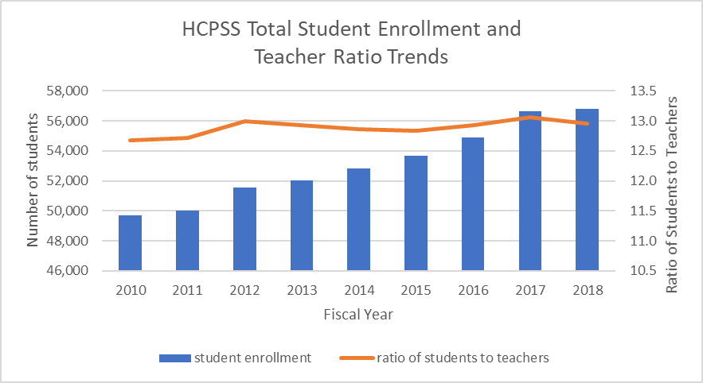
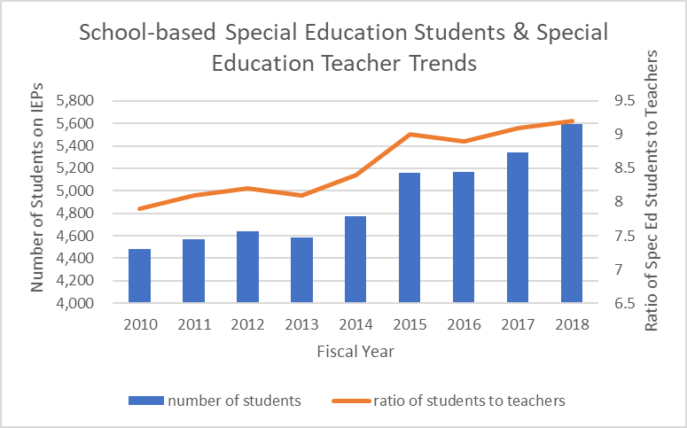

IEP Compliance
One of the significant recommendations out of the IEP compliance workgroup under the Special Education Strategic Plan was to split the duties for IEP Compliance and Nonpublic Placement. Each of these two functions require a full-time staff member to adequately manage the processes. Very little compliance data currently exists and is not being tracked. The data presented to the state each year has little value to determine true compliance as it relates to student outcomes. SECAC believes that increased data monitoring will assist in better service delivery and potentially decrease costly nonpublic placements.
Continuum of Services
The overwhelming perception of our members is that there is a general lack of services and/or programs for students with disabilities in HCPSS. While there are preschool and early elementary autism programs, there is a significant gap for later elementary and middle school students. Not every student with a disability who needs additional supports fits within the Emotional Disability or Academic Life Skills regional programs.
SECAC and the Howard County Education Association (HCEA) are investigating the lack of “on grade level” courses that are taught at a slower pace, as well as reading and math interventions, all of which are essential for students with disabilities. SECAC members have expressed concern over the push for more GT, AP, and other advanced courses and the removal of on-grade level, below grade-level, and review courses designed to meet the needs of certain students who need more time on task.
Best Practices
Some of our members speak very highly of programs, services, and expertise at their children’s schools. Some schools have developed their own “grass roots” programs that can and should be shared with the entire district. Educators who have developed expertise in certain areas should share their training, programs, and/or ideas with the DSE to be provided to all schools. SECAC requests that the “fierce urgency of now” be followed in this area. Scheduling is ongoing for next year’s students and sharing expertise to streamline this process should not wait for another year of research in a strategic plan for a staffing formula. We can, and should, use in-house expertise now.
Better Communication of services to parents – more resources for parents
As discussed at the January 2018 SECAC monthly report to the Board of Education, there is a significant difference in liaison positions in HCPSS.
In the FY2019 Superintendent’s proposed budget:
- Academic Intervention (3501) - 21 Black Student Achievement Liaisons
$892,297 in salaries for 21 BSAP liaisons, $658,026 in workshop wages
- International Student Services (9501) - 18 Hispanic Student Achievement Liaisons & 9 International Student Liaisons
$1,495,044 in salaries for 27 liaisons, $148,425 in temporary help wages
- Special Education Parent Liaison
$133,722 in salary

Job description for Black Student Achievement Liaisons, Hispanic Student Achievement Liaisons, International Student Liaisons – total of 48 liaisons - include:
- Supports students and families
- Monitors student progress to ensure appropriate placement to accelerate academic achievement
- Monitors student behavior data to increase positive learning behaviors and ensure student achievement
- Educates the school community towards a deeper understanding of these students and their families
- Facilitates involvement of these families in the educational process
- Collaborates with nonprofits and government agencies to support these students and their families
- Conducts parent information meetings in collaboration with the Department of Special Ed and Curricular programs
Compared to the special education parent liaison:
- Instead of supporting students and families, supports communication between parents and district personnel.
- Instead of monitoring progress to ensure appropriate placement and accelerating academic achievement, assists parents with the understanding of progress reports.
- Instead of monitoring behavior data to increase positive behaviors and achievement, nothing about behavior.
- Instead of educating the school community, nothing about creating a better understanding of students with disabilities.
- Instead of facilitating family involvement, supports individual schools to increase family involvement.
- Instead of collaborating with nonprofits and agencies to support students, locates community resources.
- Instead of conducting parent information meetings in collaboration with DSE and Curricular programs, coordinates academic-based learning opportunities for parents.
Additional duties listed in the parent liaison job posting included responding to parent emails, providing information on the district’s procedures, assisting with an understanding of the law and IEP process.
Even the titles marginalize students with disabilities. SECAC would like to see more emphasis on student achievement for students with disabilities on IEPs and 504 Plans. Board members have discussed the idea of a Special Education Student Achievement liaison under each Community Superintendent. SECAC supports this role and would request the job description and funding be commensurate with the other student achievement liaisons. Not only has staff to student ratios increased in special education in the recent past, but budget transfers out of special education salaries has impacted the increasing achievement gap for students on IEPs.

Reinstatement of 6 weeks for ESY
HCPSS’s Extended School Year (ESY) for students with disabilities who qualify is intended to ensure that students will not “suffer a substantial regression of critical life skills caused by the normal school break and would fail to recover those lost skills in a reasonable time.” ESY has been reduced over the past several years, from 6 weeks to 5 weeks to its current 4 weeks. The standard summer break has been 10 weeks long and increases to 11 weeks because of the Governor’s hard stop at June 15. With ESY typically beginning one week after the close of school, a four-week ESY program would leave students with disabilities, whose regression is more significant than their nondisabled peers, with a potential break in services for a full 6 weeks. Montgomery County, for example, has both 4 week and 6 week ESY programs, “depending on the need of the student”.
SECAC also requests that ESY programs be staffed with appropriately trained special educators and related service providers, as well as staff trained in the use of augmentative and alternative communication and the appropriate research-based interventions for the students enrolled in ESY.

Finally, the summer programs for students with disabilities are less focused on achievement and have fewer budget dollars than similar programs for their nondisabled peers.
Special Education Summer Services FY2019 proposed budget - $651,285:
From the HCPSS Special Education website:
- The IEP Team should determine if there are factors that will significantly jeopardize the student's ability to receive some benefit from the student's educational program during the regular school year, if the student does not receive ESY services.
- In other words – without ESY the student will not make progress on his/her IEP in the coming school year.
Compared to FY2019 budget for other summer school programs:
- $1,063,063 Comprehensive Summer School Program (2401 in the FY2019 proposed budget) to “provide engaging content instruction and enrichment activities for kindergarten through high school students. Support high school students in achieving graduation requirements to graduate college and career ready.”
- $ 1,822,701 Academic Intervention (3501) “Beyond School Hours and Academic Intervention summer programs provide students who are academically underperforming, or at risk of underperforming, with small group interventions that lead to increased understanding and improved academic achievement.”

Lack of HCPSS Policy for School Observations
When HCPSS staff are not able to accommodate a student with a disability and recommend a more restrictive program, parents should have the right to observe the more restrictive program. As is the case with other processes and policies, there needs to be consistency across the school system. Thus, a formal policy must be developed and publicized related to school observations when a student is recommended for anything other than his home school in the general education classroom. The reality of individual denials of parent requests to observe the more restrictive program needs to be formally addressed.
Data Collection
Data is an essential part of providing services to students with special needs in a manner that allows them to make educational progress. It is used by the IEP team to determine if the student is making progress towards his/her goals.
There are three major problems related to data collection.
- There is an insufficiency of data being collected by many educators. When IEP goals are not measurable, progress data is either not useful or nonexistent. SECAC can recommend experts to train staff on writing and implementing measurable goals.
- There is an unwillingness of some IEP teams to provide data to parents. Some teams are completely unwilling to provide any data, data is only allowed to be reviewed in the school with staff member present, or data is requested weeks in advance and limited data is only provided the day of the IEP meeting. Data is also not accurately recorded by some and can result in a false determination of student progress.
- Data sharing between the HCPSS Department of Education and SECAC is crucial for a trusting and collaborative relationship that focuses on student achievement.
Emergency and Evacuation Planning
Emergency and Evacuation Planning is part of the IEP and 504 process for students with disabilities. HCPSS does not have a progressive or comprehensive team approach to assessing the needs and risks of these students in case of a fire, extended shelter in place situation, active shooter or natural disaster. Poor emergency and evacuation planning puts students, staff and HCPSS at risk for litigation, life threatening issues and even death. Emergency planning should include nurses, parents, students, EMS personnel, fire marshal's office, elected officials, disability organizations and stakeholders to ensure a comprehensive individualized plan for each student is created and documented as part of the student's educational file. Since the passing of House Bill 1060, Emergency and Evacuation Plans, HCPSS has not made a final decision on the purchase of assistive devices to assist those who are non-ambulatory exit a school building in an emergency. Since this law pertains to visitors and staff as well as students, a revision of the school system’s overall emergency operation plan must be completed.
Trauma-Informed training
The need for trauma-informed schools is long overdue, as many of our children are trying to cope daily to merely survive. Student trauma does not leave very much "brain space" to focus on being successful in school. “One in four students in the United States will witness or experience a traumatic event before the age of 4, and more than two-thirds by age 16." NEAToday Winter 2017:
http://www2.nea.org/mediafiles/flipbook/nea_today_17_winter/mobile/index.html#p=44
Teachers, administrators, guidance counselors, school psychologists, and paraeducators in HCPSS are uninformed about how to teach and help students who have been impacted by trauma. These students are often the students who teachers cannot seem to reach, no matter how hard they try. Through trauma-informed training, however, all school stakeholders can learn specific techniques that will allow them to reach these students, to take their brains from "Fight! Flee! Freeze!" to a state of mind that is calm, focused, and where the feeling of safety is reaffirmed.

Thank you for your dedication to the needs of children receiving special education services. SECAC looks forward to a collaborative relationship with the Board of Education and Department of Special Education.
Howard County Special Education Citizens Advisory Committee (SECAC)

