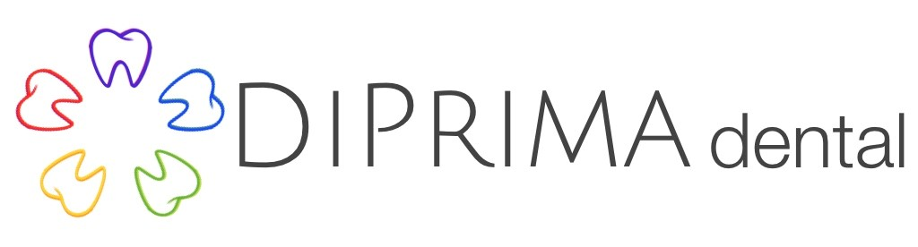

Dental History
(Please check any of the following that apply to you) What would you like to do to improve your smile?
❑ Sensitivity (hot, cold, sweets, pressure)  Whiten
❑ Discomfort when chewing    Straighten
❑ Headaches, earaches, neck pain  Close spaces
❑ Jaw joint pain  Replace silver fillings with tooth colored fillings
❑ Teeth or fillings breaking  Repair chipped teeth
❑ Bad breath/bad taste in mouth  Replace missing teeth
❑ Bleeding, swollen or irritated gums  Replace old crowns that don’t match other teeth
❑ Loose, chipped or shifting your mouth
❑ Grinding or clenching teeth

Do you have or have you ever had any of the following? How long has it been since your last cleaning?
❑ Dentures  Partial Dentures  Less than 1 yr  1-2 yrs  3-5 yrs  over 5 yrs
❑ Braces  Periodontal (gum) treatments

What is most important about your visit today? ____________________________________________________________________________

_____________________________________________________ ________________________________ _____________________________________
Name of previous dentist Phone number City & State

Why did you leave your previous dentist? ___________________________________________________________________________________

___________________________________________________________________________________________________________________________________

Previous dental experiences: __________________________________________________________________________________________________

On a scale of 1 to 10 with 10 being the highest:

How important is your dental health to you? 1 2 3 4 5 6 7 8 9 10

Where would you rate your current dental health? 1 2 3 4 5 6 7 8 9 10

Sleep History
Have you ever had a sleep study or do you currently use a CPAP? Yes No
Does your partner say that you snore? Yes No
Do you take frequent naps during the day, or often feel tired? Yes No
Other: ______________________________________________________________________________________________________

Medical History
Have you been under the care of a medical doctor during the past two years? Yes No
If yes, for what? _____________________________________________________________________________________________________________

Physician’s name: __________________________________________________ Last visit to Physician: _________________________________

Do you have high blood pressure? Yes No What is your normal blood pressure? ______________________________

Are you allergic or have you had a reaction to the following:
Local Anesthetic Yes No
Penicillin or other antibiotics Yes No
Aspirin, Ibuprofen or Tylenol Yes No
Codeine, Valium or other sedatives Yes No
Latex or metals Yes No

Have you ever had an allergic or adverse reaction to any medication or substance (including foods)? Yes No

If yes, please list: _____________________________________________________________________________________________________________

Are you currently taking any medications, drugs or pills? Yes No
If yes, please list name and dosage: ________________________________________________________________________________________

____________________________________________________________________________________________________________________________________

____________________________________________________________________________________________________________________________________

Do you use tobacco? Chew smoke How often? ____________________ How long? ____________________________________

Do you consume alcohol? Yes No How many beverages per week? _____________________________________________

Do you use any mood altering drugs other than those previously listed? Yes No

Have you had or now have the following conditions or treatments:
AIDS Yes No Heart condition Yes No
Alcoholism Yes No Heart murmur Yes No
Allergies or hives Yes No Heart pacemaker Yes No
Asthma Yes No Heart surgery Yes No
Arthritis/Rheumatism Yes No Hemophilia Yes No
Artificial heart valve Yes No Hepatitis type ______ Yes No
Artificial joints Yes No High blood pressure Yes No
Bleeding/Blood disorder     Yes No HIV positive Yes No
Blood thinners/Aspirin Yes No HPV Yes No
Bone disease or bone cancer Yes No Kidney trouble Yes No
Bruise easily Yes No Latex sensitivity Yes No
Cancer Yes No Liver disease Yes No
Chemotherapy Yes No Milk/Casein allergy Yes No
Chest pain (Angina)      Yes No Mitral valve prolapse Yes No i
Chronic cough Yes No Neurological disorders Yes No
Cold sores/Fever blisters Yes No Nervous/Anxious Yes No
Congenital heart disease Yes No Osteoporosis Yes No
Contact lenses Yes No Psychiatric/Psychological care Yes No
Cortisone medicine Yes No Radiation therapy Yes No
Diabetes Yes No Rheumatic fever Yes No
Drug addiction Yes No Sinus trouble Yes No
Emphysema Yes No Sleep apnea/Snoring Yes No
Epilepsy or seizures Yes No Stroke Yes No
Fainting or dizzy spells Yes No Thyroid problems Yes No
Family history of diabetes Yes No Tuberculosis (T.B.)       Yes No
Glaucoma Yes No Tumors Yes No
Heart attack Yes No Ulcers/Reflux Yes No

Any disease, condition or problem not listed: ________________________________________________________________________________

Women
Are you pregnant or planning a pregnancy? Yes No Are you a nursing mother? Yes No
If yes, due date: ______________________________________________ Are you taking birth control pills? Yes No

Patient/Parent signature __________________________________________________________________ Date ______________________________

