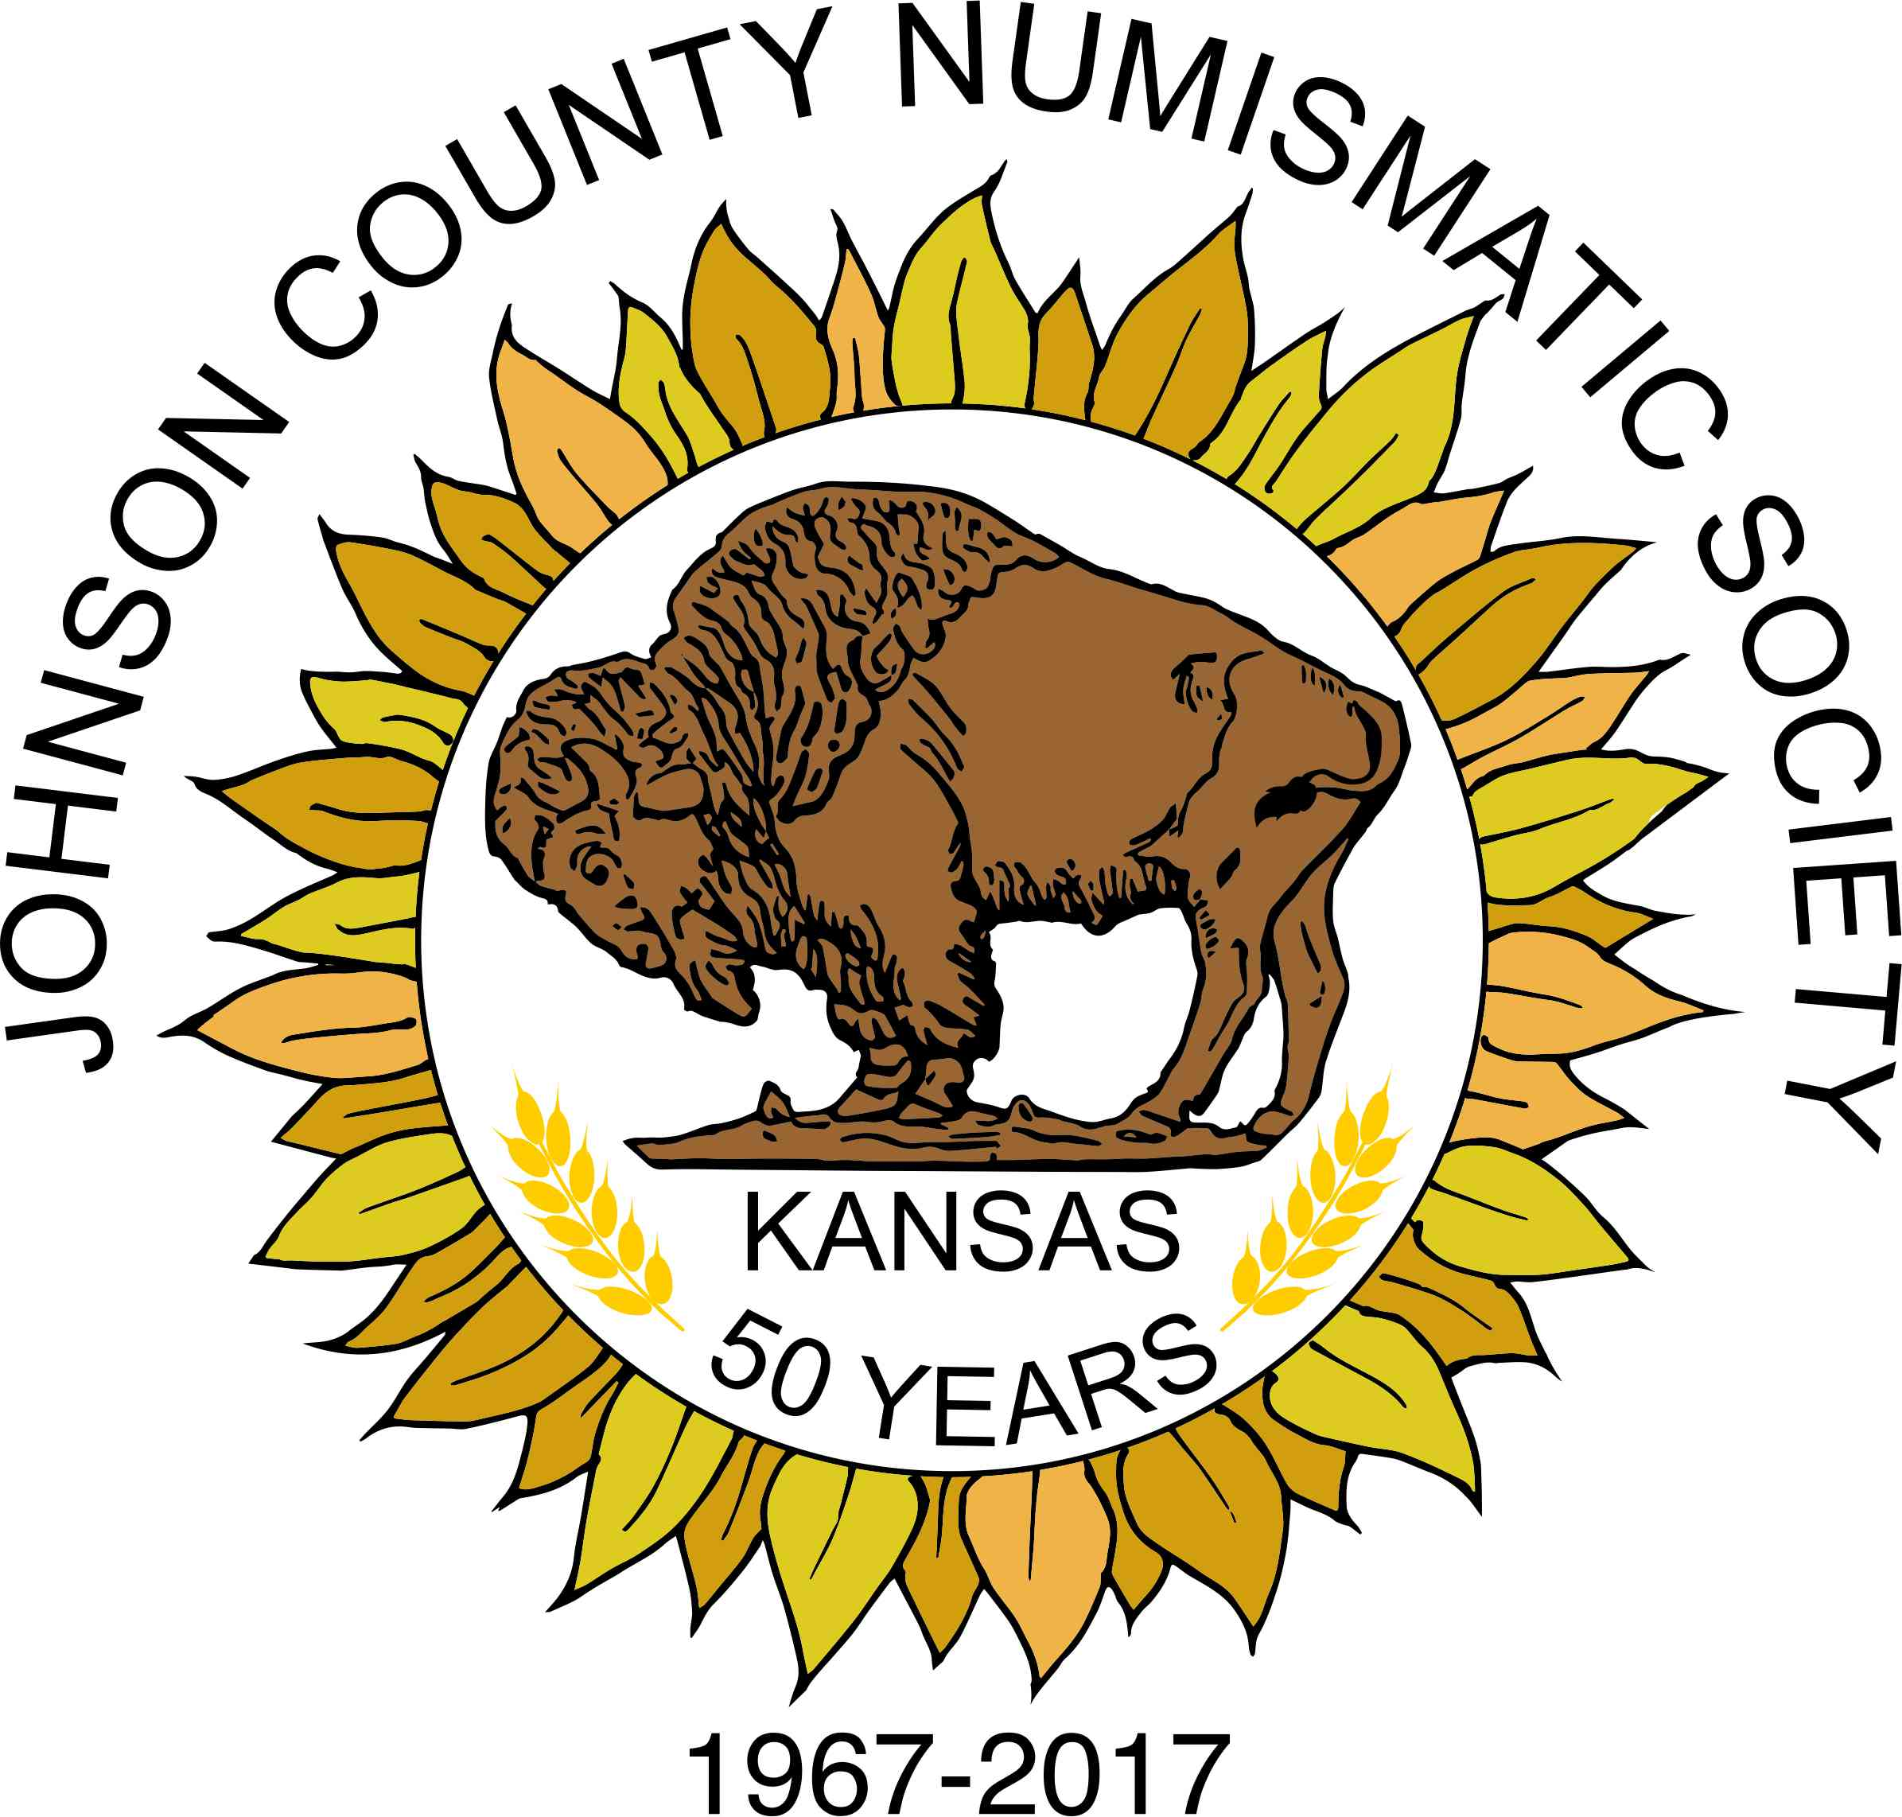
2022 Johnson County Numismatic Coin Show (54th)
October 14-15, 2022 (FRIDAY-SATURDAY)
13420 Oak St., Lenexa, Kansas 66215

We are looking forward to another great show!
Oct. 14th 6:00pm (after show), Doug Davis will be presenting on Numismatic Security and Anti-Counterfeiting (Food will be provided to dealers).

All applications received before July 30 will be put into a drawing for a (one $165) free table.

Show prices are as follows:
Single eight-foot table - $165.00 or two for $300.00
Corner (2) eight-foot tables - $235.00; Half “L” Corner $130/Each (see below)
Display cases ($15.00 each)
Lights ($5.00 each)

Dealers who wish to have the same table as last year, need to send in their application by July 30, 2022. After July 30, 2022 all tables will be assigned on a first come-first-served basis (No exceptions). No Early Birds will be allowed prior to 11:00am on Friday, without a dealers badge and floor badge issuance (see Terms and Conditions Page#2).
Dealer set-up will be 8:30 am to 11:00am on Friday.
The show hours will be 11:00am to 6:00pm. on Friday, and 9:00 a.m. to 4:00 p.m. on Saturday.
We are looking forward to seeing you there.
Regards,

Rick Raines, JCNS Show Chairman

Please Print the Following Information and Return:

Name of Applicant Name of Firm

_________________________________ _______________________________

Address City, State, Zip Code

_________________________________ _______________________________

Telephone Number (Include Area Code) E-mail (required, if available)

______________________________ ___________________________

Number of:
Checks should be Made Payable to "JCNS" and Mailed, Along With This Page of the Application, to: Rick Raines, JCNS Show Chairman
P.O Box 1221
Raymore, MO 64083-1221
_____ Regular 8’ at $165.00 Each (2 for $300)

_____ Corner at $235.00 Each

_____ Half “L” Corner at $130.00 Each
(must be shared at time of purchase)
_____ Cases at $15 Each

_____ Lights at $5 Each

_____ JCNS Show Sponsor at $50.00 (Business name added to all advertising)
The Following Persons, in Addition to Applicant, are considered employees or relatives and are to be Issued Dealer Identification Badges:

Name 1)____________________________ Name 2)____________________________

Name 3)____________________________ Name 4)____________________________

Signature of Applicant - Agreeing to the terms and conditions below: Date

X_______________________________________ ________________

Terms and Conditions (Page 2 of 2)

The undersigned (referred to hereinafter as "Applicant") hereby applies for bourse space at the 2022 Coin Show sponsored by the Johnson County Numismatic Society (referred to herein as "JCNS") to be held in Lenexa, Kansas. Table fees entitle Applicant to one eight-foot bourse table, four chairs, an eight-foot back-up table, and up to four dealer identification badges. Applicants assigned a corner table are entitled to an additional eight-foot table. Display case and light rental fees must accompany this application.

Applicant hereby agrees to the following:

1. 100 percent of the material on display on Applicant's bourse table shall consist of coins, stamps, cards or related material. No counterfeits are allowed to be sold.

2. Applicant shall abide by all the rules and regulations of JCNS and the management of the community center in which the bourse space is located. Table holders must be represented by individuals that are actual employees or household members and that no badges have been requested for any individuals who are not employees or family members and that no individuals listed for badges on this application maintain a commercial or business identity separate from his own.

3. If the Applicant desires to cancel his/her bourse table for the show, he/she will be granted a full refund only if the Bourse Chairman is notified on or before September 15, 2022. Rick Raines, PO Box 1221, Raymore, MO 64083 or call me at 816-695-7571. (Please do not send correspondence to the club P.O. Box, as there would be a time delay).

4. The Applicant releases, indemnifies, and agrees to hold harmless the JCNS, its officers, members, committee members, agents and employees in their official and/or personal capacities, the Lenexa Community Center and the legal entities which own, lease and/or operate the facility, their members, officers, directors, and employees, against any and all liability whatsoever arising from any and all claims including damage to property or personal injury caused by Applicant or his\her agents, representatives, employees or any other person. The Applicant indemnifies and agrees to hold harmless JCNS from all liability for any sums which they or either of them may pay or be required to pay to the Lenexa Community Center and the aforementioned legal entities by reason of any or all such claims. Finally, Applicant hereby releases the JCNS and its officers, members, committee members, agents and all employees in their official and/or personal capacities from all liability for loss of coins, stamps, cards, or related material. The forgoing shall not, however, limit the liability of any individual who may be personally guilty of theft, willful damage, or destruction.

5. Although security will be furnished for the bourse area, the presence of security personnel or security systems does not constitute a guarantee by JCNS against loss, a policy of insurance, or a promise to indemnify in the event of loss by fire, theft, or other casualty. Applicant is expected to insure himself/herself against any loss, which he/she might sustain, if he/she desires such protection.

6. The acceptance of this application does not guarantee Applicant a bourse table. All applications will require the approval of the Bourse Chairman. If this application is rejected or rescinded, all fees will be refunded to the Applicant.

7. I hereby agree that this agreement is governed by the laws of the State of Kansas, the proper venue being Johnson County District Court.

8.In submitting this application, the applicant hereby agrees to comply with all of the provisions thereof.

