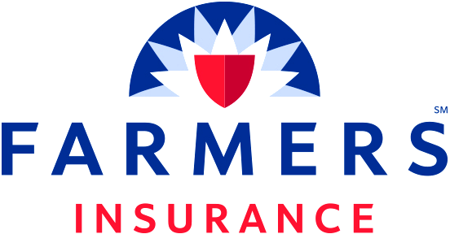

Name of HOA

Highview Meadows Colonial Association

The Master Policy for your Association through Farmers Insurance Group is a Special Form, “All In” policy that has a term length from 10/16/2024 to 10/16/2025.

Deductible

The Association’s Master Policy provides blanket building coverage in the amount of $13,976,344 with a $25,000 deductible per occurrence and a 2% wind/hail deductible per building. The policy provides replacement cost coverage and insures against direct physical loss, with some exclusions such as flood and earthquake. In the event of a loss, you could be responsible for paying for a part or all of the deductible. For this reason, it is recommended that your Loss Assessment Endorsement coverage be a minimum of $15,000. We recommend Coverage A on the HO6 policy be $15,000.

Important! Some carriers in Minnesota are adding exclusions and/or limitations to HO6 assessment coverage, including, but not limited to, capping loss assessment coverage at only $2,000. Please reach out to the carrier of your HO6 policy to ensure your policy fully covers you in the event of a loss.

FAQ’s & Other Information

Q. What does “All In” coverage mean?

- All In coverage includes everything permanently and physically attached to the building. It does not provide coverage for personal property or liability for the unit owners. It is the responsibility of each unit owner to purchase an HO6 policy with a carrier of their choice.

Q. What should an HO6 policy cover?

- An HO6 policy should provide the following protection:
- Personal Belongings (furniture, clothing, household goods, etc.)
- Personal Liability
- Loss Assessment Endorsement
- Sump Pump/Sewer Endorsement
- Coverage A $15,000

Q. Whom do I contact in the event of a claim?

- All claims should be reported as soon as possible. Contact (Management Co.) at (Phone #). This can help to minimize loss and get you immediate help in dealing with your claim. You should also contact the agent of your HO6 policy.

If you, or your personal insurance agent, have questions about the Association’s Master Policy, please contact the Association’s insurance agent:

Farmers Insurance
Matt Volgren Agency
(763) 951-3250
mvolgren@farmersagent.com

For certificates of insurance, please contact the Association’s insurance agent.

