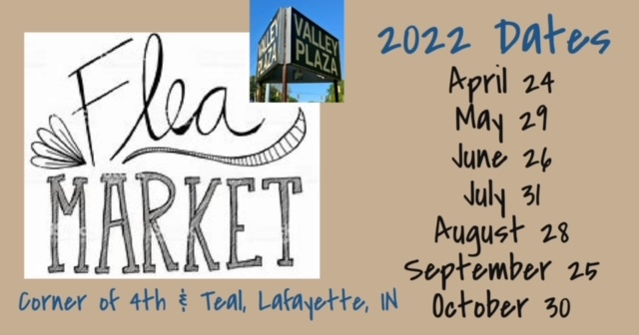
Information for Vendors
Thank you for your interest in our annual flea market. Please see the bullet points below. We appreciate our vendors and their willingness to follow some guidelines to help keep our market running smoothly, keep our customers happy, keep everyone safe, and keep the facilities clean.
1. Flea Markets will run on the last Sunday of every month, starting in April with the last market in October.
2. Market runs from 9 a.m. to 3 p.m. Vendors are encouraged to stay for the entire market. Vendors who consistently leave early will not be allowed to return.
3. Set up starts at 7:30. There will be NO loitering in the parking lot in the early morning hours. This parking lot is monitored by local law enforcement, and we do not want to raise concern. Do NOT start setting up until you check in with our staff. Must be torn down by 5:30.
4. We accept most vendors. We prefer antiques, vintage, and handmade vendors. Please avoid “garage sale” type items.
5. Spaces are 10x20. You may pay for more than one space. Small trailers and tents are allowed. Spaces are assigned first come-first served, unless you have reserved a space for the whole season.
6. Pricing is as follows:
$20/space if you pull in the day of. Fee collected day of.
$15/space if you call ahead to get put on the list. Fee collected day of. This should guarantee you a space if you show before 8:15 a.m. After that, we cannot guarantee a space. We encourage you to call before if you decide not to participate.
$70 for the whole season (7 market days). Price includes (1) 10x20 space. Space will be reserved for you every month. Space will be held until 8:15 a.m. every month. If you don’t show by then, it will be given to the next vendor. Fee collected up front, prior to the first market in April.
There are NO refunds provided. We do NOT have rain dates.
7. Vendors are responsible for bringing their own change. We will not provide change in the shop. There is WiFi available if you collect electronic payments. Password in leapingleopard
8. Vendors are also responsible for keeping their area clean and disposing of their own trash. Vendors found to be “dumping” trash or unsold items at the shop will be asked to not return.
9. Please leave your trailer/vehicle in or near your space. Please try to avoid having “extra” vehicles in our parking lot so we can keep them open for customers. For example, if you’re bringing a helper, try to ride together.
10. Restrooms are available in Leaping Leopard Antiques. Free coffee is available as well. Soft drinks and water are available for sale at Leaping Leopard Antiques and Klassy Klutter.
11. If you bring children, they must be supervised.
12. Your booth is your responsibility. We or the owners of Valley Plaza are not responsible for your items in any way.
Any questions or inquiries can be directed to Leaping Leopard Antiques:
(765) 474-9100
leapingleopardllc@gmail.com
www.leapingleopardantiques.com
www.facebook.com/LeapingLeopardofLafayette
on Instagram @LeapingLeopardAntiques

