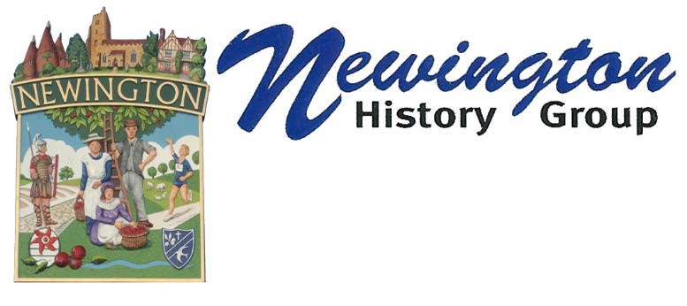

Mill Hill brickworks
Commercial brickmaking probably began in the area in the 16th century and continued until the end of the 19th.
One of the biggest brickmaking sites was on Mill Hill, just west of Newington. The land is now arable and there are no obvious structures revealing its industrial past. However, a narrow road that crosses Mill Hill tells us everything. There’s been a track here since the 11th century, therefore, much of it passes between steep embankments, worn below the original ground level by thousands of footsteps.
However, as you near the crest, the embankments drop away and the land is level with the road, or even slightly lower. This is where brick earth was extracted. The brick earth was used to make the ‘Newington Red’ which was used extensively in London as the capital grew in the Industrial Revolution.
The photograph is not of any brickworks in Newington but gives an idea of the work involved.

