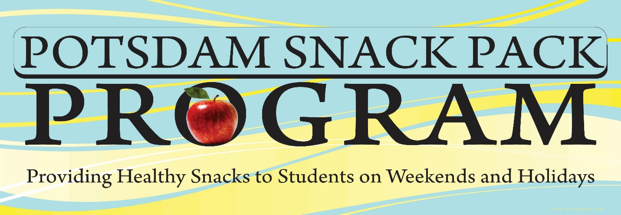

The Potsdam Snack Pack Program provides a minimum of eight non-perishable snacks to more than 400 eligible students each weekend.
How You Can Support the Snack Pack Program:
- Donate Money
- Purchase Food Items
- Volunteer to Pack Bags

Suggested Snack Pack Items (Single Serving):
Apple Sauce Cheese Snacks
Breakfast Bars Fruit Cups
Granola Bars Hot Chocolate/Cocoa
Nuts (Almond, Mixed) Peanut Butter Crackers
Pretzels Pudding
Chicken with Crackers Tuna with Crackers
Microwaveable lunch items (Spaghetti, Ravioli, Macaroni & Cheese)

