FINDING FELLOWSHIP WITH GOD... TOGETHER!
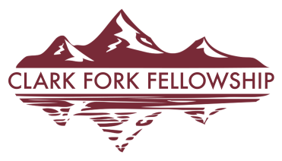
Gathering at 502 Pike Street, Superior MT

Weekly Word for 1/21/23 thru 1/27/23

BIBLE PROMISE

The Lord is gracious, and full of compassion;
slow to anger, and of great mercy.
Psalm 145:8

BIBLE READING
Date | Day | Passage
1/21/2023 | Saturday | Genesis 43-46
1/22/2023 | Sunday | Genesis 47-50
1/23/2023 | Monday | Matthew 1-4
1/24/2023 | Tuesday | Matthew 5-8
1/25/2023 | Wednesday | Matthew 9-12
1/26/2023 | Thursday | Matthew 13-16
1/27/2023 | Friday | Matthew 17-20

But if we walk in the light, as He is in the light, we have fellowship one with another,
and the blood of Jesus Christ His Son cleanseth us from all sin.
1 John 1:7

