FINDING FELLOWSHIP WITH GOD... TOGETHER!
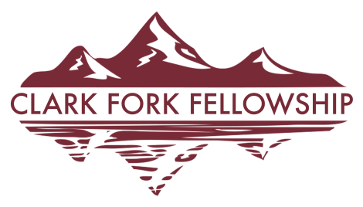
Gathering at 502 PIKE STREET, SUPERIOR MT

WEEKLY WATCH IN PRAYER
12/21/22

PRAYER REQUESTS:
- Every family surrounding 502 Pike Street and through-out Superior
- Wisdom and protection during these days of below zero temperatures for so many
- Wendy Carr, diagnosed with a tumor, being assessed for full diagnosis and treatment (Plains MT)
- Spiritual awakening, removing strongholds (2 Cor . 10:4-5), and seeing open hearts to the Gospel in Superior and Mineral County
Superior Senior Center group
- Pray Clark Fork Fellowship will point people to Jesus (John 12:32)
Newborn baby Jameson and his family (grandparents, Tom & Jamie Goebel)
- SISTER CHURCHES in Montana: Pastor, family, & congregation at Clark's Fork Baptist Church, Bridger MT
- Our "SENDING CHURCH": Prairie Hills SBC, Augusta KS (Pastor Dan Anderson & wife, Kathy)
- Salvation and Special Requests: Amanda, Bill, Travis, Tom, Patrick, Jake, Duane, Irene, Sherry, Amie, Amber, Don Jim, Dana, Liz, Angela, Tina, Rob, Robert, Pam, River, Shawn, Lisa, Jill, Loreen, Tally, Duane, Marie, Jasmine, "T", Annie, Nate, Alexa, Brenda, Donna,
Pray believing for the Lord to send Laborers for His Harvest in Superior (Luke 10:2)
- Opportunities to serve Superior outside the church walls
- Repentance, Forgiveness, Mercy, and Healing in our lives, in this fellowship, in this town, and in our nation
- Superior, Mineral County, Montana, USA and the world

PRAYER REACH: (local businesses)

Town Pump
Trail West Bank
Trax of Albertsons, Inc.
Treasure Morgans Horse Riding
Tricon Timber Post & Pole

Mineral Community Hospital
(doctors, nurses, support staff, and patients)
Mineral County Court House
(newly elected officials and staff)
Mineral County Sheriff's Department
(staff & personnel)
Superior Schools
(students, teachers, administration, families)
Town of Superior
(mayor, staff, and personnel)

PRAISE REPORTS:
- Those who Gather at Clark Fork Fellowship each Sunday @10:30 a.m.
- Thankful for the Grace of God in our hearts
- Thankful for every opportunity to meet new people in our community and share Jesus
- Thankful for the many ways God continues to lead us and provide for us
- God is at work every day--when we see it and when we don't! Pray that we will always be available and obedient to join God in what He is doing.

After this manner therefore pray ye:
Our Father which art in heaven, Hallowed be Thy name.
Thy kingdom come, Thy will be done in earth, as it is in heaven.
Matthew 6:9

