The Local Birds
The Common Koel
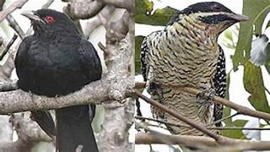
Male Female
Information Sing For Me...

The Red Wattle Bird
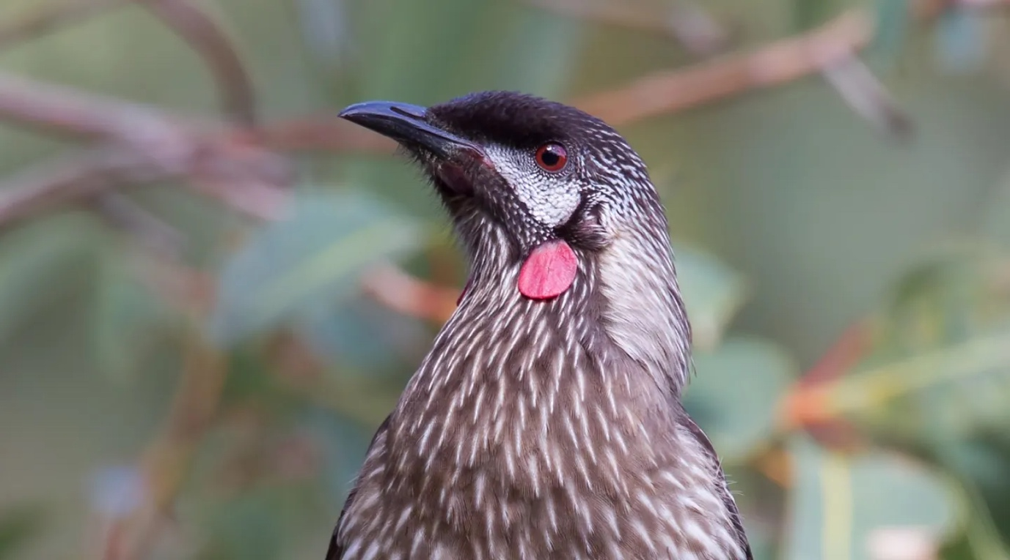
Information Sing For Me...

The Little Wattle Bird
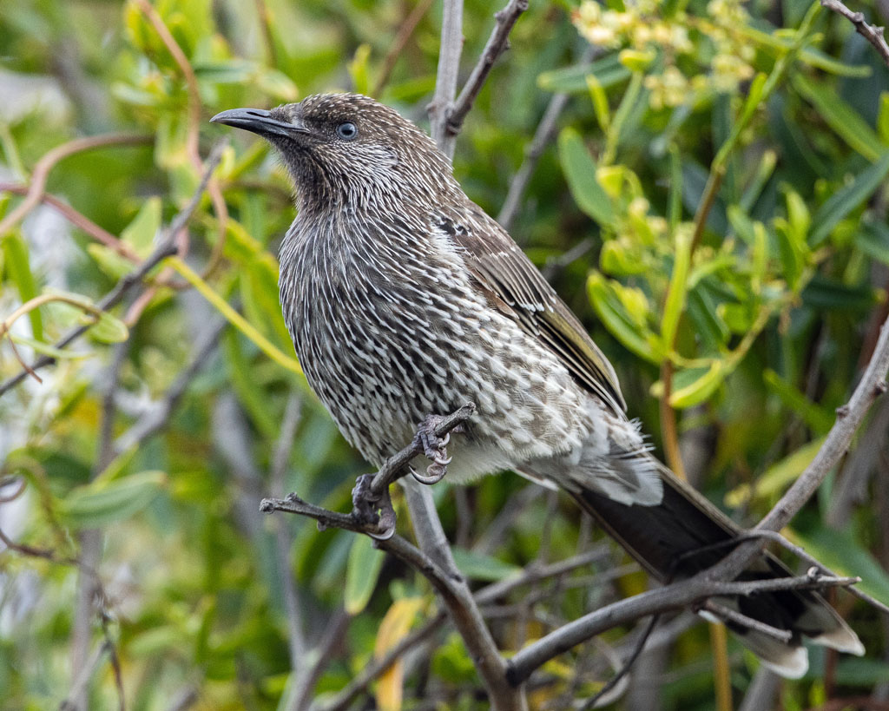
Information Sing For Me...

The Pied Currawong
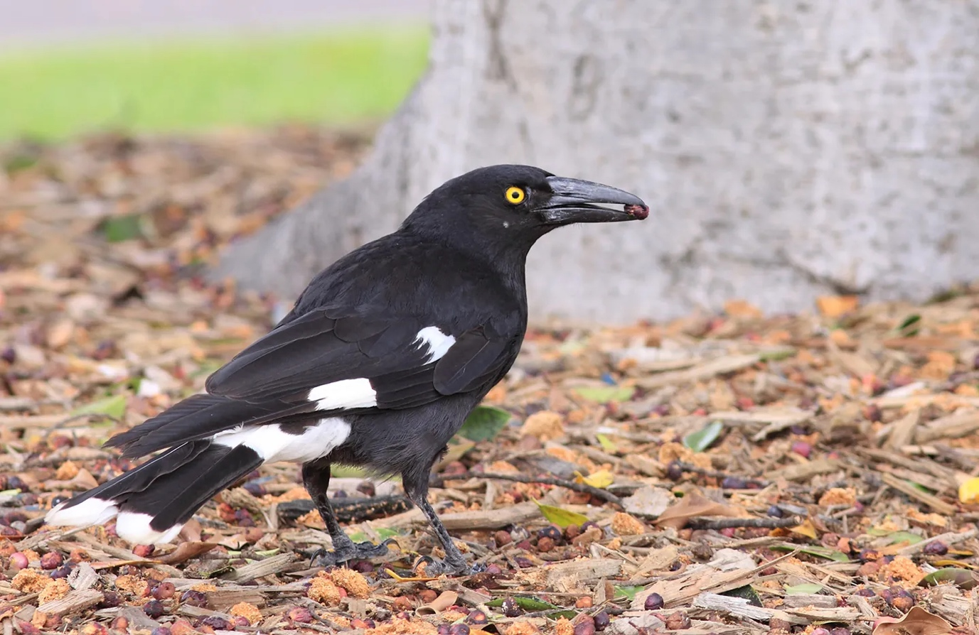
Information Sing For Me...

The Pied Currawong
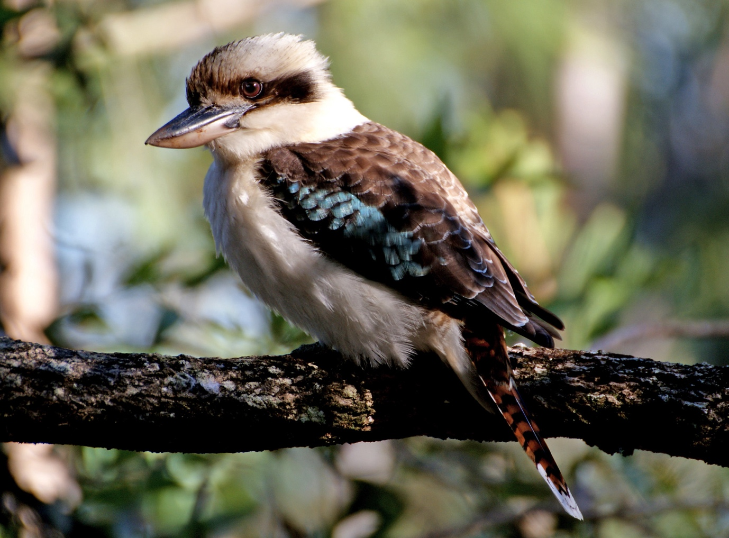 Information Sing For Me...

The Magpie-Lark
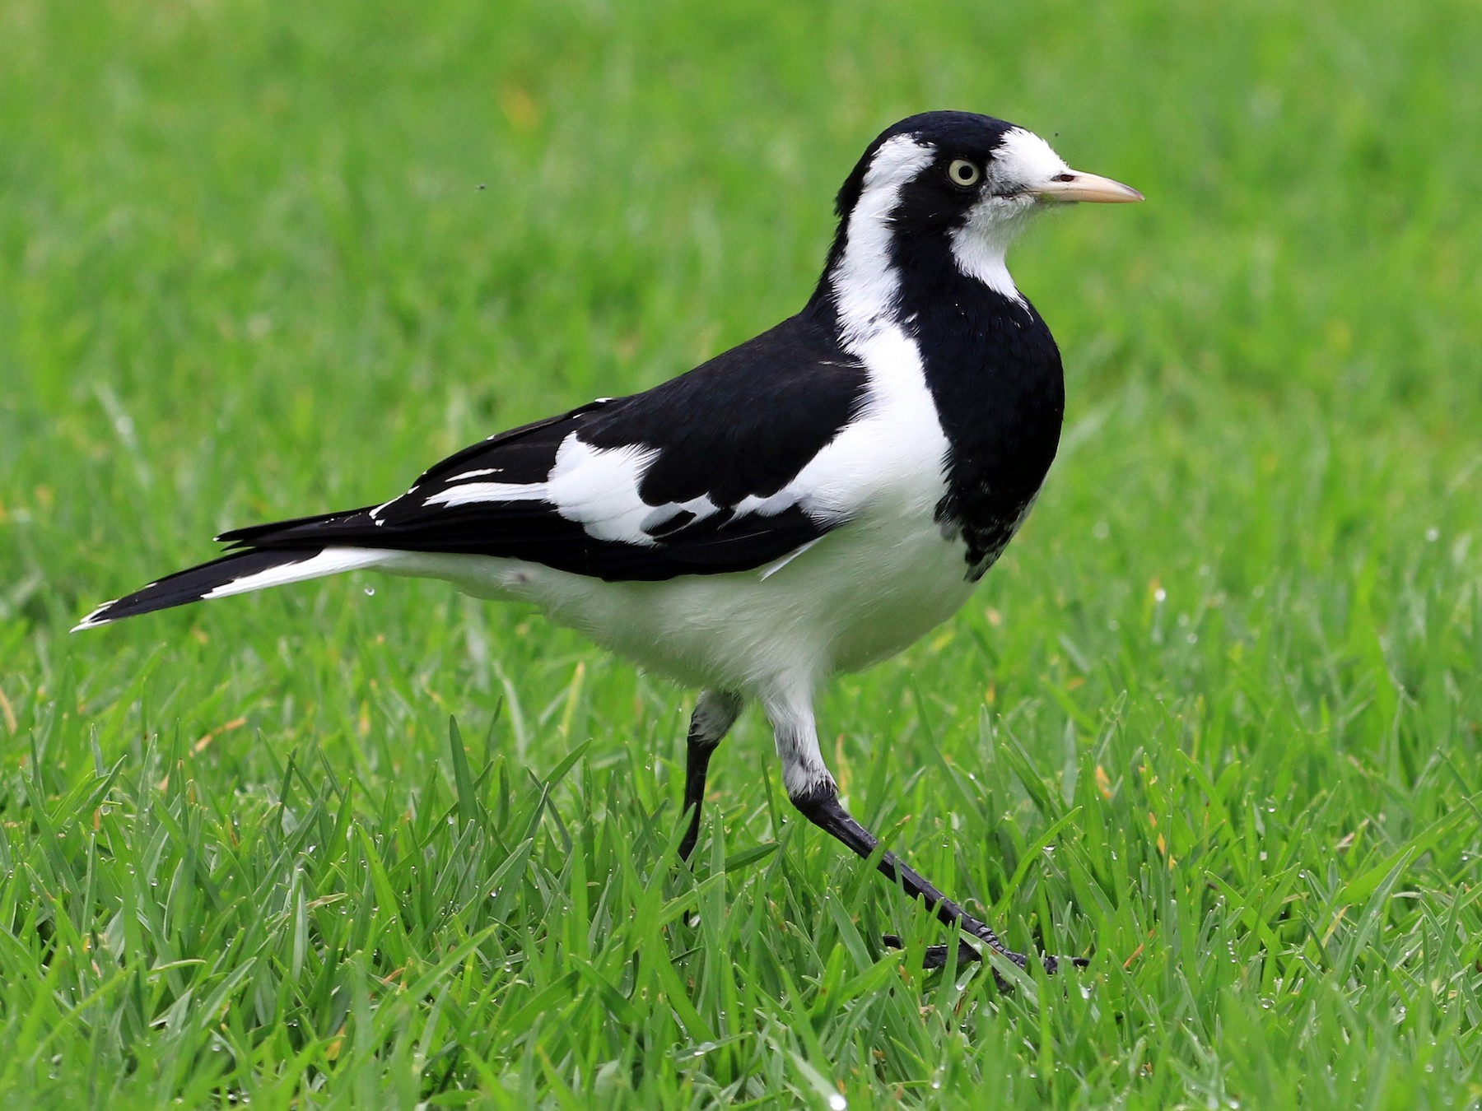
Information Sing For Me...

The Australian Magpie
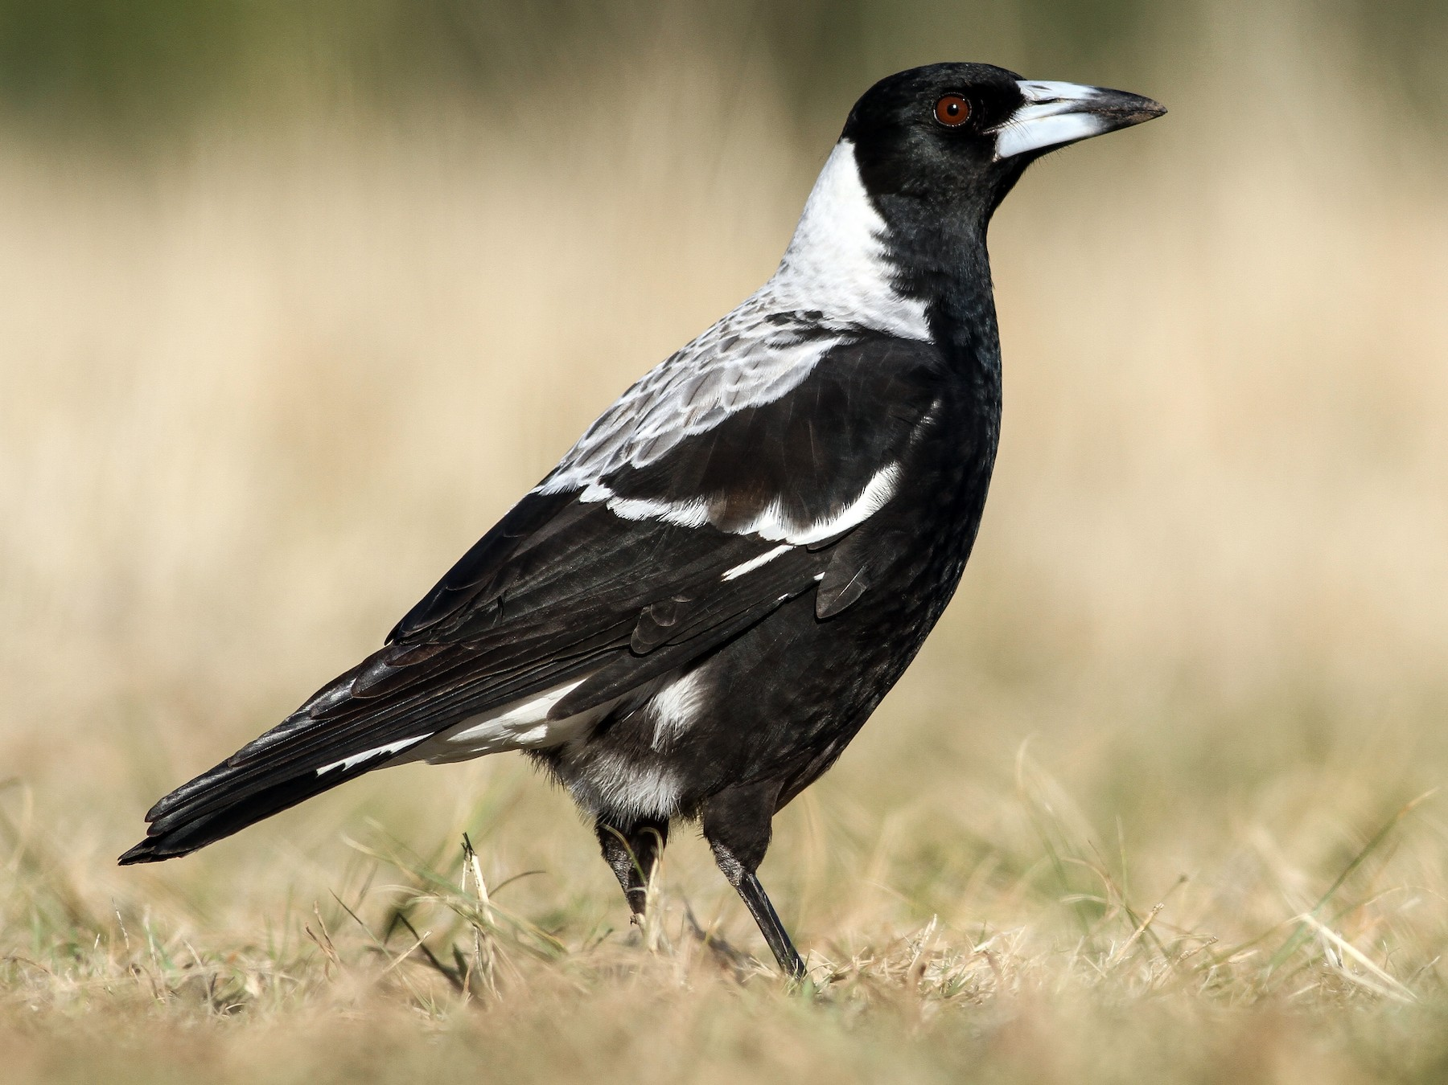
Information Sing For Me...

The Spotted Turtle-Dove
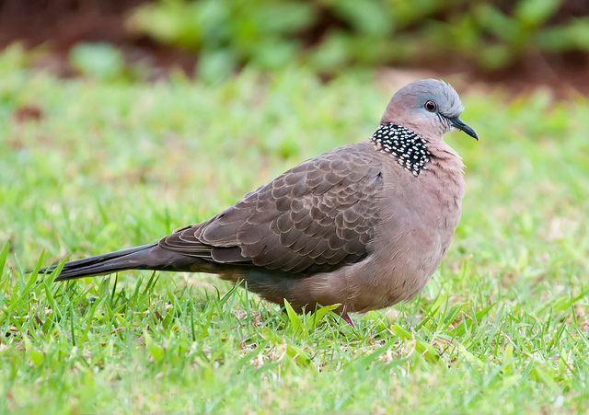
Information Sing For Me...

The Common Starling
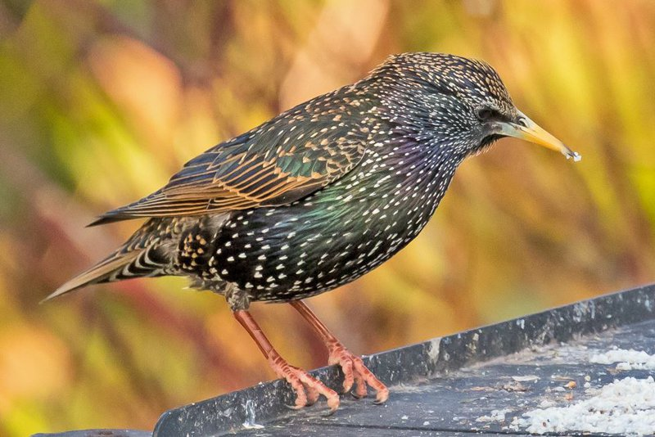
Information Sing For Me...

The Sulphur-Crested Cockatoo
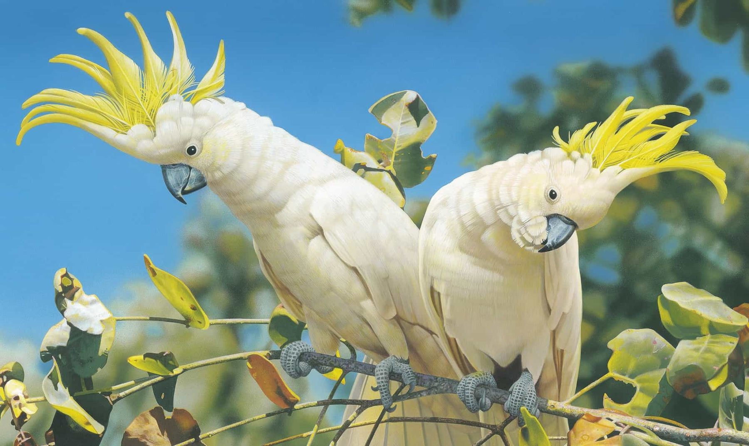
Information Sing For Me...

The Rainbow Lorikeet
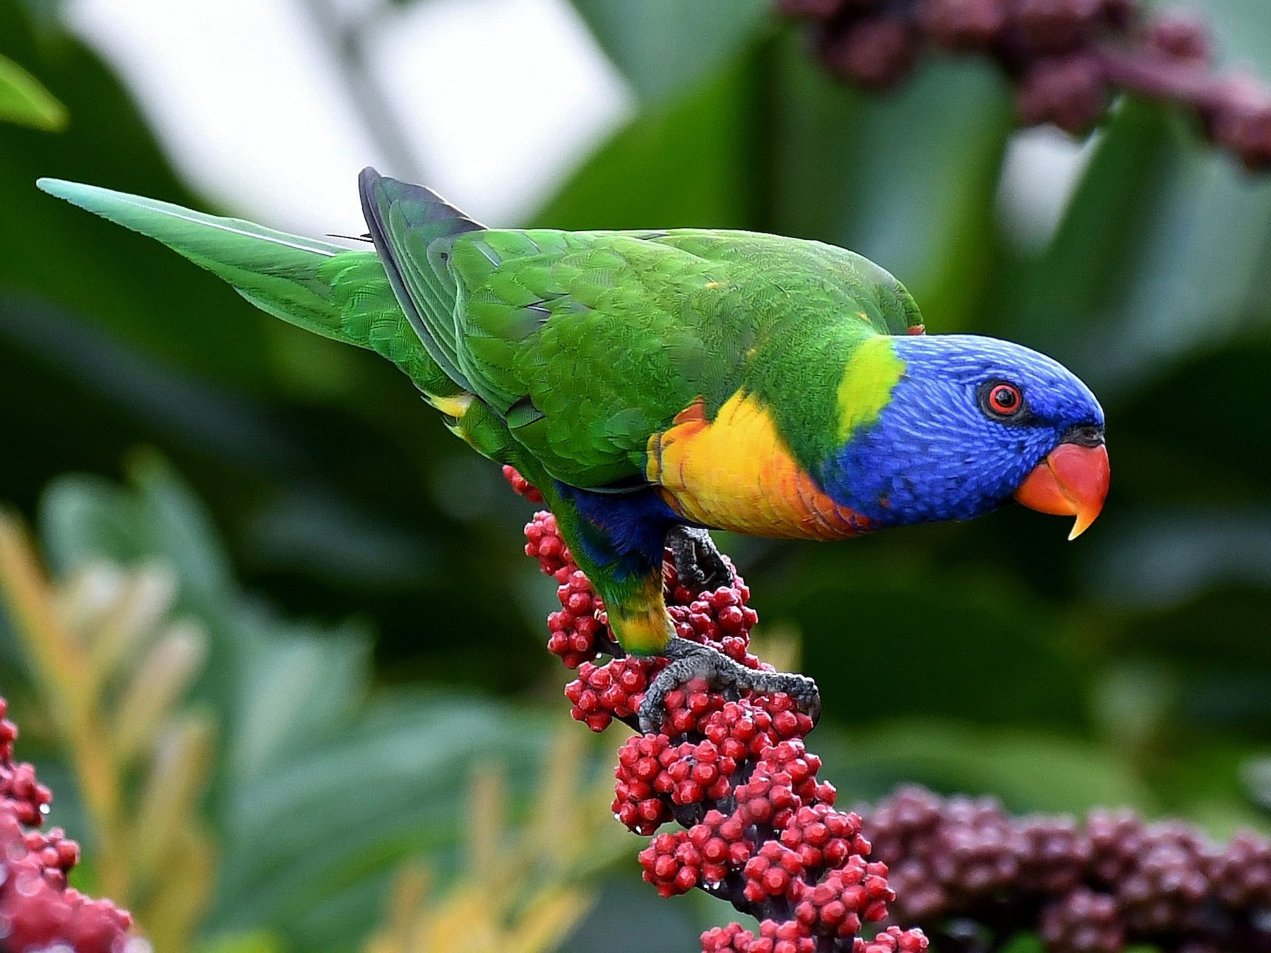
Information Sing For Me...

The Common (Indian)Myna
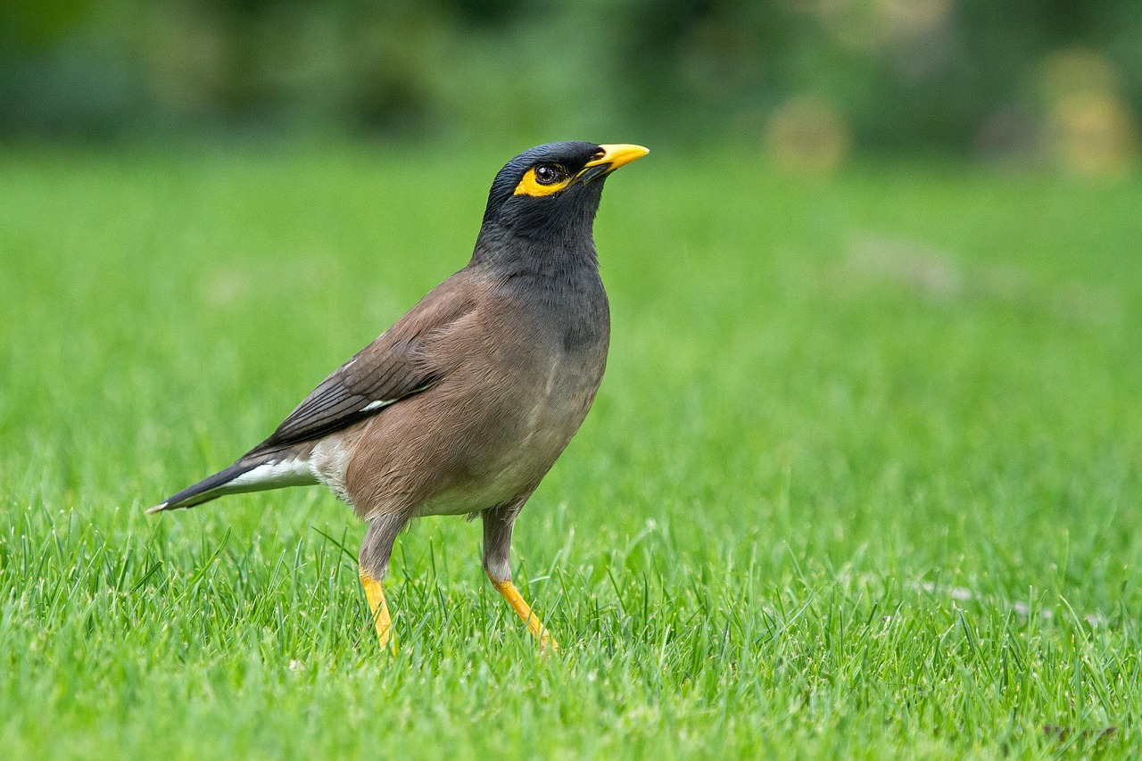
Information Sing For Me...

