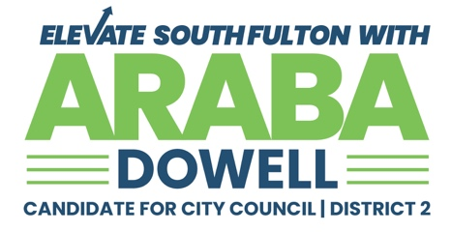
MEDIA ADVISORY
FOR IMMEDIATE RELEASE
CONTACT: info@arabadowell.com | 470.601.2613
South Fulton, GA – June 29, 2025 — Today, community advocate, business leader and civic powerhouse Araba Dowell will officially launch her campaign for City Council, District 2, with a high-energy event designed to connect residents, energize voters and spotlight the future of South Fulton. Araba is seeking to fill the seat currently held by Councilwoman Carmalitha Gumbs, who is running for Mayor of South Fulton. This pivotal election represents a significant moment of transition and opportunity for the city’s leadership.
WHO:
- Araba Dowell, Candidate for South Fulton City Council – District 2
- Residents, business owners, civic leaders, youth, and supporters
WHAT:
- Campaign Launch Event
- Will feature remarks from Araba Dowell, live testimonials, music and food, and an opportunity for attendees to share their hopes for South Fulton’s future.
WHEN:
Sunday, June 8, 2025 | 3:00 PM – 5:00 PM (Formal remarks at 4:00 PM)
WHERE:
3885 Renaissance Circle, Walden Park Clubhouse & Patio
WHY:
South Fulton is a city on the rise — and Araba Dowell is ready to lead it forward with a focus on:
- Healthy City: Safer streets, better healthcare access, youth engagement
- Smart Growth: Jobs, innovation and vibrant small business opportunities
- Future Ready: A modern, thriving city that works for all generations
Thank you!
###

