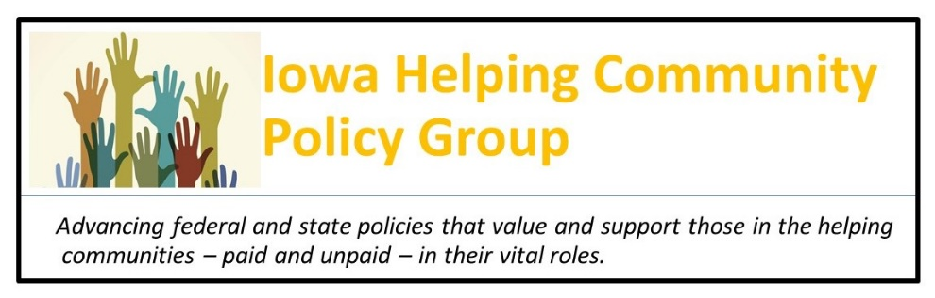
September 15, 2021

Iowa Department of Human Services Director Kelly Garcia and
Iowa Medicaid Administrator Elizabeth Matney
Iowa Department of Human Services
Hoover State Office Building
Des Moines, IA 50309

Dear Director Garcia and Administrator Matney:
First, I would like to congratulate you on the Center for Medicare and Medicaid Services’ approval of the Iowa Spending Plan for Implementation of Section 9817 of the American Rescue Plan Act and for your active solicitation of input from our group and other core Iowa stakeholders, including those receiving services and frontline staff providing them.
While one-time funding, Congress is moving forward with mark-up of a Build Back Better Act that would continue this enhanced funding for Home and Community Based Services, with an emphasis upon broad engagement in planning which you already have initiated.
At this time, I would like to request a meeting with you to discuss roles that the Iowa Helping Community Policy Group can play in supporting continued involvement of key stakeholders in this process, both with respect to Section 9817 and with respect to any further federal actions.
We look forward to scheduling a meeting to discuss what specific activities we can undertake that would be most helpful to you in planning and implementation.
Respectfully submitted on behalf of the Policy Group
Charles Bruner
Charles Bruner, Facilitator (bruner@childequity.org, 515-988-4457)
Attachments:
Appendix One: Iowa Helping Community Policy Group Feedback to the Department of Human Services on the Use of Increased Funding for Home and Community-Based Services
Appendix Two: Testimony to Iowa Council on Human Services
Appendix Three: Attachment Q & A
APPENDIX ONE: FEEDBACK TO THE IOWA DEPARTMENT OF HUMAN SERVICES ON THE USE OF INCREASED FEDERAL FUNDING FOR HOME AND COMMUNITY-BASED SERVICES

July 5, 2021

To: Iowa Department of Human Services

From: Charles Bruner, on behalf of the Iowa Helping Community Policy Group

Thank you for the opportunity to provide feedback on the new federal funding opportunity to strengthen Iowa’s home and community-based services.

The Iowa Helping Community Policy Group represents volunteers and advocates whose mission is “to advance federal and state policies that support those in the helping communities – paid and unpaid – in their vital roles in society.” We are a nonpartisan group committed to strengthening caregiving and other health, education, and human services in Iowa through greater public investments in frontline workers in these fields as essential workers, the workforce behind the workforce, and a core and vital part of Iowa’s infrastructure and economy. We are working together to increase public investments in the size, compensation, and affordability of those in the helping professions through policy maker education and advocacy, and through greater public recognition, dialogue, and mobilization.

We strongly support the federal government actions in the American Rescue Plan to initiate investments to strengthen this workforce, with one key component being the elevated federal financial participation under Medicaid for home and community-based services. This is consistent with the President’s campaign commitment to establish a 21st Century Caregiving and Education Workforce and proposals in the American Jobs Plan and American Families Plan to provide ten-year funding to expand the size and improve the compensation and support for this workforce and ensure its affordability to the people it serves – investments to produce millions of additional jobs and employment opportunities and to compensate and support them as career occupations.

This also is very consistent with Governor Kim Reynolds’ commitment in the Vision for Iowa economic recovery plan as “a new opportunity to build a better Iowa and further improve our quality
of life.” That plan specifically includes attention community-based services:

Health care the way it exists today may not be sustainable in some areas. But with change comes the opportunity to create a more integrated, coordinated system… The Governor acknowledges the importance of home and community-based care for aging and disabled individuals, and the difference these services make in maintaining health and quality of life.

While the funding available through the American Rescue Plan is time-limited, we urge you to take this as an opportunity to take a comprehensive approach to using this funding as a first step toward building the direct care workforce for Iowa’s future needs and that better Iowa.

The CMS letter to Medicaid Directors recognizes both short-term and long-term needs and the importance of an inclusive approach to developing this workforce:

States will be permitted to use the state funds equivalent to the amount of federal funds attributable to the increased FMAP through March 31, 2024, on activities aligned with the goals of section 9817 of the ARP. This time period to expend funds attributable to the increased FMAP will provide states with sufficient time to design and implement short-term activities to strengthen the HCBS system in response to the COVID-19 PHE, as well as longer term strategies to enhance and expand the HCBS system and to sustain promising and effective programs and services.

CMS recognizes the importance of effective stakeholder engagement processes that can provide states with varied perspectives on how to expand, enhance, and strengthen HCBS. States may want to consider engaging a broad community of stakeholders—Medicaid and other state agency leadership, participants in HCBS programs, residents in long-term care facilities, HCBS providers, family members and other caregivers, the aging and disability network, health plans, and the direct support workforce—to provide insight, ideas, and feedback to inform the state’s approach to developing and implementing activities under section 9817 of the ARP. [emphasis added]

The Iowa Helping Community Policy Group recognizes that the workforce providing these home and community-based services is essential to the people it serves but also is a part of Iowa’s economy and culture. This workforce needs to be recognized as essential workers, a workforce behind the workforce, and a core part of Iowa’s economy and source of employment.

Under Workforce Development, there is a child care working group that includes members of that workforce who are developing implementation plans for building a robust child care system in Iowa, recognizing its contribution to the economy.

Equivalent attention is needed in developing implementation plans for a robust home and community-based services workforce, starting with the opportunities presented through the American Rescue Plan Act. Soliciting this feedback is an initial step, but there needs to be concerted, inclusive, and high visibility engagement of stakeholders to ensure success. We strongly recommend you develop an implementation process that continually engages stakeholders and, in particular, draws from the insights of those providing these frontline services and the people they serve.
COVID-19 has brought much greater recognition to the essential nature of this workforce, but also to its current fragility at the same time the demand for such a workforce is increasing. All three areas cited in your request for feedback require attention, but key to a robust workforce is recognizing its value in providing compensation and benefits that enable those seeking such work to sustain themselves and their families and see this work as a long-term career.

A major share of this work is financed through the Medicaid program, including but not limited to workers providing in home and community-based services (many other direct care workers also are employed in nursing homes, hospitals, and other institutional settings serving people with disabilities or behavioral health or substance abuse concerns). Ultimately, Medicaid reimbursement and regulations for providers determine, in large measure, the compensation this work provides

With a Presidential commitment to “building back better” and a Gubernatorial vision of “building a better Iowa,” we encourage you to prioritize state actions that do build a better direct care workforce.

The Iowa Helping Community Policy Group has produced a number of resources about the size, composition, demand for, and current composition of the different parts of this workforce – early care and education, direct caregiving for seniors and persons with disabilities or special health care needs, and public and community health workers. Many are on the Group’s website, www.iowahelpers.org and we can share them in other ways. We also are eager to provide additional information, feedback, and perspectives as you continue your work. Thank you for seeking feedback. We encourage you to continue your leadership in engaging stakeholders and taking leadership to elevate these issues to greater public policy visibility and dialogue.

Respectfully submitted on behalf of the Iowa Helping Community Policy Group

Charles Bruner, founding steering committee member and facilitator
1148 Oklahoma Drive
Ames, IA 50014
bruner@childequity.org
515-988-4457
Iowa Helping Community Policy Group webpage – www.iowahelpers.org

Appendix Two: Testimony to Iowa Council on Human Services
August 12, 2021
[T]he moral test of government is how that government treats those who are in the dawn of life, the children; those who are in the twilight of life, the elderly; and those who are in the shadows of life, the sick, the needy and the handicapped. – Hubert H. Humphrey
President Biden has committed to “building back better” and Governor Reynolds has committed to “building a better Iowa.” Both recognize the imperative for creating a solid infrastructure that includes roads and bridges and other physical elements but also relies upon a robust workforce that includes essential workers in health, human services, and early care and education. COVID-19 has made clear how essential these workers are and yet how vulnerable this workforce currently is -- and the need to ensure that in the future there will be adequate investments to meet the level of need for them, support them for the value of the services they provide, and consider them as both the “workforce behind the workforce” and a source of Iowa jobs and part of the Iowa workforce and economy.
These essential workers rely, sometimes directly but often indirectly, upon public support. They serve Iowa’s children, seniors, and those in between who need their help but cannot afford to cover their true costs and value by themselves. Through its programs and services, the Iowa Department of Human Services, with the Iowa Department of Public Health, bears the chief responsibility for publicly financing this workforce.
The Iowa Helping Community Policy Group is a voluntary, nonpartisan group composed of individuals and organizations dedicated to “advancing federal and state policies that value and support those in the helping communities – paid and unpaid – in their vital roles.”
We believe, over the next two years, Iowa has the opportunity – with new federal funding support – to build a better Iowa through greater attention to and investments in this workforce, particularly those serving on the frontlines in child care and early education, direct care in community-based and in-home and nursing home and other institutional settings, and in public and community health.
This requires leadership from the Iowa Department of Human Services in deploying federal funding to achieve these aims, which requires obtaining input from and working with those in the field who do this work and the people they serve. This includes giving major attention to how this workforce must be supported and valued in its own right, including its compensation, benefits, and work supports.
We encourage the Council to recommend the Department establish an inclusive and concerted design and implementation process for making use of new federal funds and state and community funding to truly build a robust workforce – and to place a priority on actions the state can take to ensure that workers receive the compensation, benefits, and supports they need to provide caring, consistent, and compassionate care. This has begun with the feedback the Department sought for the use of home and community-based services funds received from the American Rescue Plan Act, but now should continue and expand as implementation begins and as further federal funding is made available. It is critical that those on the frontline and the people they serve inform design and implementation processes. The Iowa Helping Community Policy Group is eager to participate in such a process.
Thank you for your work. As further information on the Iowa Helping Community Policy Group and the Iowa helping workforce, I am attaching further information about the Policy Group and the helping workforce, below.
Charles Bruner, facilitator for the Iowa Helping Community Policy Group
1148 Oklahoma Drive, Ames, IA 50012 (bruner@childequity.org, 515-988-4457)

Appendix Three: Attachment Q & A
Iowa Helping Community
Policy Group – Mission Q & A
January 20, 2021
The Iowa Helping Community Policy Group’s mission is to advance federal and state policies that recognize and support those in the helping fields – paid and unpaid – in their vital roles in society. The Group believes that strengthening this workforce is core to reflecting Iowa values in policy, meeting the needs of Iowans young and old and in-between, and ensuring Iowa’s prosperity.
The Iowa Helping Community Policy Group includes those working in the different helping professions, those who care about and advocate for them, those receiving support from them, and those who see this work as vital to Iowa society. These workers have been the backbone in the country’s response to COVID-19 and will be needed in continued response and recovery. In economic terms, they are essential both to enabling Iowa workers to be productive and in themselves contributing to the economy as a valued part of the workforce.
The following offers some Q’s and A’s about this workforce and its importance to Iowa’s prosperity.
- Who is in the Helping Community Workforce?

The helping community workforce includes those providing direct care to support children, seniors, and those in between, offering care and help to meet health maintenance and development needs – social workers, counselors, home health aides, nurses and aides in nursing homes and hospitals, child care workers, home visitors, and workers in child protection and group homes and other settings for persons with disabilities.

Their, and society’s goals, are to provide direct, day-to-day supports that ensure safety, promote independence and self-sufficiency, and provide supportive services to enable people to live in dignity.

- Why Do We Need to Look at the Helping Community Workforce Today?

COVID-19 has raised the visibility and recognition of frontline workers in health, education, and human services. They have been the backbone of the country’s response to COVID-19, both medical and social. They have stepped up to respond – in the immediate term despite strains on themselves and their families.

At the same time, the COVID-19 pandemic has shown the precarious nature of their work and often the lack of support they are provided in performing their roles, including very low pay for many frontline positions.

In terms of further responses to COVID-19 – stimulating an economic recovery and ensuring a robust helping workforce as a part of the economy – the helping community must not be taken for granted. It deserves and requires concerted public policy attention. The helping community workforce is a core part of the economy and should be viewed in that right.

During the campaign, Presidential candidate Joe Biden proposed what the press called a “transformational agenda for caregivers” and a “New Deal for the Helping Community.” That Plan for a 21st Century Caregiving and Education Workforce called for a ten-year, $775 billion federal investment in strengthening the direct care and child care workforces. Coupled with other Plans to strengthen school-based services, health care, juvenile justice, and early childhood, the Biden campaign outlined a fulsome agenda for economic recovery and meeting the needs of rural and urban America for quality health, education, and human services. Congress has an opportunity and responsibility to flesh out the plans the Biden administration brings forward to advance this workforce.

- What Has Been Government’s Role in Supporting this Workforce?

This workforce is at the frontline in responding to the long-recognized role of government in ensuring the safety and health of the population, meeting basic and special needs, and enabling people to be as productive and self-sufficient as possible.

Through Medicare, Medicaid, and public health services, the federal government funds a large share of this workforce – in hospitals, nursing homes, and as home health aides to seniors and persons with special health care needs. Through block grants like TANF, SSBG, CCDBG, CAPTA, Title IV-b, and CSBG; and through Head Start, WIC, EFNEP, IDEA, and MIECHV, the federal government supports child care, home visiting, and special needs services to children that enable their parents to work and provide for their families, as well as supporting services to enable seniors and those with disabilities to live and contribute. Some of these workers are public employees, but a large share work in nonprofit community organizations with whom government contracts for such services. Government plays a key role in supporting this workforce, as many of those receiving help cannot afford to pay for the cost of the services they receive, particularly when they have special care needs.

- What is the Size, Composition, and Compensation of the Helping Community Workforce?

Broadly considered, the health, education, and human services workforce represents nearly one-fifth of the overall workforce nationally, when including teachers in the K-12 education system. This workforce helps ensure the long-term well-being of society through its emphasis upon human capital development and maintenance – performing roles essential for the private sector workforce and economy. It both contributes to the prosperity of the economy and is a part of that economy. The Bureau of Labor Statistics provides information at both the state and federal level on the workforce in terms of different job classifications. These allow estimates of the size of this helping community workforce, shown for 2019 for Iowa. As the chart shows, 180,000 jobs, or one in eight jobs in the Iowa economy, are in one of these helping professions, and another five percent are in the K-12 education fields.

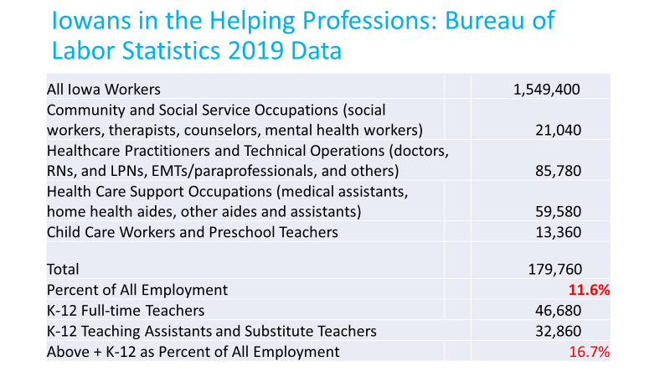
This workforce includes many highly-trained professionals (particularly in the medical world), but a large share of those providing care and help is done by aides, assistants, and paraprofessional and community-based staff – those providing the most day-to-day caregiving and support. Frontline workers in these health and human services positions themselves represent at least five percent of the overall workforce. They are primarily women (90 percent of all such positions in Iowa) and a disproportionate source of employment for people of color. Despite their value and need, those at the frontline also have some of the lowest levels of compensation of workers in the economy.
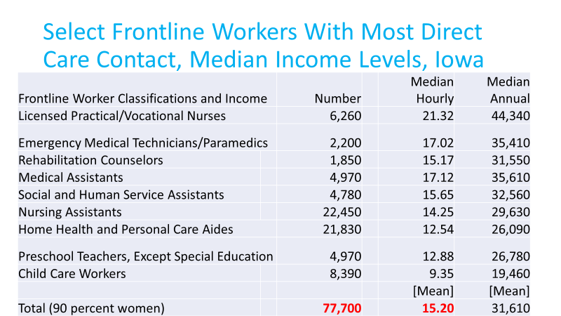
As the chart shows, according to the BLS classifications, there are at least 77,700 Iowans working in direct care in lower-level positions – positions with generally lower formal education and certification requirements. The lowest paid of these – nursing assistants, home health aides, and child care and preschool teachers – are the primary focus of the Plan for a 21st Century Caregiver and Education Workforce and make less, and many substantially less, than $15 per hour or $30,000 per year. Raising the minimum wage to $15 per hour would affect many of these workers and begin to raise their compensation closer to levels of their worth and value.
Most of these workers rely in very significant measure upon the government and the public sector to support their work, as a public good and because most of the people they serve cannot afford to bear the full cost for their services. Their low compensation, in large measure, is a consequence of low levels of reimbursement received for their services, including public sector reimbursements. Many direct care workers are part of health systems which rely upon Medicare and Medicaid payments, while half of all current financing of child care is through federal child care subsidies or tax credits (the rest is from parent contributions).
Other positions in the helping professions – registered nurses, social workers, therapists, and mental health providers – receive higher rates of compensation, but still well below that for other workers with similar education and training backgrounds.
- What Will Increasing the Size, Compensation, and Resources for the Helping Community Workforce Do.
The first and most important benefits to strengthening the size, compensation, and resources for the Helping Community Workforce is to improve the quality of life of those who need and benefit from the services they provide. This includes eliminating shortages in the availability of such workers, but it also means improving the continuity and skill of this workforce in providing care. Reducing turnover and burnout is particular important for jobs that require trusting and respectful relationships to the people being served.
In addition, however, the Helping Community Workforce plays a vital role in ensuring economic vitality and prosperity. In fact, investing in this workforce has multiple “returns-on-investment” to business, society, and the economy as a whole, through:
- Strengthening society through enabling people to maintain themselves and reach their potential.
- Providing new sources of jobs (in a world where many sectors are subject to AI and automation and competition in an increasingly world-wide source of labor) and therefore growth in the economy.
- Making those currently in the workforce more productive (through providing child care to enable work and home health care to remove burdens from families for 24-7 care)
- Reducing poverty within the helping workforce itself and creating long-term and career employment (also reducing turnover and therefore improving continuity and skill in the workforce)
- Advancing equity in society – through both employment and earnings and response to people in urban and rural communities most affected by COVID-19 and by economic disadvantage
- As part of a stimulus package, immediately putting money into local economies to aid in economic recovery
- Reducing needs for other government safety net expenditures and increasing the overall tax base, through providing more family-sustaining employment and higher earnings.
Simply put, increasing the size and improving the compensation for this workforce should be viewed as an investment in the economy and recognized for the jobs such investments create and sustain.
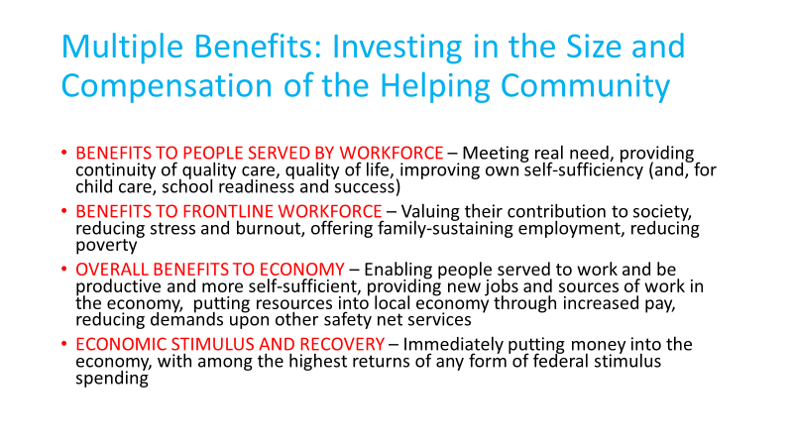

- Where are there Current Opportunities for Leadership in Public Policy?

The COVID-19 pandemic has raised to new visibility the importance of this workforce. At both the federal and state levels, leaders have provided a new vision for government in recognizing and advancing this workforce.

At the federal level, President Joe Biden has proposed a “Plan for a 21st Century Caregiving and Education Workforce” involving a ten-year, $775 billion federal investment in strengthening the direct care and child care workforces. Coupled with other plans to strengthen school-based services, health care, juvenile justice, and early childhood, President Biden has outlined an agenda for economic recovery and meeting the needs of rural and urban America for quality health, education, and human services. Some of these provisions have been incorporated into both CARES Act funding and the American Rescue Plan Act funding. The Administration and Congress now are working on infrastructure legislation, with specific provisions to build that workforce and make permanent some of the funding provisions in the Rescue Plan Act.

At the state level, in her Vision for Iowa, Governor Kim Reynolds has emphasized the need for prioritizing support for this essential workforce of caregivers and educators:

“Iowa’s economic recovery plan is about more than yesterday’s goals. It’s a new opportunity to build a better Iowa, elevate how we do business, modernize how we work and learn, and further improve our quality of life.”
- “One of the most significant barriers to entering the workforce is the availability and affordability of childcare. … The child are crisis is not only affecting families, it’s impacting the state’s workforce at a time when Iowa is missing out on nearly $675 million in annual GDP because of a shortage of employees.”
- “Health care the way it exists today may not be sustainable in some areas. But with change comes the opportunity to create a more integrated, coordinated system promoting the health and wellness of every Iowan. … The Governor acknowledges the importance of home and community-based care for aging and disabled individuals, and the difference these services make in maintaining health and quality of life. “ – from – Vision for Iowa: Preparing a Future Ready Iowa … Supporting Strong & Healthy Families … Empowering Rural Iowa

Through Iowa Workforce, there is a specific planning group focusing upon child care.

While the federal government is essential in providing financing to strengthen this workforce, states must play a major role in implementation and making effective use of that federal financing. Leadership is required at the federal and state levels at the policy-making and administrative levels.

There is strong public support for such actions, based upon Iowa values of community spirit, caring for one another, and enabling Iowans to contribute to the economy and raise the next generation. The Iowa Helping Community Policy Group is committed to working in a nonpartisan way to advance this work, bringing the expertise of those in the caregiving and education community and the people they serve – to enacting and implementing effective approaches to advance this workforce.

*****
For more information about the Iowa Helping Community Policy Group, contact Charles Bruner at bruner@childequity.org or visit and join the facebook group, Iowa Helping Community Policy Group (https://www.facebook.com/groups/3401982129885549) and the group’s website, www.iowahelpers.org. The Group has not yet incorporated and is supported by inkind contributions of its members but considers itself a nonpartisan, nonprofit group.

