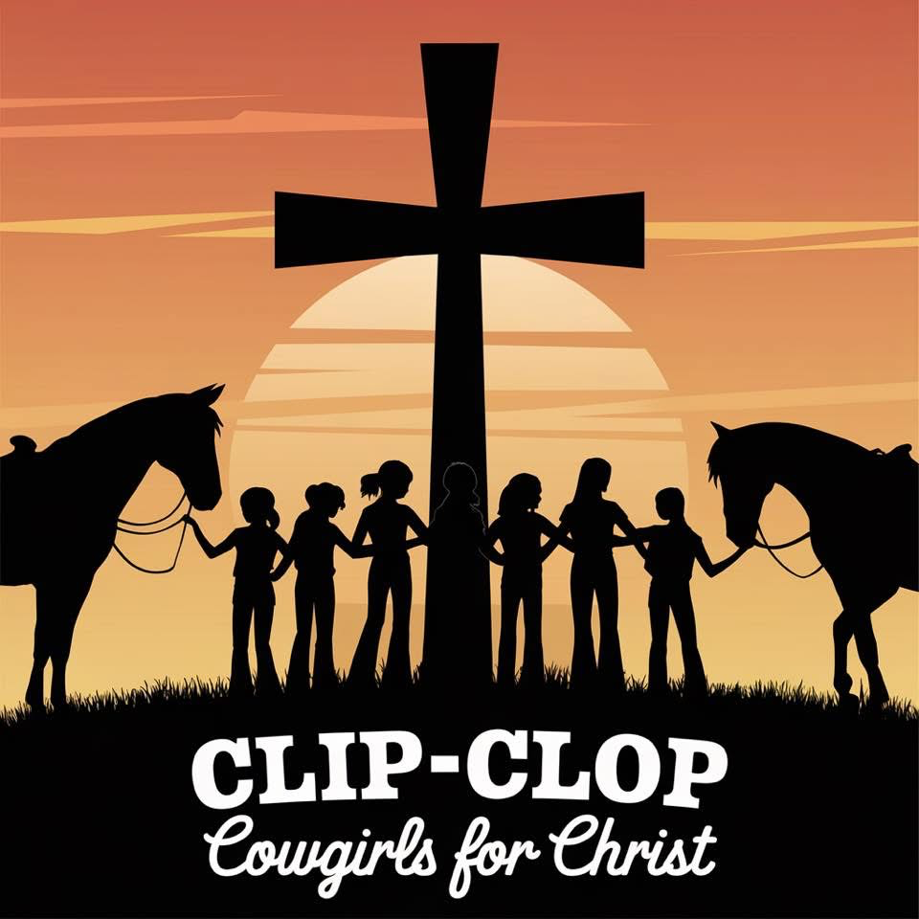  
**CLIP-CLOP FARM 2025 HORSE CAMP REGISTRATION FORM**

Name_______________________________ Age________ Height_______Weight_________

Address____________________________________________________

City_______________________State_____________Zip_____________

Cell phone___________________________________

Email Address________________________________

Emergency Contact_______________________ Phone___________________

Known allergies/Health concerns____________________________________

T-shirt Size • Youth S M L XL

• Adult S M L XL

Camp Dates (Circle which camp you plan to attend)

* June 30-July 3, 2025 (Lead-line & Beginner Camp)
* July 14-17, 2025 (Lead-line & Beginner Camp)
* August 11-14, 2025 (Intermediate Camp)

Camp time- 9AM-2PM

Each camp is $500.

$200 Non-Refundable Deposit due at time of Registration.

The remaining balance of $300 will be due on the 1st day of camp. Make checks payable to Clip-Clop Farm, 24949 SW Baker Road, Sherwood Oregon 97140 or can Venmo @clipclopfarmllc

Things to Bring to Camp

1. Lunch/Drinks
2. Bible/Journal
3. Riding clothes/boots
4. Helmet

Briefly describe the camper’s riding experience: ____________________________________________________________________________

____________________________________________________________________________

CLIP-CLOP FARM, LLC & ROLLING ROCK FARM, LLC Release and Waiver of Liability and Indemnity Agreement For valuable consideration, receipt of which is hereby acknowledged, and with the knowledge that the undersigned is undertaking to walk, ride, and control a horse, an inherently dangerous activity, with or without the supervision of an instructor, the undersigned:

Hereby RELEASES, WAIVES, DISCHARGES AND COVENANTS NOT TO SUE Eva Cameron, Jan Noordhoff-Hammond or Ned Hammond, individually and doing business as Clip-Clop Farm/Rolling Rock Farm LLC, their personal representatives, heirs, assigns and next of kin and hereby releases them, (hereinafter “RELEASEES”) from all liability to the undersigned, his personal representatives, assigns, heirs, and next of kin for all loss or damage, and any claim or demands therefore on account of injury to the person or property or resulting in the death of the undersigned, whether caused by the negligence of the Releasees or otherwise, while the undersigned is walking, riding or standing in proximity to any horse whether under the supervision of the Releasees or not and regardless of the horse’s ownership.

Acknowledges the inherently dangerous activity described above and hereby ASSUMES FULL RESPONSIBILITY FOR AND RISK OF BODILY INJURY, DEATH, OR PROPERTY DAMAGE due to negligence of Releasees, or otherwise while in proximity, walking, riding or controlling any horse.

THE UNDERSIGNED EXPRESSLY ACKNOWLEDGES AND AGREES THAT THE ACTIVITIES UNDERTAKEN BY THE UNDERSIGNED ARE DANGEROUS AND INVOLVE THE RISK OF SERIOUS BODILY INJURY AND/OR DEATH AND/OR PROPERTY DAMAGE. THE UNDERSIGNED ACKNOWLEDGES THE VOLUNTARY PARTICIPATION BY THE UNDERSIGNED IN THESE ACTIVITIES. The undersigned further agrees that this Release, Waiver and Indemnity Agreement is intended to be as broad and inclusive as permitted by the laws of the State of Oregon, and that if any portion hereof is held invalid, then the remainder of this agreement shall continue in full force and effect.

THE UNDERSIGNED HAS READ AND VOLUNTARILY SIGNED THE RELEASE AND WAIVER OF LIABILITY AND INDEMNITY AGREEMENT, AND EXPRESSLY ACKNOWLEDGES THAT NO INSURANCE COVERAGES OF ANY KIND IS TO BE PROVIDED, INCLUDED OR GUARANTEED BY Releasees. The undersigned expressly acknowledges that no oral representatives, statements or inducements apart from the foregoing written agreement have been made.

DATED________________________________2025

Signature (Parent or Guardian) ___________________________________________________

Rider’s Name_________________________________________________________________ Address______________________________________________________________________

City, State, Zip_________________________________________________________________

Phone ___________________________________ Email_______________________________