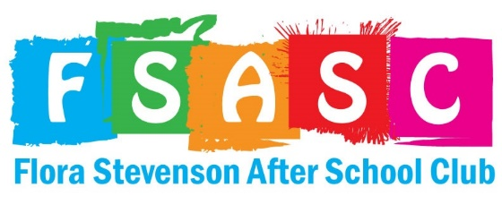
Family Honesty and Integrity Policy
Flora Stevenson After School Club prides itself on the open and honest relationships we develop with our service users. To ensure we provide a safe, fair and supportive environment for all children, it essential that guardians provide accurate and honest information in all interactions and paper work at flora Stevenson after school club. This policy applies to all guardians who communicate or interact with FSASC in any capacity. This includes registration, health information and daily club operations. This is an unsigned agreement between FSASC and guardian who registers their child with us.

Accurate Information
- Guardians are expected to provide FSASC with accurate information during registration
- Guardians are expected to update FSASC with any information changes in a timely manner. This includes but it not limited to contact information, medical information, custody arrangements, name changes etc.
- Guardians expected to provide authentic documents to FSASC when required (for example medical plans given by a GP/Hospital, proof of place at Flora Stevenson primary school)

Honest Communication
- Guardians will communicate openly and truthfully with staff at FSASC
- Guardians will not intentionally withhold relevant information that could impact the child’s safety or well being when we care for them

Ethical Conduct
- Guardians will refrain from making false claims, accusation or statements about other children using the service, the staff team or Flora Stevenson After School Club in general
- Guardians will address any concerns they have by following our complaint procedure with integrity and respect

Failure to abide by this policy
If guardian fails to comply with this policy the following will take place
- FSASC may request a meeting to discuss concerns
- FSASC will document the incident in our records
- FSASC could limit or remove all sessions offered to the family
- FSASC could reject all future application to the service
- FSASC will take any additional actions they feel are required e.g reporting the parent to social services, sharing the incident with the school

Commitment to an open and honest relationship between guardians and FSASC
FSASC believe that positive, open and honest partnerships between families and Flora Stevenson After School Club lead to better outcomes for children who attend. By adhering to this policy guardians support us to create a community built on trust safety and mutual respect for one another.

