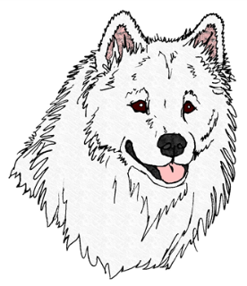

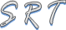
Recognized Affiliate of National Samoyed Rescue

ASSUMED OWNER SURRENDER

Date: ___________________
I, __________________________, give ___________________________full authority to act as sole owner in matters relating to the Transfer of Ownership of the Samoyed(s) known as _______________________________________________________to Samoyed Rescue of Texas.

I understand, and agree that _______________________________is transferring ownership of the Samoyed(s) known as _____________________________to Samoyed Rescue of Texas for adoption. This is being done with my full knowledge, understanding, and consent.

__________________________________,____________________ Date: ___________

__________________________________, Samoyed Rescue of Texas, Officer

Samoyed Rescue of Texas Use Only:
Accepted: (SRT Officer):
Printed Name: Date:

Email: samrestx@yahoo.com

