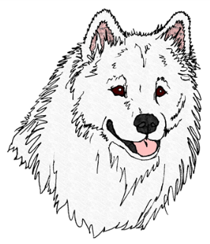
1.

Shelter Evaluation
Evaluator: Click here to enter text.
Date: Click here to enter text.
Location: Click here to enter text.
Dog ID # and Name: Click here to enter text.
Microchip Number: Click here to enter text.
Status:
O/S: Click here to enter text.
Stray: Click here to enter text.
Other: Click here to enter text.
Intake Date: Click here to enter text.
Rescue Only: Click here to enter text. Adoptions: Click here to enter text.
Hold Date Up: Click here to enter text.
Euth. Date: Click here to enter text.

Overall Condition of Dog
Age: Click here to enter text.
Fur: (double-coated, thin, full, dirty, matted, etc.) Click here to enter text.
Skin: Click here to enter text.
Color: Click here to enter text.
Fleas, Ticks, sores: Click here to enter text.Injuries / Infections: Click here to enter text.
Paws: Click here to enter text.
Gums/Teeth: Click here to enter text.
Eyes, (Color & Condition): Click here to enter text.
Nose: Click here to enter text.
Ears: gtood, clean
Height: Weight; Click here to enter text.
Underweight: Click here to enter text.
Overweight: Click here to enter text.
Normal: Click here to enter text.
Spayed/neutered: Click here to enter text.

General Info:
Sex: Click here to enter text.
Overall temperament: Click here to enter text.
Reaction to other dogs in shelter: Click here to enter text.
Reaction to cats in shelter: Click here to enter text.

Food aggressive; w/humans: Click here to enter text. W/dogs: Click here to enter text.
Known/Unknown: Click here to enter text.
Toy aggressive; Click here to enter text.
Known/Unknown: Click here to enter text.
Behavior around kids: Click here to enter text.
Know any commands: (sit, down, shake, etc.): Click here to enter text.
Leash training: (Pulls hard, wanders, turns, well-trained): Click here to enter text.
HW Status: Click here to enter text.
Known Medical conditions: Click here to enter text.
Housebroken: Click here to enter text.
Crate trained: Click here to enter text.
Heartworm/Flea & Tick Prevention: Click here to enter text.
Known/Unknown: Click here to enter text.
Vaccinations: Click here to enter text.
Vet records available? Click here to enter text.
Reaction to touch: (Paws, head, legs, hips, ears, mouth) Click here to enter text.
Head Shy? Click here to enter text.
General behavior; (Outgoing, friendly but hesitant, submissive, scared, attentive, aloof, playful): Click here to enter text.

What is this dog’s story?
Click here to enter text.

General Comments & Observations:
Click here to enter text.

Photographs & Videos: Please try to get several close ups of head, eyes, teeth, paws, side view (left & right), tail set, frontal view (head & legs)

Additional Information:
Click here to enter text.

