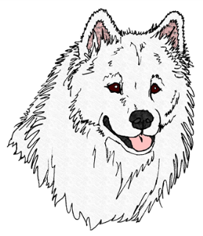

Recognized Affiliate of National Samoyed Rescue

Release, Surrender, and Transfer of Dog Ownership
I/WE, , the owner or authorized agent of the Samoyed / Samoyed mix dog described below, do hereby relinquish all my/our ownership rights and responsibilities of the dog and donate the dog to Samoyed Rescue of Texas. To the best of my/our personal knowledge, the dog HAS ( ), or HAS NOT ( ) bitten any person. (Initial answer and explain details of known bite history below, or use additional sheet.)

Call Name: Registered Name:
Microchip #/Tattoo: Registration #:
Age/DOB: Weight: Sex: Spay/Neuter:
Color and Markings:
Medical Condition’s:
Existing Food(s): Medications:
Rabies Tag/Date: DHLP: Parvo: Bordetella:
Canine Influenza: Other:
Reason for Surrender:
General Comments/Bite History Information:
Surrender of Rights: By executing this document, we understand that we are giving up forever all right, title, and interest to the aforementioned dog(s).
Release and Indemnity: Donor hereby specifically and forever release, and hold SRT (its Board of Directors, its members, officers, and agents) harmless from all claims, demands, actions, causes of action, and any and all liability arising from the placement for adoption by SRT, in accordance with, and in reliance on, the representations we have made and the authorizations we have provided under the terms of this document. I/we agree to indemnify and hold harmless SRT for any damages suffered and expenses incurred (including legal fees) in defending any legal action, whether for bodily injuries
or death, property damage, breach of contract, or otherwise, whether instituted by us or by any other person or persons including the adoptive owners, arising out of or in consequence of the placement of the dog, in reliance on the authorizations, representations, and warranties we have made in this agreement.
Donations: It is understood that rescue does not buy, or pay for dogs. This is a service to help place Samoyeds and Samoyed mixes in new homes when their present owners, municipal or private shelters, or animal sanctuaries can no longer care for them. This service is free, and no dog will ever be turned down because of the lack of donation, but a donation to help pay for rescue expenses is appreciated.

Donor(s) Signature:
Address:
Phone: Date: Email:
Donor Is: [ ] Owner, [ ] Finding Individual, or [ ] Organization/Other:

Receivers Name:
Receivers Signature:
Receivers Address:
Receivers Phone: Date:
Receivers Email:
Affiliation of Receiver:

Email - samrestx@yahoo.com

