NORTH-EAST’S DAIRY CHAMPION WINS GOOD FARMING PRACTICE AWARD

North-east dairy farmer, Roddy Catto, who has ridden out the milk price crisis by creating innovative new income streams for his farm of Hillhead of Muirton, Whitecairns, has been named as winner of the Royal Northern Agricultural Society’s annual good farm practice award, sponsored by Aberdeenshire Council.

Judge, Martin Birse, farm manager at Pitgaveny Estate, Elgin, and a former president of the society, admitted he was looking for something “quirky” and different in judging this year’s award.
“We are facing strange times in farming at the present time and creating a diversified income is one way of maintaining the viability of a farm in difficult times,” said Mr Birse.

He commended Mr Catto and his wife, Angela, for their canny investment in second hand robotic milkers to improve their quality of life compared with the drudgery of getting up at 4.00am every morning to milk cows.

They had also taken advantage of their location close to the new Western Peripheral Route around Aberdeen to provide temporary parking for lorries on a site earmarked for a new Dutch barn and had invested in a 200kW biomass boiler to heat four houses.

“They are demonstrating real drive to diversify their business and create additional income strains for their business,” said Mr Birse.

Current Scotch Beef Farmer of the Year, Pete Watson, who runs a beef herd of 440 suckler cows and followers at Darnford, Durris, with sons, Adam and David, and their wives, Aynsley and Lynne, took the runner-up award.

“It was a very difficult competition to judge and the Watson’s have a perfect business,” said Mr Birse. “But the Catto’s met the criteria I had set myself for judging more closely.”
Deputy Provost Alison Grant said the two winning farms had set an “outstanding example” to others in the industry.

“The study of the land-based sector commissioned by the council earlier this year highlighted the ready willingness of the farming industry to adopt innovation and continuous improvement,” said Ms Grant. “But the evidence suggests meaningful progress is invariably driven by exemplars and role models.”

Ms Grant confirmed the council’s continued support for the good farming practice award, which the council had sponsored since 2005, and said the council recognised the huge contribution made by the farming, food and drink sector to the economy of Aberdeenshire.

Mr and Mrs Catto farm a total of 700 acres in three blocks and milk 135 cows, with all milk being sold on a Tesco contract, as well as running a small beef suckler herd of 24 cows. Total stock on the farm, with young stock, is 400 and cropping comprises 340 acres of winter and spring barley and oats.

A land improvement project has recently started and additional income comes from three properties which have been let out.

Mr Catto has been at the forefront of fighting the cause of dairy farmers as chairman of the Muller Wiseman Milk Group, representing the interests of 2000 UK milk producers and chairman of the North-east region of NFU Scotland.

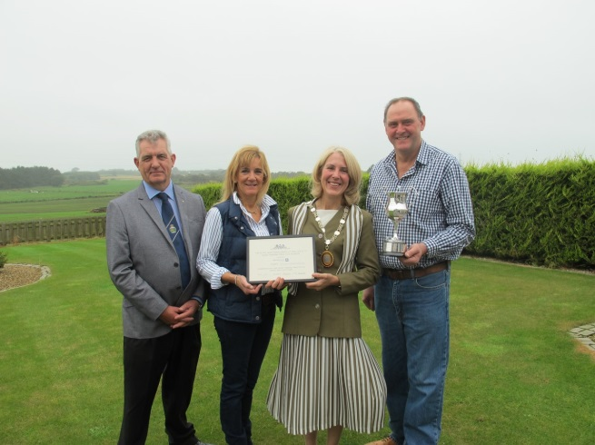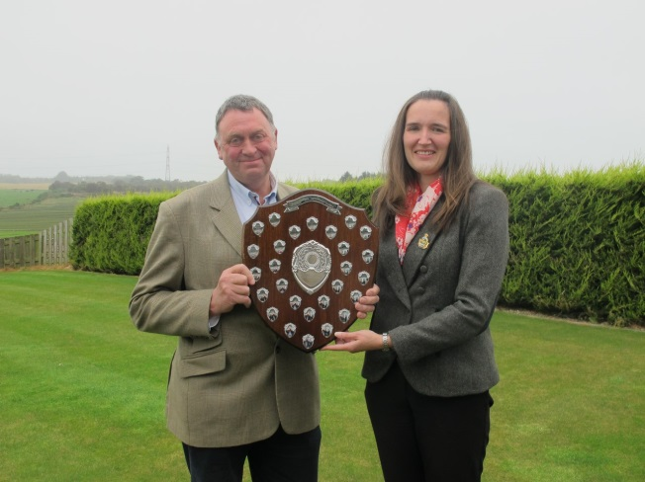
Pictured: RNAS President, Janelle Anderson presenting the runner-up award to Pete Watson.

Pictured: Judge, Martin Birse & Deputy Provost, Alison Grant presenting the Award to Roddy & Angela Catto.

Report courtesy of Farm North-East publication

