Transition Advisor Meeting Minutes, 11/02/2020

In attendance: Peggy Raun-Linde (minutes), Desirie Torres, Christian Rodriguez, Janie Garcia, Tina Dave, Felisa Vilaubi, Anthony Moss

Agenda Minutes:

- Review minutes: All fine. Will post on web.

- Debrief MVLA Fair:

- Tina: Goal was to make it focused, concise. Past large number of colleges and career folks. This time very focused and less. Students in classes 9:30-12 so hard to fit it all in such a short time. Students seemed like they got what they needed and happy to get what they need without having to reach out.
- Felisa: Really good event. Outreach folks had some feedback: Having two separate presentations with FHDA was a little complicated. Outreach is wondering if it can be done together in the future: FHDA in same room. Also, Tina had a lot to organized and was moving back and forth between concurrent sessions; maybe have someone could help Tina with this so she is not split.
- Specific “hear is what the students want to hear about” ahead of time would be good. Maybe a google form ahead of time to get a questions would help presenters be ready. Adjust slides and have specific information that they have requested. We learned that at the FUHSD joint event. Really helped get students what they needed.
- CTE and ASE together will follow common steps to enroll. Potentially put those together and ESL in their own.
- Dual enrollment: Nubia and AE students different; how do we make sure outreach knows what is happening with Dual Enrollment? Felisa: Trying to intentionally get AS to reach out to outreach and have them present to help them see how important AS is.
- CAA: Teachers want to go with their ESL students.
- Peggy: Super great event. Great questions from students. Students were so brave to unmute and ask questions. Came prepared and had done research on colleges and programs.
- Felisa: Yes, great event and metacognitive above is for future but it was a great event. Tina please know it was a great event you hosted and the metacognitive notes don’t take away from how great it was.

- Desirie share out of FHDA joint presentation:
- Went really well. Debriefed after and some thoughts:
- Going to go back into pushing it into the classroom because didn’t get as many
- Exit survey: 100% learned something and 100% felt it was worth their time.
- 10 of 12 were sped students and was helpful to have smaller size; they were more comfortable group and they unmuted and asked questions.
- Felisa: Desirie asked for separate sessions and turned out to be the best even though CC asked about joining them. Worked out the best.
- Desirie: CC slides were really good. Felisa: Was helpful Desirie told what students needed ahead of time so could tailor slides accordingly.
- CC really enjoyed doing them jointly. Different energy when it is combined versus compartmentalized. Seeing colleges together helps to see there are some differences but it’s the same district.

- ESL Placement: What do Transition Advisors need to know to guide students through the process of placement for enrollment?

- Placement test: If they have it before they meet with counselor, then they can have a better session. It will be concrete versus hypothetical. Less confusion for the students. Also helps that warm handoff.

- Foothill: Best process: Language Arts Guided Self-Placement. Once they apply to Foothill and have their CWID, they should email their first and last name to: FHtesting@fhda.edu and request the LAGSP. Staff will then connect them with the placement test.

- De Anza is almost the same except they are using the placement test. Link online to fill out the form and start the process for the placement test. Here’s a video of Felisa showing us: https://youtu.be/UMrcVi1ABZk
Student will get an email within three days: very “thick” text that talks them through what to do. Tell them to be on the lookout, look in spam/bulk mail. NOTE: ESL results takes 2-3 weeks. Would be good to let them know this so they do it well in advance. Do it way ahead of registration opening. Foothill gets it out quicker.

- Please note that if they get a split placement due to reading and writing, they must register for the lower level first (all three courses) to complete it before they can advance unless they petition for advancement and are approved.
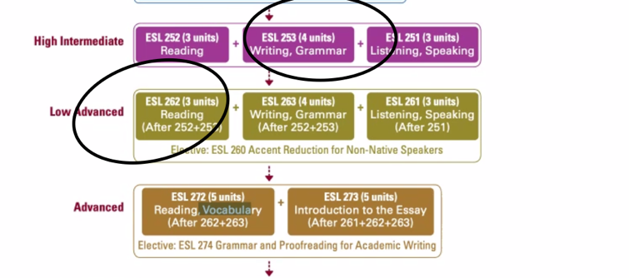
Good for AS to know. CC counselors will work with the student, but should be aware if they contact you. 92% accurate but 8% this could happen.

- Both websites outline it well also. Peggy can put those links on the counselor page on our website NSCAdultEd.com.
- De Anza Placement: http://deanza.edu/assessment/
- De Anza ESL Placement: https://www.deanza.edu/assessment/esl.html
- Foothill Assessment: https://foothill.edu/assessment/

- Another thing to know, De Anza recommends that students are in the 260 levels before taking other non-ESL courses. Sometimes it works with certain classes like ECE but important for the CC counselors to have the conversation.
- Issue of caseload for De Anza counselors discussed. 3000 student caseload. Each counselor meeting with about 250 students per month.

- Dual enrollment form: One adjustment still to be made.

- MVLA will meet about the form tomorrow.
- Desirie met with Lori and Adrienne: Go over concurrent opportunities. Identified some who are in ASE and classes they could take. DT will go over it at presentations tonight or tomorrow night with students.
- Anthony chatted with Alex. Was well aware. One or two students may be ready to dual enroll. Anthony will go over with new supervisor Lynn Tanner.
- Scenario: A student is in an ESL class and au pair, do they have to have F1? No. just have to be dual enrolled. Social security and visa status does not matter.
- Reminder that student can enroll in 11.5 total students per quarter (note it’s combined: FH and DA). Students CAN petition to take more than 11.5 units and not start the Promise; note that they will have to pay for all of the units. If you have this, contact Felisa/Christian/Janie and they can help. Students in spring quarter may want to do this to NOT start the promise clock so they will have 2 full years under promise.

Next Steps: Email about placement process for clarification. Please group email all listed above. We will clarify via email since next meeting is in December.

Next Meeting: December 7th, 1-2:30pm (expanded since we went 90 minutes the last two meetings).

