- Student Support WG Strategies
- Review all
- Actions needed from Board:
- Strategy 1: Survey and no responses from March request
- Outreach booking schedule: Due 6/5/2020. NOTE: June 8th Student Support: Assistant Principal or Principal representation from Adult Schools requested.
- Program contacts updated: Due 6/15/2020 https://nscadulted.com/consortium-contacts

- Transition Advisor / Counseling Page: Go here to track your student/counselor opportunities/responsibilities: https://nscadulted.com/counseling-services

- Leadership Retreat:
- Date of retreat
- Focus 2020-2021: Annual Plan and prioritizing “waiting” items in three-year plan

- CFAD Allocations:
- Review
- Vote (because Amendment)
- Next Steps: Approve via NOVA asap.

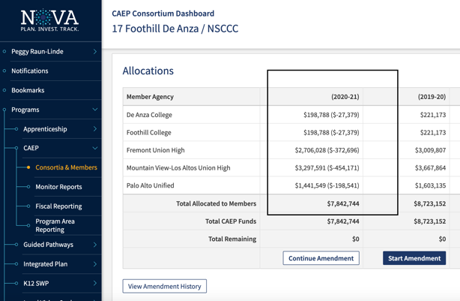

- Communication and engagement needs by the Board Members: Full participation by one member at each site for three work groups; response to WG requests; proactive with schedule conflicts; minutes; counselor/advisor engagement.

- Director’s Contract: Leadership Board continues without Director to determine 2020-2021 Contract
- Determine contract parameters
- Communicate with Director by 6/15/2020
- If applicable, MOU with RDA, invoice, and payment all completed by 6/30/20

- Adjorn

