

**Folding RC Car Stand Assembly Instructions**

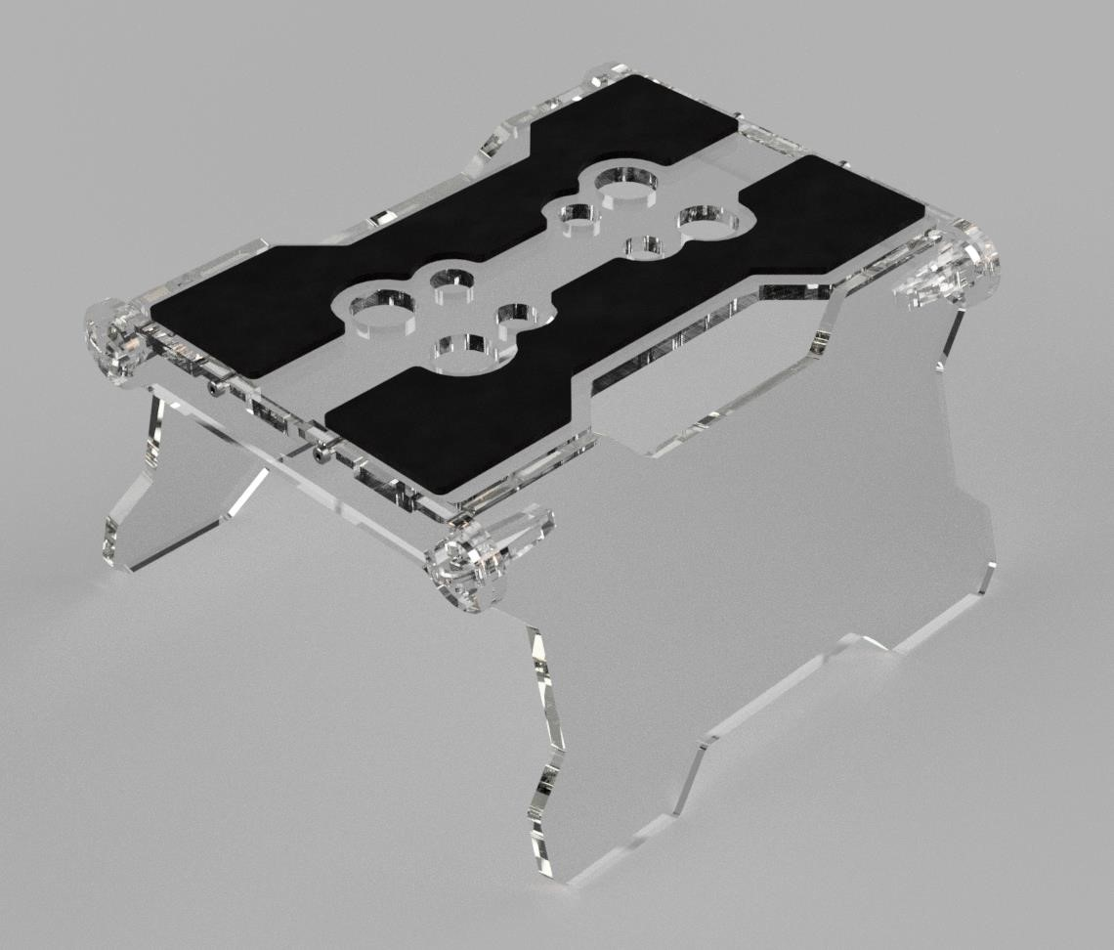

Join top part together with one connector, use 2x M3x12mm screws with a M3 nut on each. Just snug, Do not over tighten! A broken panel will result.

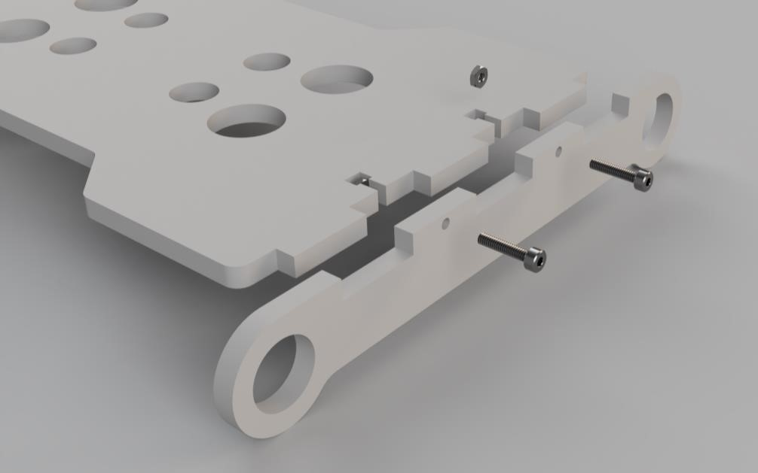

Place the 2 side panels (foots) in the holes of the connector and join the second connector to the top part with 2x M3x12 screws with a M3 nut on each. Do not over tighten! A broken panel will result.

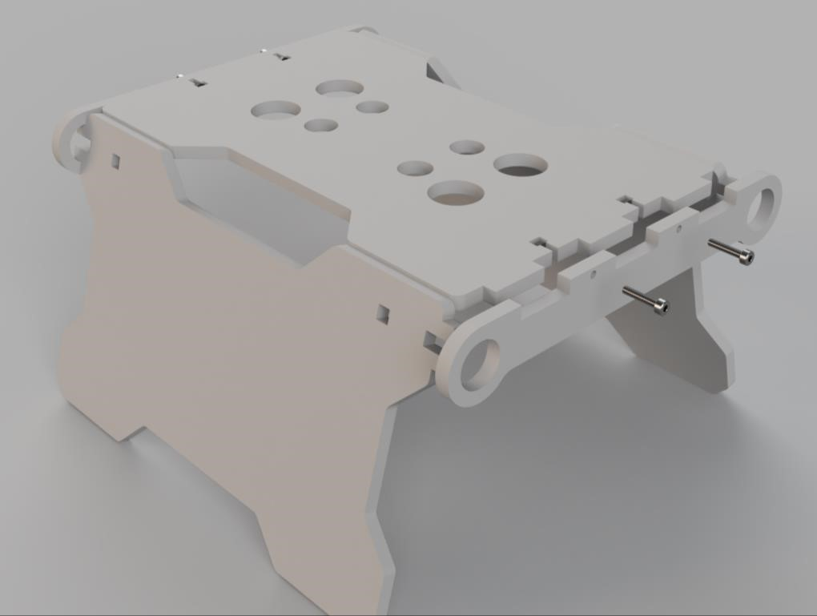

Attach the 4 clips shown below to the side panels, they will clip into place.

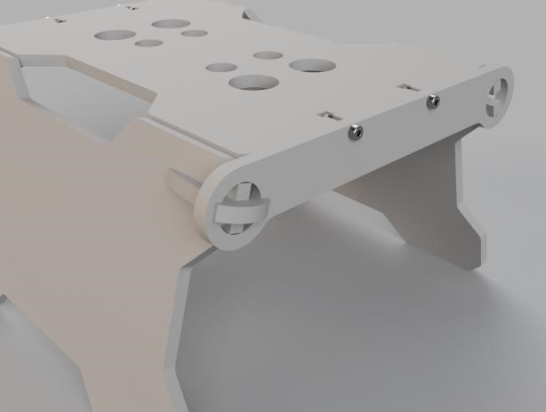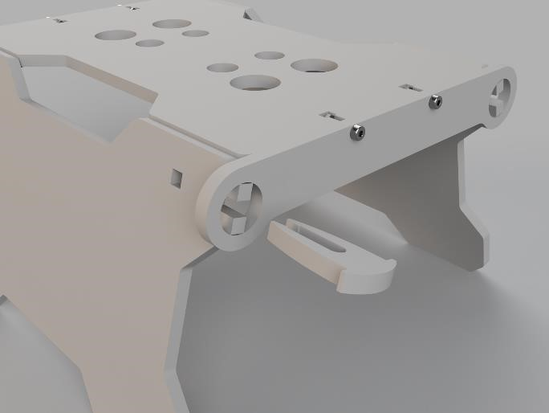

Stick the 2 foam rubbers to the top part. And your finished!

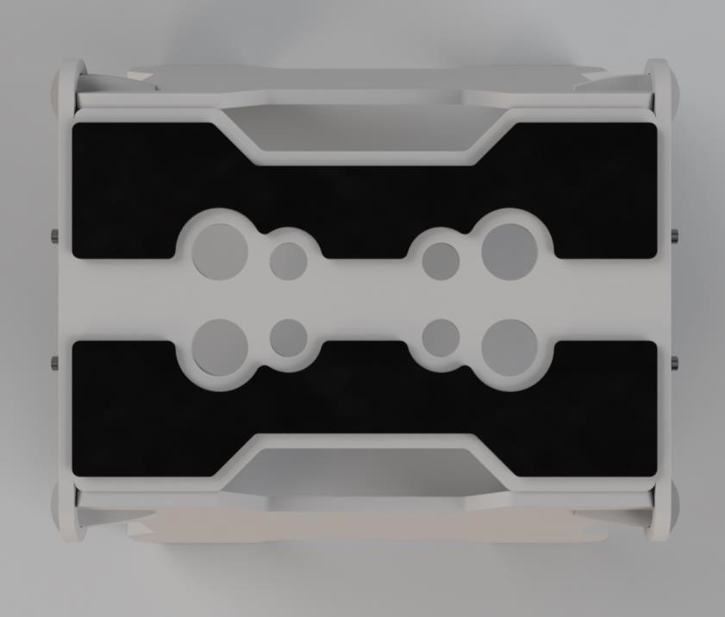

This document and all documents received are protected by copyright.Transfer, selling, publishing and commercial

use is strictly prohibited.