Caregivers do need to be licensed and certified to work in most settings.

How to get certified ....

CNA - the traditional Certified Nurses Aid – 70 hrs class 40 hrs clinical

HCA - Home Care Aid certification – 75 hours

Bridge HCA to CNA – 24 hours (HCA must be active prior to completing bridge)

Things to Consider

- Job options - who hires CNAs, who hires HCAs???

- Future education - thinking about nursing school or other health care profession??

- Portability - what if you change employers or move to another state

- Time Commitment

HCA - 75 classroom hours. Class meets 3 times a week for 5 weeks. Attendance required (no make-ups).
.
CNA - 65 classroom hours. Class meets three times a week for 6 weeks. During weeks 5 & 6 student will complete 40 clinical hours (5-6 shifts at local nursing facility). Attendance required (no make-ups).

Some recent changes to state law:
CNA students have 4 tries to pass the state test before having to retake a class. The CNA course completion certificate no longer “expires” after a year. The state test application is done on-line and requires email address.

HCA students must submit their license application and test application at the same time with total fee of a $222. This is the student’s responsibility but we will help you with the process.

Check point – how many hours in your class

On-line background checks:
You need a SAW account (Secure Access Washington) for background checks and renewing you license on line. Might as well get it done now. Follow this link to get your background check code. Submit that code before start of class.

Here’s the link
https://www.dshs.wa.gov/ffa/background-check-system

CNA CLASSES AND CLINICAL

Certification programs start every month. CNA classes 9am to 2:30pm Monday and Wednesday, skill labs 9-12 Friday. When there is interest, we will add an evening class 4pm to 9:30pm.

Clinical hours are required for CNA and Bridge programs. Clinical shifts generally start at 6am evening clinicals start at 2:30pm.

Clinical shifts are generally are Monday through Friday, during weeks 5 & 6.

Students must have a 2 step PPD (or equivalent) to be accepted at a clinical site. You can get PPDs at Care plus or your doctor’s office (check the health department too). You should get this done a couple weeks prior to start of class.

CNA students also need a “learner’s permit” – well, that’s what I call it. The health department calls it an R-NA (registered nursing assistant). This is required for clinical, but is quick to do on-line.

Here’s the link https://www.doh.wa.gov/LicensesPermitsandCertificates/ProfessionsNewReneworUpdate/ApplyOnline/OnlineInstructions

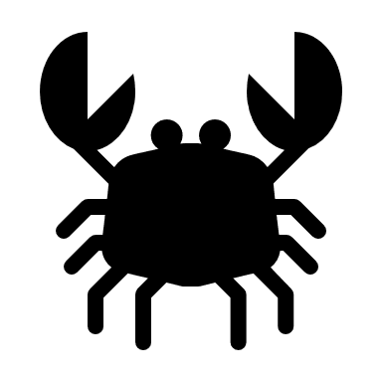Check point – what three things do you need before class starts?

HCA CLASSES

Classes are Tuesdays and Thursdays for 5 weeks. Classes begin at 9am but end times vary from 2pm to 5pm. There are 4 skill labs. There are Fridays 9 to noon during the first 4 weeks of class.

What else do I need to know? Glad you asked, well …..

Most clinicals are help in Bremerton or Silverdale. Sites cannot be confirmed in advance.

Bridge students will set up their schedule with the instructor after class one. Much of the classwork can be done in the Care Plus computer/skills lab. Bridge students are welcome to attend class with CNA students for a broader experience if they wish.

Nurse Delegation and Insulin Delegation are included in the HCA class and meet the Special Populations requirement. Dementia Level 1 and Mental Health Level 1 are part of the HCA program, as is 7 hour HIV-AIDS training and Orientation & Safety.

While not included in the CNA Program, CNA students may choose to take Nurse Delegation and Level 1 classes. It is recommended that this is done after completion of the CNA program.

Check point – What days and times does you class met?

Please plan ahead so that you may have a clear schedule to attend your classes.

Attendance to all classes is required. Missing class (or clinical) requires you re-enroll to a future program at full tuition. Missing a class makes it difficult to be well prepared for the state test. No make-ups or do overs.

Clinical sites schedule additional staff based on number of students doing clinicals. It creates a burden for our clinical partners when students do not attend clinicals as scheduled. CNA students need to make any arrangements needed to attend these 5 clinicals on the days and times scheduled.

Hey, do me favor….go back and read that last section again…I’ll wait……thanks

Fragrance free zone

No fragrance in the building. This is the current standard in health care. No fragrance in class or clinicals

Tuition Reimbursement – available from all skilled nursing facilities.

Other means of funding include Work Source and DVR if you qualify for these programs. KCR is another funding program and they invite you to drop in to an orientation to learn about all the ways they can help. In Port Orchard orientations are Mondays at 11am. Work Source is in the same building as well.

Job Placement Assistance – available to all graduates

Care Plus maintains the highest level of professionalism and care for our developmentally disabled and frail elderly clients. We expect this commitment from our students just as we do our staff. All are expected to dress and behave in a professional manner at the classroom and the clinical sites.

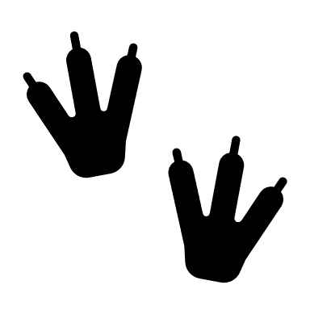Check point – what kind of fragrance should you wear to class?

One last thing about your Health Professional License (that’s the RNA, CNA or HCA)

Your license expires every year on your birthday. It is up to you to renew your health professional license every year in advance of your birthdate. Renewal fees are listed on the Health Department website as well as the continuing education requirement.

Continuing Education is required to work in most settings (by DSHS) even if it is not required for your license (by DOH). CE goes from birthdate to birthdate. That means it doesn’t carry over from year to year. Don’t wait until the last minute. Plan on done one CE every month so you are always up to date. Those mandatory trainings are there for a reason, so just do it.

Remember…behind every good nurse is a GREAT aid.

Check point – how often do you renew your health profession license?

When you use the shopping cart, you pay the application fee (CNA Program), tuition and books.

Supplies and uniforms are extra, averages costs are listed below. We’ll discuss getting yours supplies on day one of class.

Full cost of the CNA application fee, tuition and books is currently $800. When paid On-line this is discounted to $680

Full cost of HCA tuition and books is currently $495. When paid On-line this is discounted to $445.50

Payment plans are available too, just to an in-person Info Session to apply for a payment plan

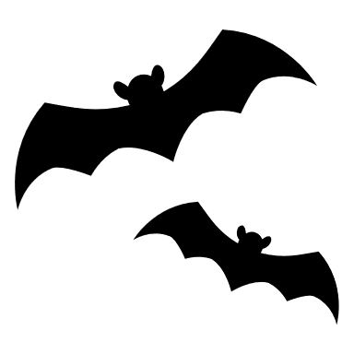Check Point – how must are tuition and books for my class?

You may get everything you need for class through Care Plus, but you are free to make other arrangements.

Other costs for CNA Program
PPD  (Tb skin test) | Recent 2 step required for clinicals | $ 30 each PPD at Care Plus other places vary
Gait Belt | Required for CNA students | $15 at Care Plus, other places vary
Scrubs | One set is required for CNA students. | $30 per set ($15/piece) from Care Plus (special orders extra), other places vary
RNA | Required for clinicals. | $65 payable to DOH  $67.50 when done on-line – which we encourage
Stethoscope & BP cuff | Required f or CNA students | $45-$65
Flu Shot | Required for clinicals during flu season | $ 25 at Care Plus other places vary

Check Point – Is gait belt required for your program?

FAQ type stuff

CNA students – Using the shopping cart is your registration – call or email if you don’t receive an email confirmation in a week or so. You receive $50 gift card upon course completion.

Complete your background check, apply for RNA license, get your two step PPD. You will receive another confirmation email with your class start day and time when we have approved your background check.

HCA students are registered when you use the shopping cart. You will also need a background check which can be done at the first class

All CNA candidates are given a standard sixth grade reading level test as well as a basic math test. It is intended to assure students will be able to manage the reading require during the class. The state test is only given in English and Spanish.

HCA students should use the Prometric web site to research language availability for testing.

CNA students need to get started on the 2 Step PPD/Doctor’s approval letter (or bring in your shot record). PPDs are available at Care Plus when reserved on day one. Failure to meet this requirement will mean removal from the program.

What about tuition payments? If the shopping cart doesn’t work out for you just come to an Info Session. Payments plan are approved at Information Sessions and a down-payment of $200 is due at first class.

What if I’ve paid for my program but find out Work Source will pay? No problem. You will receive a full refund on any amount you paid which is later paid by Work Source or KCR.

What if my boss said they will pay everything? You will need to attend an Info Session. Some employers are contracted with Care Plus, some can be invoiced for Tuition and books, some require you pay the application fee. Best to just come to a meeting and we’ll figure it out.

Do I need a book before class starts? Students may provide their own text (as long as it is the appropriate edition) or may order through Care Plus at the first class.

What about scrub & supplies? Students may provide their own or may order through Care Plus. We order scrubs and supplies in week 2. All students need to be in uniform by week three.

Check Point – do I take an English comprehension test for my class?

All certifications require a state administered test.

Pearson Vue does testing for CNA licensing at several locations.

HCA testing is done by Prometric in Port Orchard and in Bremerton.

Test sites fill very quickly, and it can often take 4 to 6 weeks after course completion to get a test date.

Good web sites to bookmark:
- Pearsonvue.com
- Prometric.com
- DSHS.wa.gov
- DOH.wa.gov
- CarePlusTraining.com

Wow…. that’s a lot of information. So, am I done?

No – that would be too easy….

You passed the class and passed your state test …now you are “certified”, but not licensed.
The last step is getting your DOH issued license. This means another form, some more money, and a bit more time.

Check Point – who is the testing company for my program?

So what do I do right now
CNA Students

- Get your Background check code number
- Get your RNA number
- Get your two step PPD
- Use the shopping cart to register
- Watch for a confirmation email
- Bring your picture ID to day one

HCA students
- Use the shopping cart to register
- Bring your picture ID and Background check code
- Watch for a confirmation email

