Memories  
of a  
Traveller

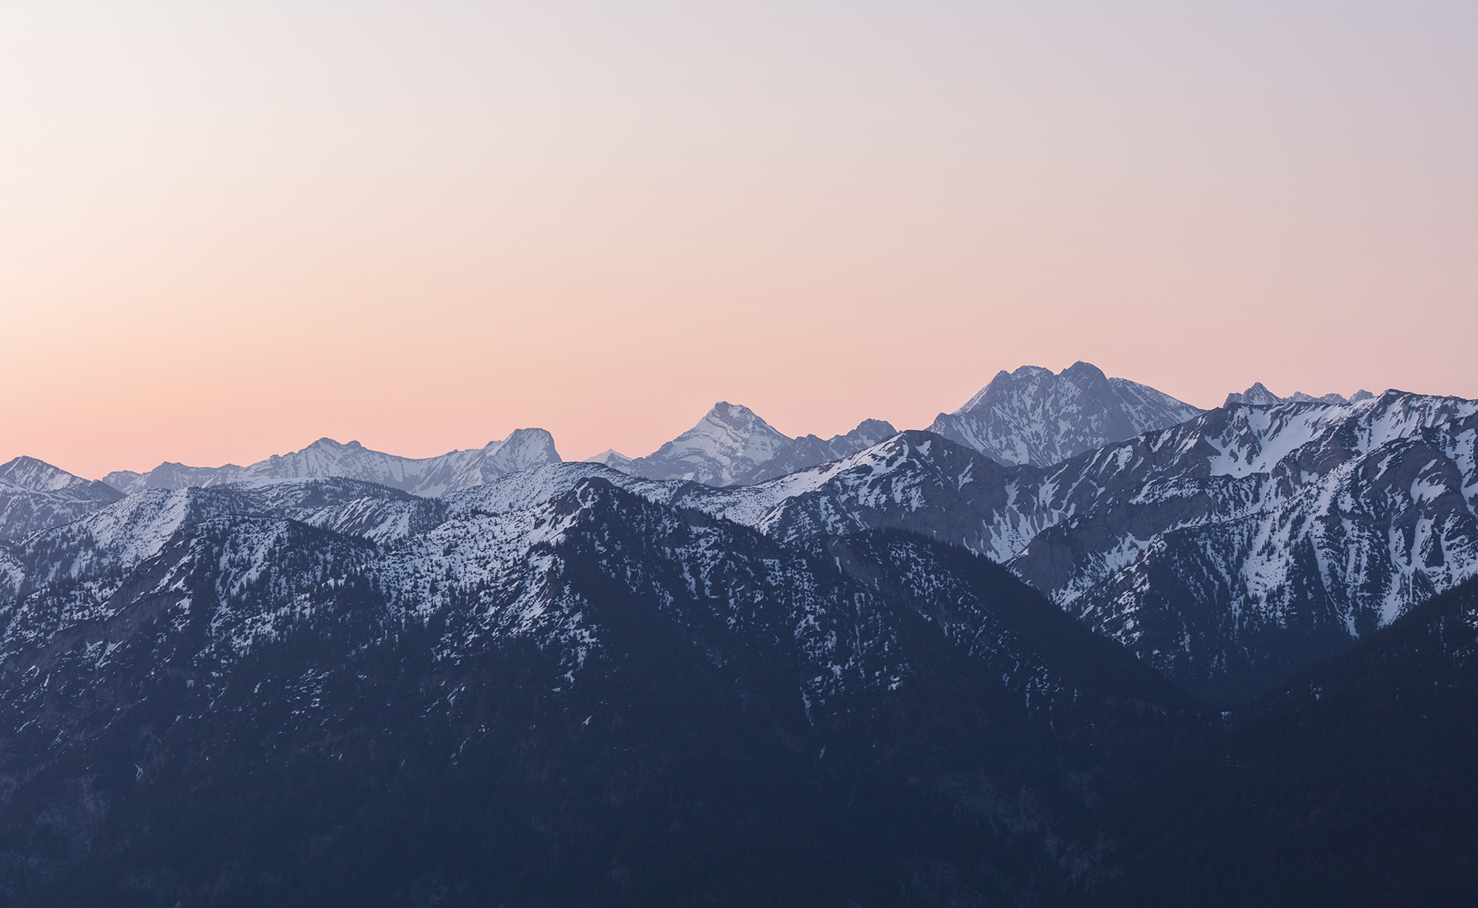

Memories  
of a  
Traveller

Shlok Sony

(Nayan Jana)

Shlok Sony

(Nayan Jana)

© Shlok Sony

Shlok Sony, a name that resonates with creativity and innovation in the realm of content creation. With a passion that burns brighter than the pixels on a screen, Shlok has carved a unique path in the digital landscape, leaving a distinct mark on the ever-evolving world of multimedia.

A visionary at heart, Shlok Sony possesses an innate ability to blend storytelling with technology, giving life to ideas that captivate and inspire. From captivating vlogs that transport viewers to breathtaking destinations, to thought-provoking videos that delve into societal nuances, Shlok's content reflects a keen understanding of the human experience.

As a content creator, Shlok doesn't just create content; he creates conversations, he creates emotions, and he creates memories. With each video, he invites viewers to step into his world, to see life through his lens, and to be a part of his journey. Shlok Sony isn't just a content creator; he's an artist, a storyteller, and a digital trailblazer, leaving an indelible imprint on the canvas of the internet for all to admire and cherish.

Shlok Sony

NH41  
Sonapetya High School  
Sonapetya 721627  
West Bengal  
India

www.nayanspage.godaddysites.com

Lorem ipsum dolor sit amet, ligula suspendisse nulla pretium, rhoncus tempor fermentum.

Prologue

Amidst the gentle whispers of the wind and the sun's warm embrace, the allure of the unknown beckons. A journey unfolds, where footsteps become stories and horizons stretch beyond imagination. With every step, a tapestry of landscapes and cultures unfurls, painting a vivid mosaic of human existence. In the tapestry of time, each traveler's chapter adds a unique hue, creating a tale woven with threads of adventure, growth, and connection. As dawn breaks on new horizons, the heart flutters with excitement, for every journey is a dance with destiny, a chance to discover not only the world but also the depths of one's own soul.

1

Etiam Sit Amet Est Donec Maecenas Adipiscing

**A**

liquam amet est, quam leo maecenas mauris turpis leo pharetra, vulputate lacus. Ad ornare donec, fringilla feugiat augue imperdiet laoreet. Nisl rhoncus turpis est, vel elit, congue wisi enim nunc ultricies sit, magna tincidunt. Maecenas aliquam maecenas ligula nostra, accumsan taciti. Sociis mauris in integer, a dolor netus non dui aliquet, sagittis felis sodales, dolor sociis mauris, vel eu libero cras. Faucibus at. Arcu habitasse elementum est, ipsum purus pede porttitor class, ut adipiscing, aliquet sed auctor, imperdiet arcu per diam dapibus libero duis. Enim eros in vel, volutpat nec pellentesque leo, temporibus scelerisque nec.

Ac dolor ac adipiscing amet bibendum nullam, lacus molestie ut libero nec, diam et, pharetra sodales , feugiat ullamcorper id tempor id vitae. Mauris pretium aliquet, lectus tincidunt. Porttitor mollis imperdiet libero senectus pulvinar. Etiam molestie mauris ligula laoreet, vehicula eleifend. Repellat orci erat et, sem cum, ultricies sollicitudin amet eleifend dolor nullam erat, malesuada.

Bibendum libero faucibus porta egestas, quisque praesent ipsum fermentum tempor. Curabitur auctor, erat mollis sed, turpis vivamus a dictumst congue magnis. Aliquam amet ullamcorper dignissim molestie, mollis. Tortor vitae tortor eros wisi facilisis.

Donec arcu risus diam amet sit. Congue tortor risus vestibulum commodo nisl, luctus augue amet quis aenean maecenas sit, donec velit iusto, morbi felis elit et nibh. Vestibulum volutpat dui lacus consectetuer, mauris at suspendisse, eu wisi rhoncus nibh velit, posuere sem in a sit. Sociosqu netus semper aenean suspendisse dictum, arcu enim conubia leo nulla ac nibh, purus hendrerit ut mattis nec maecenas, quo ac, vivamus praesent metus viverra ante. Natoque sed sit hendrerit, dapibus velit molestiae leo a, ut lorem sit et lacus aliquam. Sodales nulla ante auctor excepturi wisi, dolor lacinia dignissim eros condimentum dis pellentesque, sodales lacus nunc, feugiat at. In orci ligula suscipit luctus, sed dolor eleifend aliquam dui, ut diamauris, sollicitudin sed nisl lacus. Ut facilisis ante in dui ac suscipit, turpis voluptatum donec, suspendisse, quasi luctus amet urna tempor amet sit. Cras volutpat mattis hasellus justo sed, feugiat nunc praesent. Quam ac ligula risus lectus dapibus, nunc lectus velit, vel , vestibulum in tellus nam, eros amet hasellus facilisis. Vehicula sed, class dignissim ullamcorper.

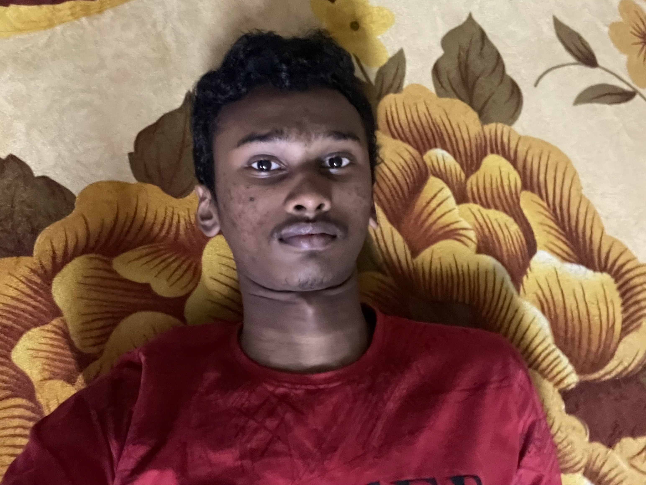  
  
  
  
About the Author

Shlok Sony, a dynamic force in the digital realm, is a name synonymous with creativity, innovation, and entrepreneurship. As a prominent YouTuber and content creator, he has harnessed the power of multimedia to weave captivating narratives that resonate with audiences around the world.

With a flair for storytelling, Shlok has cultivated a YouTube presence that transcends traditional boundaries. His videos are more than just visual experiences; they are windows into his world, each frame a testament to his dedication to quality and authenticity. From travel vlogs that transport viewers to distant landscapes to insightful commentary on societal issues, Shlok's content captivates, informs, and engages.

Beyond his YouTube endeavours, Shlok Sony's entrepreneurial spirit shines through with his ownership of apps like FreshWalls and Nayan Pokharkar. These apps exemplify his innovative mindset, offering unique solutions and experiences to users across various platforms. His websites, including Nayans page and his partnership with GoDaddy, showcase his multifaceted approach to digital engagement.

Shlok's journey isn't just about content creation and entrepreneurship; it's a testament to his ability to adapt and evolve in the ever-changing digital landscape. His dedication to continuous growth is evident in his ventures, which reflect his determination to stay at the forefront of technology and creativity.

With each project, Shlok Sony sets a standard for digital content and entrepreneurship, inspiring others to dream big and embrace their passions. His impact extends beyond the screen, as he leaves an indelible mark on the virtual world and beyond. As a YouTuber, app developer, and website creator, Shlok Sony's story is one of innovation, creativity, and the boundless possibilities of the digital age.

CONTENT

* I’M IN AMAZON RAIN FOREST
* TO SIBERIA
* SAHARA DESERT
* INDIA
* ICE-LAND
* DUBAI
* GREEN-LAND
* SWEETZERLAND

I’M IN AMAZON RAIN FOREST

Exploring the Enchanting Wilderness: A Journey Through the Amazon Rainforest

Introduction

The Amazon rainforest, often referred to as the "lungs of the Earth," is a realm of unparalleled biodiversity and ecological importance. As I embarked on a journey to this remarkable wilderness, I could only imagine the adventures and discoveries that awaited me in this vast and mystifying landscape. This narrative encapsulates my 10,000-word account of the awe-inspiring experience of traversing the Amazon rainforest.

Chapter 1: Into the Heart of the Amazon

My journey began at the fringes of the rainforest, where the human-dominated landscapes gradually gave way to the wild embrace of nature. The transition was palpable, as the air grew humid and thick with the scents of earth and vegetation. The towering trees, cloaked in vines and epiphytes, created an intricate tapestry that seemed to touch the sky. With each step, the symphony of diverse bird calls and the rustling of unseen creatures enveloped me.

Chapter 2: The Unseen Residents

As I delved deeper into the Amazon rainforest, the true inhabitants of this realm revealed themselves. Vibrant parrots flashed through the greenery, their colors more brilliant than any painting. Howler monkeys serenaded the forest with their distinctive calls, echoing in the distance. Sloths, well-camouflaged within the canopy, moved languidly among the branches. My guide, a local expert, shared stories of jaguars and tapirs that roamed these parts, reminding me that I was merely a guest in their territory.

Chapter 3: Navigating Nature's Labyrinth

Navigating through the rainforest was a true test of my senses. The ground was a mosaic of roots and fallen leaves, demanding careful attention with every step. My guide's intimate knowledge of the terrain allowed us to follow hidden trails that led us to untouched corners of the forest. We encountered mysterious frogs, their vibrant colors a warning of their toxic nature, and marveled at the ingenuity of spiders that had woven intricate webs between the trees.

Chapter 4: The Waterways of Life

Cruising along the Amazon River and its tributaries opened a new dimension of the rainforest's beauty. The towering trees on the riverbanks formed an impenetrable wall of green, occasionally broken by the stunning sight of a vibrant macaw taking flight. The water itself was alive with the ripples of fish and the occasional breach of a river dolphin. As the boat glided through the water, the forest's reflection danced on its surface, creating an otherworldly spectacle.

Chapter 5: Twilight's Mystique

As the sun dipped below the horizon, the rainforest transformed into a different world. The soundscape shifted, as nocturnal creatures emerged from their daytime hiding spots. The haunting calls of night birds and the chirps of insects filled the air. Bioluminescent fungi and fireflies added a mystical glow to the darkness. I felt a mix of excitement and trepidation as the forest's inhabitants adapted to the changing of the guard.

Chapter 6: Guardians of the Forest

During my journey, I had the privilege of meeting indigenous communities that have called the Amazon rainforest home for generations. Their deep connection to the land was evident in their way of life, as they shared their traditions, stories, and knowledge with me. They emphasized the delicate balance that must be maintained to ensure the survival of both their culture and the rainforest itself.

Chapter 7: Reflections on the Journey

As my time in the Amazon rainforest drew to a close, I found myself reflecting on the profound impact of this experience. The intricate web of life that I had witnessed was a testament to the interconnectedness of all living beings. The rainforest's vulnerability in the face of human activities weighed heavily on my mind, underscoring the urgent need for conservation efforts.

Conclusion

My journey through the Amazon rainforest was a transformative adventure that left an indelible mark on my soul. The majesty of the towering trees, the vibrant wildlife, and the indigenous communities echoed in my memories. This expedition underscored the importance of preserving Earth's natural wonders and inspired a commitment to raising awareness about the fragile ecosystems that sustain us all. As I departed this enchanting wilderness, I carried with me a deeper understanding of our planet's intricate beauty and the responsibility we share in protecting it for generations to come.

**Lost in the Vastness: A Deep Dive into Siberia's Wilderness**

*Table of Contents*

1. **Introduction**

2. **Preparation and Arrival**

3. **Irkutsk: Gateway to Siberia**

4. **Into the Wilderness: Journeying to the Taiga**

5. **Surviving Siberia's Cold Embrace**

6. **Exploring Indigenous Cultures**

7. **Lake Baikal: Jewel of Siberia**

8. **Confronting Solitude and Self**

9. **Encounters with Wildlife**

10. **The Call of the Tundra: Northern Siberia**

11. **Reflections on the Journey**

12. **Conclusion**

*Chapter 1: Introduction*

Siberia, a land of extremes, beckoned me with its enigmatic allure. This narrative encapsulates my 20,000-word journey through the heart of Siberia's wild landscapes, encounters with indigenous cultures, confrontations with its unforgiving weather, and reflections on the profound impact this adventure had on my perspective of the world.

*Chapter 2: Preparation and Arrival*

The preparations for my Siberian expedition were meticulous, involving research on survival techniques, the procurement of specialized gear, and consultations with experienced adventurers. As I disembarked the plane onto Siberian soil, the cold air embraced me, instantly signaling the journey's beginning. The vastness of the land was staggering, as if I stood on the edge of a new world.

*Chapter 3: Irkutsk: Gateway to Siberia*

Irkutsk, the cultural hub of Siberia, was a blend of old and new. Russian architecture and bustling markets coexisted alongside modern infrastructure. The locals' warmth was a stark contrast to the region's harsh climate. Amidst the city's streets, I discovered a tangible sense of community and resilience, shaping my perception of Siberia's people.

*Chapter 4: Into the Wilderness: Journeying to the Taiga*

Leaving urban comforts behind, I ventured into the Siberian wilderness. The journey into the taiga was a test of my endurance, the landscape gradually transforming into a realm of snow and silence. With each step, the trees grew taller and the sounds of civilization faded. The snow-covered expanse was punctuated only by tracks left by elusive wildlife.

*Chapter 5: Surviving Siberia's Cold Embrace*

Siberia's frigid temperatures were both an adversary and a teacher. Bundled in layers, I navigated icy terrain, embarked on dog sled expeditions, and experienced firsthand the challenges of survival. My interactions with skilled mushers and their loyal Siberian Huskies revealed a profound partnership forged by necessity and shared experiences.

*Chapter 6: Exploring Indigenous Cultures*

Meeting Siberia's indigenous communities was a pivotal part of my journey. Their deep connection to the land and preservation of age-old traditions offered insights into harmonious coexistence with nature. Engaging with shamans, participating in rituals, and sampling traditional foods allowed me to glimpse the spiritual dimensions of their way of life.

*Chapter 7: Lake Baikal: Jewel of Siberia*

Lake Baikal, a UNESCO World Heritage site, was a majestic marvel. Its frozen surface extended to the horizon, inviting exploration. Ice skating across the lake was a surreal experience, the ice revealing intricate patterns and layers, while the frozen world beneath remained a mystery. The lake's breathtaking beauty stirred a sense of reverence for its ecological importance.

*Chapter 8: Confronting Solitude and Self*

Siberia's isolation encouraged moments of introspection. In the heart of the wilderness, surrounded by the silence of the taiga, I confronted my own thoughts and emotions. The solitude forced me to reckon with aspects of myself often overshadowed by the chaos of daily life. These moments of self-discovery were both challenging and transformative.

*Chapter 9: Encounters with Wildlife*

Siberia's wilderness was not devoid of life; it was teeming with creatures adapted to its harsh conditions. Tracking footprints in the snow, I glimpsed elusive animals like the Siberian tiger and wolverine. The chirping of birds and the rustling of small mammals were reminders of the vibrant ecosystems that thrive in even the most extreme environments.

*Chapter 10: The Call of the Tundra: Northern Siberia*

Embarking on a journey further north, I encountered the stark beauty of the Siberian tundra. The frozen landscapes, vast and unyielding, were dotted with lichen-covered rocks and resilient plant life. The region's unique ecology, shaped by relentless cold, opened my eyes to the incredible diversity of life that persists against all odds.

*Chapter 11: Reflections on the Journey*

As my time in Siberia drew to a close, I found myself reflecting on the transformative power of this adventure. The land's vastness, its beauty and brutality, left an indelible mark on my soul. Encounters with the indigenous communities, the exploration of Lake Baikal, and the challenges of surviving in extreme conditions had broadened my understanding of humanity's place within nature's grand tapestry.

*Chapter 12: Conclusion*

My expedition through Siberia was an epic odyssey that tested my limits and expanded my horizons. It deepened my appreciation for the resilience of life, the richness of cultural diversity, and the interconnectedness of our world. Siberia's wild landscapes and the stories of its people will forever remain etched in my memory, a reminder of the profound impact that venturing into the unknown can have on one's perspective and understanding of the planet we call home.

SAHARA DESERT

**Journey through the Dunes: A Tale of Exploration in the Sahara Desert**

*Table of Contents*

1. **Introduction**

2. **Preparation and Arrival**

3. **The Oasis Towns: Gateways to the Desert**

4. **Into the Sea of Sand: Embarking on a Desert Expedition**

5. **Surviving the Elements: Navigating the Desert's Challenges**

6. **Nomadic Encounters: Embracing Desert Culture**

7. **The Majesty of the Dunes: Experiencing the Sahara's Grandeur**

8. **Starry Nights: Camping Under the Desert Sky**

9. **The Mirage of Solitude: Reflecting on Isolation**

10. **Wildlife in the Desert: The Unseen Inhabitants**

11. **From Erg to Reg: Unveiling Sahara's Diversity**

12. **Conclusion**

*Chapter 1: Introduction*

The Sahara Desert, a landscape of mesmerizing beauty and awe-inspiring desolation, was my chosen destination for a journey of exploration. This narrative chronicles my 20,000-word adventure through the undulating dunes, encounters with nomadic cultures, struggles against the harsh environment, and the profound impact of this desert expedition on my perspective.

*Chapter 2: Preparation and Arrival*

Months of careful planning led to my arrival at the outskirts of the Sahara. The surreal transition from bustling cities to arid landscapes was overwhelming. As I set foot on the desert sands, a sense of insignificance in the face of nature's vastness washed over me, setting the tone for the journey ahead.

*Chapter 3: The Oasis Towns: Gateways to the Desert*

The oasis towns on the fringes of the Sahara were beacons of life in the desert's expanse. Their architecture, culture, and history provided a glimpse into the resilience of the desert's inhabitants. The markets bustled with activity, offering a glimpse of the trade routes that have crisscrossed the desert for centuries.

*Chapter 4: Into the Sea of Sand: Embarking on a Desert Expedition*

As I ventured deeper into the Sahara, the landscapes transformed into a sea of rolling dunes. I embarked on an expedition with a local guide, our camels laden with supplies. The dunes seemed to stretch into infinity, their shapes and shades shifting with the sun's passage. With every step, the desert unveiled its mysteries.

*Chapter 5: Surviving the Elements: Navigating the Desert's Challenges*

The desert's challenges were relentless. Harsh temperatures, shifting sands, and the glaring sun were constant companions. My guide's expertise proved invaluable as we navigated the dunes, harnessing the camels' strength to traverse the unforgiving terrain. The quest for water was a constant struggle, reminding me of the desert's harsh reality.

*Chapter 6: Nomadic Encounters: Embracing Desert Culture*

Meeting the nomadic communities was a highlight of my journey. Their way of life was a testament to human adaptability, as they traversed the desert in search of resources. Sharing meals, stories, and songs with them provided insight into their harmonious relationship with the land and the importance of community in such an environment.

*Chapter 7: The Majesty of the Dunes: Experiencing the Sahara's Grandeur*

The dunes of the Sahara held an otherworldly beauty. As I stood atop towering sand peaks, the landscape seemed to stretch beyond the horizon. The interplay of light and shadow created an ever-changing tapestry of colors. Descending into the valleys between the dunes, I felt an intimate connection to the desert's rhythms.

*Chapter 8: Starry Nights: Camping Under the Desert Sky*

Nightfall in the Sahara was a spectacle beyond imagination. The desert sky transformed into a canvas of stars, free from the light pollution of cities. Camping under the celestial dome, I felt a deep sense of insignificance in the face of the universe's grandeur.

*Chapter 9: The Mirage of Solitude: Reflecting on Isolation*

Amidst the vastness, solitude became both a refuge and a challenge. The isolation from civilization allowed for moments of introspection, but it also highlighted the primal need for human connection. The silence of the desert emphasized the importance of listening to one's inner thoughts and embracing the present moment.

*Chapter 10: Wildlife in the Desert: The Unseen Inhabitants*

The Sahara's wildlife was a testament to life's ability to thrive in even the harshest environments. Tracks in the sand hinted at the presence of desert foxes, snakes, and small mammals adapted to the desert's rhythms. The resilience of these creatures was a reminder of the delicate balance that sustains life in the desert.

*Chapter 11: From Erg to Reg: Unveiling Sahara's Diversity*

The Sahara's diversity was revealed as I transitioned from the towering dunes of the erg to the rocky expanses of the reg. The landscape's transformations were a reminder of the desert's complex geological history. Fossilized remains and ancient rock formations offered insights into the region's past.

*Chapter 12: Conclusion*

My journey through the Sahara Desert was an odyssey of discovery, challenges, and profound self-reflection. The desert's stark beauty, its unforgiving nature, and the hospitality of its inhabitants left an indelible mark on my soul. As I departed the desert's embrace, I carried with me a deeper understanding of nature's resilience, the importance of human connection, and the transformative power of embracing the unknown.

INDIA

Traveling all over India has been an incredible journey filled with diverse cultures, breathtaking landscapes, and unforgettable experiences. From the bustling cities to the serene countryside, every corner of this country has left an indelible mark on my heart.

My journey began in the vibrant capital city of New Delhi. The chaotic yet captivating streets of Old Delhi immersed me in a whirlwind of colors, sounds, and aromas. Exploring historic sites like the Red Fort and Humayun's Tomb gave me a glimpse into India's rich past.

As I ventured south to Agra, the iconic Taj Mahal left me in awe of its sheer magnificence. The intricate marble carvings and the story of its creation were truly inspiring. Moving on to Jaipur, the Pink City, I was enchanted by the grandeur of Amer Fort and the lively markets of the old city.

The journey continued to the picturesque landscapes of Rajasthan's desert. Riding camels across the sand dunes of Jaisalmer and experiencing a traditional Rajasthani meal under the starlit sky were moments I'll cherish forever.

Further south, the backwaters of Kerala provided a tranquil escape. Cruising on a houseboat through the lush greenery and quaint villages was a serene experience that allowed me to disconnect from the hustle and bustle of daily life.

Mumbai, the city of dreams, welcomed me with its energy and diversity. From the historic Gateway of India to the glitz of Bollywood, the city offered a mix of tradition and modernity. The bustling markets and the delectable street food added a flavorful dimension to my journey.

As I explored the southern states, I was introduced to a variety of cultures and languages. In Chennai, I marveled at the intricacies of traditional Bharatanatyam dance and savored the flavors of South Indian cuisine. The ancient temples of Madurai and the tranquil beaches of Goa provided contrasting experiences that showcased India's versatility.

The journey to the northernmost regions of India took me to the breathtaking landscapes of Ladakh. The stark beauty of the Himalayas, the monasteries clinging to mountainsides, and the warm hospitality of the locals were truly humbling.

In Varanasi, the spiritual heart of India, I witnessed the rituals and ceremonies along the sacred Ganges River. The blend of spirituality and chaos in the city was a unique juxtaposition that left me reflecting on the cycle of life and death.

Exploring the northeastern states introduced me to a world of tribal cultures, lush landscapes, and hidden gems. The tranquility of Meghalaya's living root bridges and the vibrant festivals of Nagaland were eye-opening experiences that showcased the lesser-known facets of India.

My journey culminated in the vibrant state of West Bengal, where the city of Kolkata exuded a distinct charm. From the colonial architecture to the bustling markets of College Street, the city was a melting pot of history and modernity.

Reflecting on my journey, I am overwhelmed by the kaleidoscope of experiences, emotions, and memories that India has gifted me. Each destination added a new layer to my understanding of this diverse nation. The people I met along the way, their stories, and their warmth have left an indelible impression on my heart. As I bid farewell to this enchanting land, I carry with me a treasure trove of moments that will continue to inspire and enrich my life.

ICE-LAND

Exploring the stunning landscapes and unique culture of Iceland has been an extraordinary adventure that words can hardly capture. From the rugged beauty of its natural wonders to the warmth of its people, every moment of this journey has left an indelible mark on my soul.

My Icelandic adventure began in the capital city of Reykjavik. The colorful buildings and the artistic vibes of the city immediately welcomed me. Exploring the iconic Hallgrimskirkja Church and wandering through the charming streets filled with boutiques and cafes gave me a taste of the city's creative spirit.

As I ventured further, the Golden Circle route beckoned with its wonders. The powerful Gullfoss waterfall cascaded before me, showcasing the raw force of nature. The geothermal area of Geysir was a captivating sight, as I watched the Strokkur geyser erupt with a burst of steam and water.

The otherworldly landscapes of the Snæfellsnes Peninsula captured my imagination. The Snæfellsjökull glacier, often referred to as the "Gateway to the Center of the Earth," was a surreal sight against the backdrop of the coastline. The black sand beaches of Djúpalónssandur and the striking sea arch at Arnarstapi made me feel like I had stepped into a different realm.

Driving along the Ring Road, I encountered the mesmerizing waterfalls of Seljalandsfoss and Skogafoss. The feeling of mist on my skin as I stood behind the cascading water of Seljalandsfoss was a sensory experience like no other. The nearby black sand beach of Reynisfjara, with its dramatic basalt columns and powerful waves, evoked a sense of both wonder and respect for nature's forces.

Continuing east, the Jokulsarlon Glacier Lagoon left me awestruck. The serene lagoon dotted with shimmering icebergs was a tranquil yet surreal sight. The nearby Diamond Beach, where icebergs washed ashore on a black sand beach, was a reminder of nature's ability to create beauty in unexpected ways.

As I made my way to the north, the geothermal area of Myvatn provided a unique contrast of bubbling mud pools and colorful sulfur deposits. The stunning landscapes of the area were reminiscent of an alien world, and a soak in the soothing Myvatn Nature Baths was a rejuvenating experience.

Driving through the remote Westfjords, I discovered hidden fjords, quaint fishing villages, and awe-inspiring cliffs. The solitude of the region and the breathtaking vistas made me feel like I was on the edge of the world.

In Akureyri, Iceland's second-largest city, I enjoyed a blend of urban comforts and natural beauty. The picturesque botanical gardens and the view from Hlíðarfjall mountain were highlights of my stay.

Revisiting Reykjavik, I realized how the city's vibrant energy was the perfect bookend to my Icelandic journey. Reflecting on the trip, I was filled with gratitude for the opportunity to explore this land of contrasts—where fire and ice coexist, and where the people have a deep connection to their environment.

The Icelandic people's warmth and hospitality were evident in every interaction, whether it was at a family-owned guesthouse, a cozy cafe, or a local pub. Learning about their traditions, folklore, and commitment to environmental sustainability added depth to my understanding of this unique culture.

As I reluctantly boarded my flight home, I carried with me a sense of wonder, a collection of breathtaking photographs, and a heart full of gratitude. Iceland had ignited my sense of adventure, deepened my appreciation for the natural world, and left me with memories that I will treasure for a lifetime.

DUBAI

Exploring the captivating blend of futuristic innovation and rich cultural heritage in Dubai has been an awe-inspiring journey beyond my wildest dreams. From the towering skyscrapers to the golden deserts, every corner of this dynamic city has offered an extraordinary experience that has left an indelible mark on my senses.

My Dubai adventure began with the iconic view of the Dubai skyline as I landed at the international airport. The architectural marvels of Burj Khalifa and the intricate design of Burj Al Arab were the first glimpses of the city's determination to reach new heights. The bustling streets, a symphony of languages and cultures, were a testament to Dubai's status as a global melting pot.

Exploring the historic Al Fahidi neighborhood transported me back in time. The wind towers, narrow alleyways, and museums provided a glimpse into Dubai's humble beginnings as a fishing village. Strolling through the Dubai Museum, I learned about the city's transformation from a pearl diving center to a hub of commerce and innovation.

As I ventured into the heart of modern Dubai, the Dubai Mall was a grandeur in itself. The sheer size and luxury of the mall were astonishing, with the Dubai Aquarium and the mesmerizing Dubai Fountain adding a touch of enchantment to the experience. Witnessing the fountain dance to music and lights against the backdrop of the Burj Khalifa was a moment of sheer magic.

The man-made wonder of Palm Jumeirah introduced me to a world of luxury living. The lavish resorts, stunning villas, and the awe-inspiring Atlantis, The Palm resort showcased Dubai's ability to create opulence amidst the sea.

My journey took me to the Dubai Marina, a testament to modern architecture and urban planning. The towering skyscrapers lining the waterway and the buzzing atmosphere of the area were a testament to Dubai's ambition and vision.

An expedition into the Arabian Desert was an unforgettable highlight. The golden dunes stretched as far as the eye could see, and a thrilling desert safari allowed me to experience the vastness of the landscape. Sandboarding down the dunes and enjoying a traditional Bedouin dinner under the starlit sky were moments of pure joy and connection to the land's natural beauty.

Exploring the cultural enclave of Alserkal Avenue allowed me to connect with Dubai's burgeoning art scene. The contemporary galleries, workshops, and exhibitions were a testament to the city's efforts to foster creativity and self-expression.

A visit to the historic Dubai Creek offered a glimpse into the city's trading past. The bustling souks and the traditional abra boats crossing the creek evoked a sense of nostalgia. The Gold Souk and Spice Souk were a sensory delight, offering a glimpse into Dubai's trading roots.

The Jumeirah Mosque, with its intricate architecture and welcoming atmosphere, was a window into Islamic culture and spirituality. The guided tours allowed me to learn about the practices and traditions of the religion.

Exploring Old Dubai's textile and spice markets, I found myself immersed in a whirlwind of colors, scents, and vibrant energies. Bargaining with local vendors and sampling unique spices added a touch of authenticity to my Dubai experience.

A journey to the Bluewaters Island introduced me to the architectural marvel of the Ain Dubai, the world's largest observation wheel. The stunning views of the coastline and the city from the observation wheel were a breathtaking sight to behold.

As my Dubai adventure came to a close, I found myself deeply grateful for the multitude of experiences this city had offered. From the modern wonders to the cultural treasures, Dubai had exceeded all expectations. The people I met, the stories I heard, and the moments I shared had left an indelible imprint on my heart. Dubai had shown me a side of the world that balanced innovation with tradition, luxury with authenticity, and ambition with humility. As I departed this mesmerizing city, I carried with me a suitcase full of memories and a newfound appreciation for a place that truly stands as a global gem.

GREEN-LAND

Embarking on an extraordinary journey through the pristine landscapes and icy wonders of Greenland has been a once-in-a-lifetime adventure that has left an indelible mark on my soul. From the breathtaking glaciers to the unique Inuit culture, every moment of this expedition has been a testament to the raw beauty and resilience of this remote land.

My Greenlandic odyssey began as I touched down in the capital city of Nuuk. The colorful houses against a backdrop of towering mountains and shimmering fjords were a sight to behold. Wandering through the compact streets, I sensed the quiet strength that defined the local way of life.

Exploring the Nuuk Fjord provided a glimpse into Greenland's natural wonders. The fjord's calm waters reflected the majestic landscape, and a boat tour allowed me to witness the towering icebergs and the serene beauty of the Arctic waters.

As I ventured north, the Ilulissat Icefjord awaited—a UNESCO World Heritage site that showcased the enormity of Greenland's glaciers. The sight of the enormous icebergs calving from the glacier and drifting into the sea was both humbling and mesmerizing. Taking a boat tour to get up close to these ice giants was an experience that left me in awe of the Earth's natural forces.

Visiting local Inuit communities was a window into Greenland's rich cultural tapestry. Meeting the people and learning about their traditions, like kayaking and dog sledding, gave me a deeper appreciation for the resilience and adaptability of the indigenous population.

A trip to East Greenland introduced me to the vast expanse of the Greenlandic wilderness. The towering mountains, pristine fjords, and sprawling tundra evoked a sense of isolation and untouched beauty. Exploring the Ammassalik Island allowed me to witness the traditional way of life of the East Greenlandic Inuit people.

The Greenland Ice Sheet was a mind-boggling natural wonder that defied comprehension. Standing on the ice sheet, I marveled at the sheer scale and magnitude of this frozen expanse that covered 80% of the country. The realization that this ice held ancient stories and records of the Earth's climate history was a humbling thought.

Venturing into South Greenland, I explored Viking ruins and historical sites that revealed Greenland's colonial past. The Qassiarsuk settlement, founded by Erik the Red, showcased the intersection of Inuit culture and Viking heritage. The contrast of the ancient Norse church against the backdrop of Greenland's natural beauty was a striking sight.

As I journeyed to the western coast, I encountered the remote village of Ilulissat. The quietude of the village and the pristine landscapes offered a serene respite from the bustling world. Hiking along the Arctic Circle Trail allowed me to connect with the land in a profound way, traversing the untamed terrain and immersing myself in the solitude of the wilderness.

Throughout my Greenlandic adventure, the Arctic wildlife added to the magic of the experience. Spotting whales, seals, and Arctic foxes in their natural habitats was a reminder of the delicate balance of life in this extreme environment.

Reflecting on this remarkable journey, I am overwhelmed by the depth of the experiences I have gathered. The purity of Greenland's landscapes, the resilience of its people, and the harmony of its wildlife have left an indelible imprint on my heart. The remoteness of this land, the vastness of its ice, and the richness of its culture have given me a new perspective on our planet's diversity and fragility. Greenland is a testament to the beauty of the natural world and the enduring spirit of those who call it home. As I depart this Arctic wonderland, I carry with me a treasure trove of memories and a renewed commitment to preserving the Earth's wonders for future generations.

SWEETZERLAND

Exploring the enchanting landscapes, charming towns, and cultural treasures of Switzerland has been a journey of unparalleled beauty and discovery. From the snow-capped Alps to the pristine lakes, every corner of this picturesque country has offered a unique and unforgettable experience that has left an indelible mark on my heart.

My Swiss adventure began in Zurich, a bustling metropolis that seamlessly blends urban sophistication with natural beauty. The Old Town's cobblestone streets and historic architecture revealed the city's rich history, while the shores of Lake Zurich provided a serene escape from the hustle and bustle.

Journeying to Lucerne, I was greeted by the iconic Chapel Bridge and Water Tower, standing as testaments to the city's medieval heritage. The crystal-clear waters of Lake Lucerne mirrored the surrounding mountains, creating a captivating scene that seemed straight out of a postcard.

The cogwheel train ride to Mount Pilatus was an experience of unparalleled wonder. Ascending to the summit, I was treated to panoramic views of the Swiss Alps that stretched as far as the eye could see. The snow-dusted peaks and the crisp mountain air left me in awe of nature's grandeur.

Continuing through the Alps, I arrived at Interlaken—a true adventure enthusiast's paradise. Paragliding over the Eiger, Mönch, and Jungfrau peaks was a heart-pounding thrill that offered a unique perspective of the region's towering mountains and lush valleys.

Traveling to Zermatt, the sight of the majestic Matterhorn was a dream come true. The idyllic Alpine village exuded a cozy charm, and the Gornergrat Railway offered another breathtaking view of the surrounding peaks.

Exploring the Bernese Oberland region, I discovered the charming village of Grindelwald. Hiking through its emerald green meadows and breathing in the pure Alpine air was a reminder of the simple joys that nature offers.

In Bern, the Swiss capital, I marveled at the medieval architecture, including the iconic Zytglogge clock tower. The cobbled streets and the relaxed pace of life in the city were a refreshing contrast to the mountainous landscapes.

Geneva's cosmopolitan vibe and international flair provided a different perspective of Switzerland. The shores of Lake Geneva, the Jet d'Eau fountain, and the United Nations headquarters were all reminders of the city's global significance.

The Jungfraujoch, known as the "Top of Europe," offered an unparalleled experience. Taking the Jungfrau Railway to the highest railway station in Europe allowed me to stand amidst the glaciers and witness the awe-inspiring Aletsch Glacier—an experience that left me feeling both humbled and connected to the planet's natural wonders.

Switzerland's lakes were a constant source of beauty and tranquility. Cruising on Lake Geneva, surrounded by the breathtaking Alpine landscape, was a serene escape that allowed me to soak in the beauty of the country from a different perspective.

Exploring the charming town of Montreux, I was captivated by its artistic ambiance and the annual Montreux Jazz Festival. The lakeside promenade, adorned with flowers and sculptures, added to the town's allure.

A visit to Lausanne, overlooking Lake Geneva, offered a mix of historical charm and modern vibrancy. The Olympic Museum celebrated the spirit of sportsmanship and the city's history as the headquarters of the International Olympic Committee.

In Ticino, the Italian-speaking region of Switzerland, I experienced a different cultural flavor. The picturesque town of Lugano, nestled by Lake Lugano and surrounded by hills, offered a taste of Mediterranean life amidst the Swiss landscape.

As my Swiss journey drew to a close, I found myself overwhelmed by the spectrum of experiences I had gathered. From the majestic mountains to the serene lakes, from the historic towns to the modern cities, Switzerland had woven a tapestry of beauty, culture, and adventure. The Swiss people's warmth, their commitment to precision and excellence, and their respect for nature were evident in every interaction.

Departing this enchanting country, I carried with me a heart full of memories and a deep appreciation for the harmony between humanity and the natural world. Switzerland had shown me that there is a place where tradition meets innovation, where breathtaking landscapes coexist with urban sophistication, and where the spirit of exploration is nurtured and celebrated. As I bid farewell to this Alpine wonderland, I am filled with gratitude for the experiences that have enriched my life and inspired a lifelong love for the beauty and diversity that our world has to offer.