# ImageSocial and Life Skills Expressive Art GroupsImage

Professionally facilitated opportunities for youth to come together in meaningful ways to explore, discover, and grow.

Small developmentally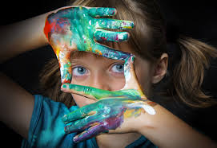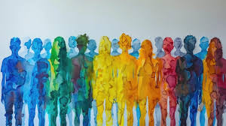-appropriate groups will engage with learning about communication, executive functioning, awareness of self and others, emotional regulation, and personal growth in a safe creative space.

PONY PALS SOCIAL GROUPS

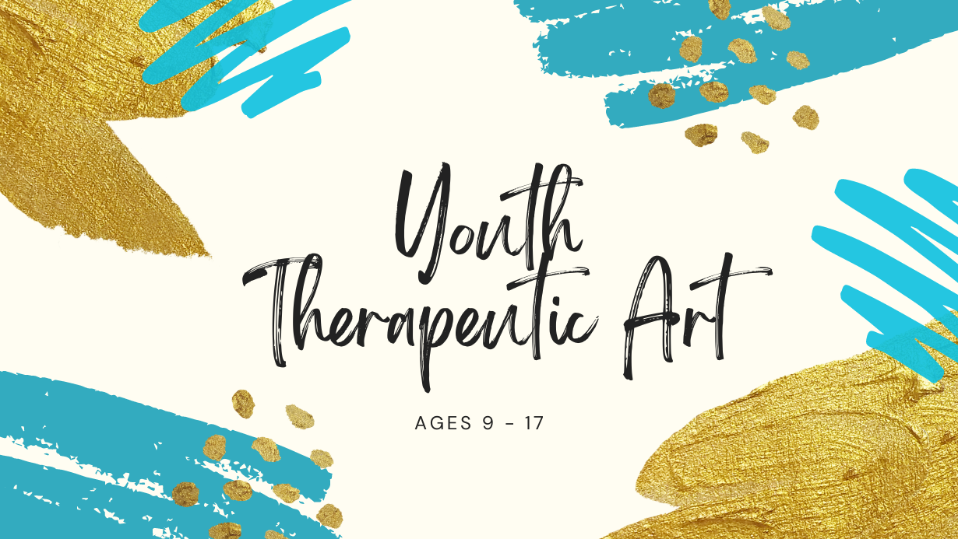

## Expression

**Learn about yourself and others**

## Engagement

**Connect through shared experiences**

## Life and Social Skills

**Supported and emergent learning**

### 1.5 HOUR PRIVATE

**time to explore and connect**

### 1.5 HOUR semi private

**developmentally-appropriate groups**

### 1.5 hour Group

**weekly session options**