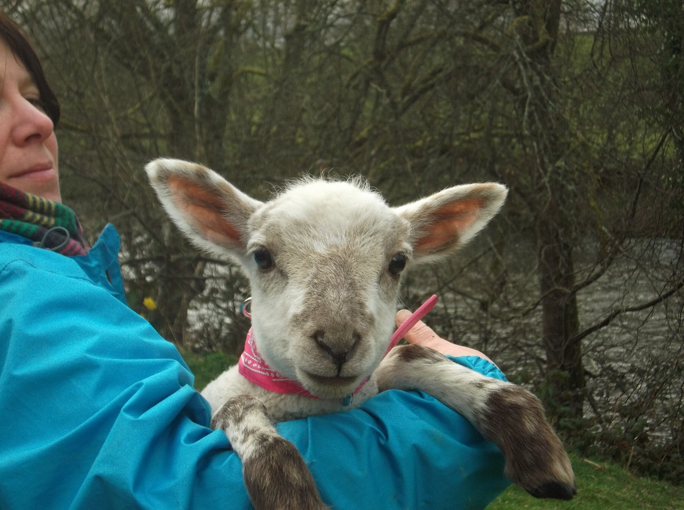
Apple Blossom Care Farm, social enterprise.
Working with Land, Nature and Animals
A Care Farm promotes Health, social and educational services through farming related activities supporting a wide range of vulnerable groups such as people with learning difficulties, recovering mental health problems and social isolation in an around the community of Builth Wells, Powys.
Working in the countryside promotes physical and mental health wellbeing and provides excellent therapeutic and educational opportunities.
If you would like to get involved please get in touch.
Booking is essential for more information please contact us.
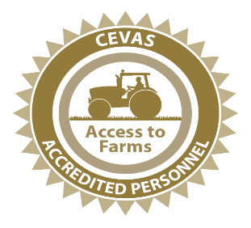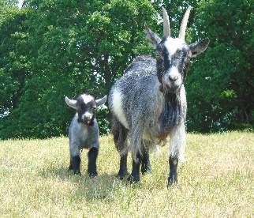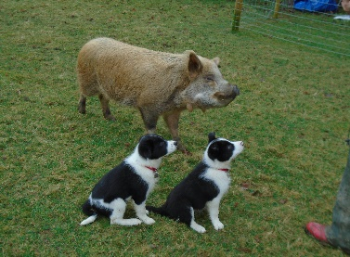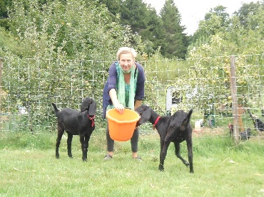
www.appleblossomcarefarm.co.uk T. 07933779703 01982 551608

