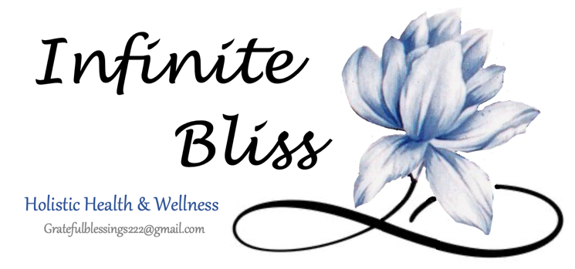

**Informed Consent / Liability Waiver**

**Please read and initial each the following, indicating your understanding:**

**______ What is Reiki?**

Reiki Healing is an energetic healing practice that uses the Universal life force energy to balance the subtle energies within our bodies to promote healing from within. Reiki practitioners act as a conduit or channel through which Reiki energy travels through the body to open and align any blocked or stagnant energy channels. The intended result of receiving Reiki is a balanced physical, mental, emotional, and spiritual being. Reiki is an ancient healing method that is being used today by practitioners all over the world to support health, wellness, and transition.

**______ What happens during a Reiki treatment?**

During a Reiki treatment, you will lay fully clothed on a massage table, covered with a light blanket if you choose, listening to soothing music. If lying flat on the table is uncomfortable, Reiki can be performed while you sit in a chair or on a stool. Your Reiki practitioner will lay their hands on, or float their hands above, your body in a series of hand positions used to deliver Reiki energy. While there is a traditional protocol of hand placement, the practitioner may use their intuition to guide them to which hand positions to use. There is no difference in the benefit experienced by the placement of hands on the body or above the body (floating hands technique). Open communication is essential between you and the Healing Practitioner to facilitate a mutual understanding and acceptance of the energy work. Please feel free to ask your practitioner to change hand positions or use the floating hands method at any time during the session.

|  |
| --- |
| **Special requests or comments for ‘hands-on’ or ‘floating-hands’ technique**  *ex. Please use floating hands for entire body, please use floating hands over lower stomach area*  ___________________________________________________________________________________________________________________________________________________________________________________________________________________________________________________________  Initials |

**______ What does Reiki feel like?**

Clients often feel warm & relaxed during a Reiki session. You may also feel the hands of the Reiki practitioner become hot or tingly. Some people describe a floating sensation, see colors or shapes, or receive intuitive messages during the session; while others may fall asleep. Some clients experience an emotional release. Should you begin to feel emotional or anxious at any time during the session, please let your practitioner know. Often times, deep breathing and reassurance will assist during the release of the blocked accumulation of old energy. There is no expected experience during Reiki, the experience during and results of each session are unique for the individual who receives it.

The most common results of Reiki treatment include:

* Perceived reduction in stress
* Increased feelings of relaxation
* Enhanced sense of balance, centeredness, and stability

**______ What are the benefits of several sessions?**

Just like meditation, yoga, or exercise, the effects and benefits of repeated Energy Healing / Reiki sessions are cumulative over time. While one session can provide significant benefits, multiple sessions can have a much more profound impact on your physical and mental health and spiritual wellbeing. For example: if you exercise one day, you will feel better, however If you exercise 3-4 days a week day for an entire month, the results will be much more beneficial. Reiki works similarly – regular sessions help improve the flow of energy, providing support for your energetic and spiritual well-being.

**______ Can Reiki “cure” me?**

Reiki is a complementary medicine therapy that works well alone or in addition to other treatments. Most often, healing is the result of gentle shifts in the conscious awareness, a deeper connection to spirit, and the release of emotional patterns. Reiki is not intended to be an alternative therapy or a replacement for traditional medical treatment.

By signing below, I attest that I understand that Energetic Reiki Healing & Mindfulness Practices are complementary healing modalities that in no way substitute for medical interventions or psychotherapy. I further understand that any Energetic Reiki Healing Session, or Mindfulness Practice Instructions received from practitioners affiliated with *Infinite Bliss Holistic Health & Wellness* are not to be construed as a substitute for medical examination, diagnosis or treatment. It is recommended that I see a licensed health care professional for any physical or psychological ailment I may have.

I further understand that there are numerous benefits possible through Energetic Reiki Healing & Mindfulness Practices such as diminished pain sensation, increased relaxation, relief from anxiety, recovery from emotional disturbances, and an enhanced sense of well-being. These effects may vary depending on each individual’s response patterns. Long-term imbalances in the body sometimes require multiple sessions in order to facilitate the body’s natural ability to heal itself.

Having read, completed, and understood the foregoing, I request to receive an Energetic Reiki Healing treatment and/or Mindfulness Practices instructions. I understand that my practitioner is providing these treatments for me at my request, and is not responsible for the outcome of the Energetic Reiki Healing treatment and/or Mindfulness Practice instruction Sessions. Although there are no known harmful effects from these types of interventions, I hold my Healing Practitioner harmless from any possible effects that may cause temporary physical or emotional discomfort and agree to take full responsibility for my self-care and personal development. **I further agree to hold *Infinite Bliss Holistic Health & Wellness* and/or their healing practitioners harmless for any intended or unintended result from the aforementioned services, classes, or events provided.**

Signature: _____________________________________ Date: _______________________

Print Name: _____________________________________ Healing Practitioner: Jodie Smith

PRIVACY NOTICE:

*No information about any client will be discussed or shared with any third party without the written consent of the client or parent/guardian if the client is under 18 years of age.*